Reading Genres - Fiction and Non Fiction
Fantasy | 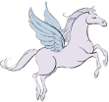 | Fairy Tale | 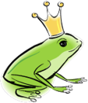 | Letter |  | Detective | 
Horror/ghost | 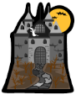 | Biography | 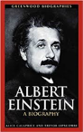 | Autobiography |  | Science Fiction | 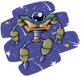
Adventure/  Quest | 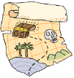 | Detective/  Mystery |  | Myth |  | Legend | 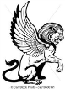
Newspaper  Articles |  | Fables | 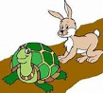 | Poster | 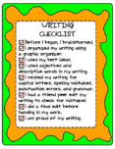 | Leaflet/  Advertisement | 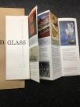
Diary | 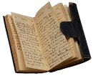 | Poetry |  | Modern  Fiction |  | Report | 

