St Julie Catholic Primary School - Computing
Computing – Spring Term 1 | Year: 3 | Unit Title: Programming – sequencing sounds.

Sequencing sounds
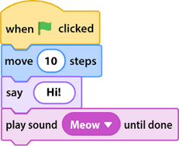

Sticky Knowledge
I know how to program a sprite.
I know how to order commands.
I know how to sequence sounds and debug.

What should I already know?
- That I can give a route on a mat.
- That I can change the order of directions.
- That I can make an algorithm.


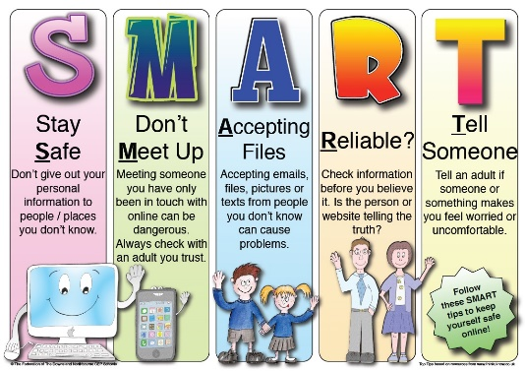
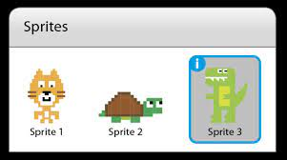
What I will Learn.
1 What is the program Scratch?
2 How to program a sprite?
3 What are sequences?
4 How to order commands?
5 How does it look good?
6 How to make an instrument?
Vocabulary
Sprite | A 2D bitmap image.
Programming | Instructions a computer can understand.
Commands | To direct a computer to complete a task.
Sequencing | To order algorithms.
Coding | How we communicate with computers.

