St Julie Catholic Primary School - Computing
Computing – Spring Term 2 | Year: 3 | Unit Title: Data & Information – Branching Diagrams.

Sticky Knowledge
I know how to create two groups of objects separated by one attribute.
I know how to arrange objects into a tree structure.
I know how to create a branching diagram.

What should I already know?
- That I have made pictograms.
- That I have recorded data in a tally chart.
- That I have entered data into a computer.
Branching Diagrams
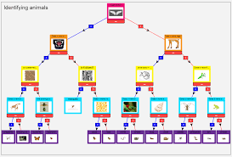



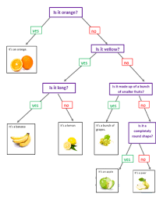
What I will Learn.
1 How to answer Yes or no questions.
2 How to make groups.
3 How to create a branching database.
4 How to structure a branching database.
5 How to use a branching database.
6 There are other ways of presenting information.
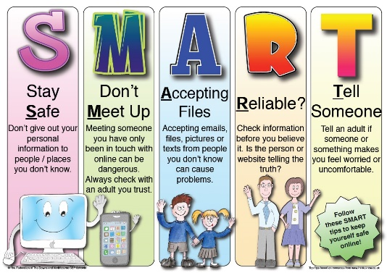
Vocabulary
Branching database | A way of classifying a group of objects.
Database | A collection of data.
Attribute | A certain value of an object.
Structure | A design and operation.

