St Julie Catholic Primary School - Computing
Computing – Summer Term 1 | Year: 3 | Unit Title: Creating Media

Sticky Knowledge
I know that text and images have differences.
I know how to edit text and layout.
I know how to add content to a desktop publishing publication.
Desk Top Publishing

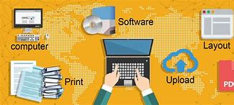

What should I already know?
- That I have taken digital photographs.
- That I changed an image.
- That you can write digitally using text.


Vocabulary
Desk Top publishing | To combine text, numerical data, photographs, charts, and other visual elements in a document that can be printed.
Layout | How text or pictures are set out on a page.
Content | The text within an e-mail, web page, or another file.

What I will Learn.
1 What are words and pictures?
2 Can you edit it?
3 What is a great template?
4 Can you add content?
5 How to lay it out.
6 Why desk top publishing?
