St Julie Catholic Primary School - Computing
Computing – Summer Term 2 | Year: 3 | Unit Title: Events and actions in programs.

Events & actions in programs 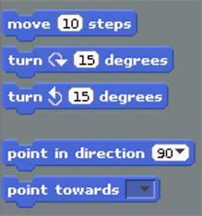

Sticky Knowledge
I know how to explain the relationship between an event and an action.
I know to create a program to move a sprite in four directions.
I know how to develop my program by adding features.

What should I already know?
- How to program a sprite.
- How to order commands.
- How to sequence sounds and debug.


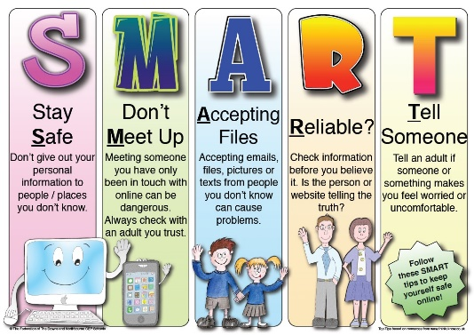
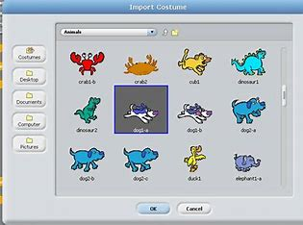
What I will Learn.
1 How to move a sprite.
2 How to move in a maze.
3 How to draw lines.
4 How to add features.
5 How to Debug movement.
6 How to make a project.
Vocabulary
Project | To develop and test out an idea.
Event | An action recognised by the computer program.
Adapt | To change an event.
Features | Information about the content of an image.

