Geography
Topic: How can we live more sustainably? | Year: 3 | Strand: Locational & Place Knowledge, Human & Physical geography
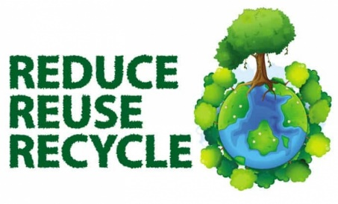
Vocabulary
Sustainable | Being able to do something for ever without having a negative impact on the environment or on people.
Solar energy | Energy given off by the sun’s ray.
Wind turbine | An engine that turns wind movement into energy usually electricity.
Finite  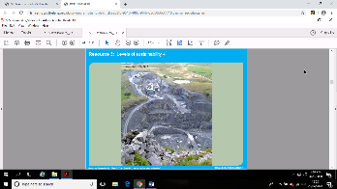 | Non-renewable, ultimately run out altogether such as quarrying for coal and drilling for gas.
Infinite  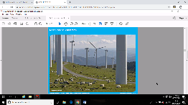 | Renewable, that will not run out such as wind, tidal, solar.
Atmosphere | Is the layer of gas that surrounds Earth.

What should I already know?
- Year 1-- Human features of local area. Identify four countries that make up the United Kingdom.
- Year 2 - There are 7 continents Asia, Africa, North America, South America, Antarctica, Europe and Oceania.
- There are 5 oceans, The Pacific, Atlantic, Indian, Artic and Southern Ocean.
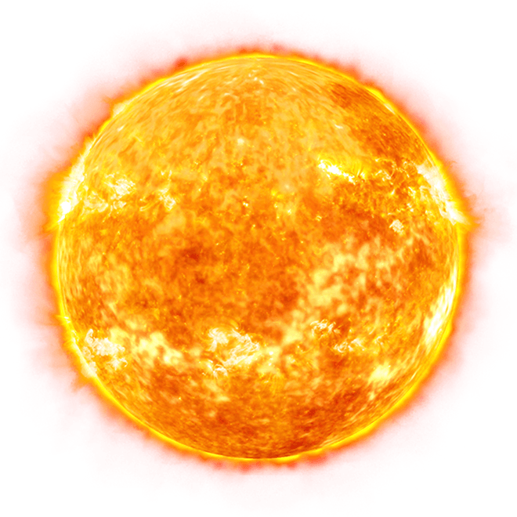
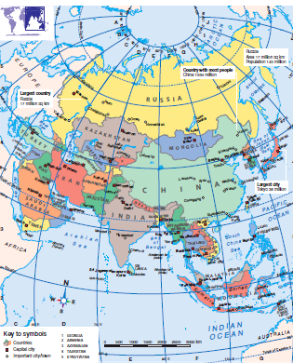
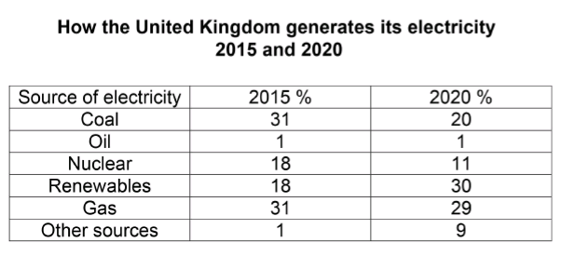
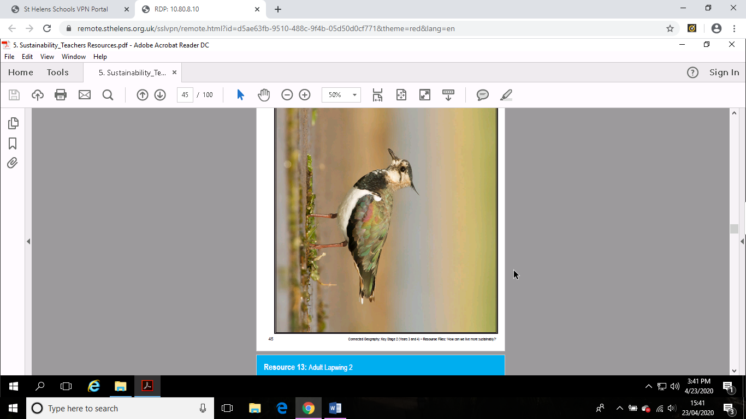
Nepal is one of the very poorest countries in the world. Only 24 percent of people here have electricity!
Every day more energy is received from the sun in one hour than all 7 billion people in the world use in one year!
11 areas of sustainability
Energy
Litter
Waste
Water
Transport
Healthy living
Biodiversity
School grounds
Global perspective
Green procurement
Pupil participation
Adult lapwing
What will I learn during this topic?
- What being sustainable actually means.
- How we help make our school more sustainable.
- Why we are seeing more wind and solar farms in the countryside.
- How sustainable development is helping the lapwing out of the red.
- How solar cookers are helping Sunita and her family live more sustainably.

