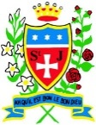
Year 5 - Our Reading Spine

At St. Julie’s Catholic Primary School, we want it to be a place where children are read to, enjoy listening to high-quality books and share their enjoyment of stories through discussion.

Our 'Reading Spine' is one element of the approach we take to foster a love for reading in our children. The spine is a core of books that create a living library inside our children's minds. It is a store of classics and essential reads that help our children engage at a deeper level and enter the world of the story. We have produced our very own 'Reading Spine' for every year group; giving children access to these high-quality texts.
Ultimately, while our children are continuing to enjoy a range of books throughout their school journey, they are also learning to become meta-cognitive readers.

We use the reading spine books in every year group over the school year. From your child starting in Reception at St. Julie’s Catholic Primary School, to leaving in Year 6, they will have been immersed into 50 of the most fantastic books available to children!

Year 5 - Reading Spine
Autumn | The Wolves of Willoughby Chase – Joan Aitken  Book Awards St Helens, children are encouraged to read new and enticing fiction, written specially for them. By debate and critical appreciation, the pupils vote for their favourite book and choose a winner. | 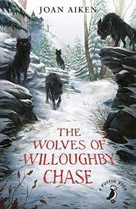  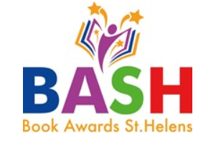
Spring | The Works4 – Poetry Book – Gaby Morgan and Pie Corbett | 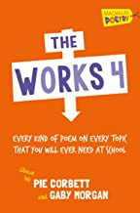
Summer | The Last Bear – Hannah Gold and Levi Pinfold | 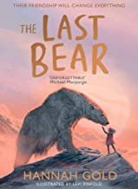

The books from the ‘Reading Spine’ will be shared with the children during the year

