1. Handwriting:
- Copy out the poem in your BEST, JOINED handwriting – don’t forget capitals and punctuation. Set it out as it is below.
- When you have finished, you can decorate the page if you want to.
2. Learning challenge:
- BRONZE- recite (learn by heart) the first verse.
- SILVER – recite the first and second verse of the poem.
- GOLD – recite the whole poem!
Think about how you will read the poem – loudly, quietly, firmly, gently, slowly, quickly, pitch, intonation – a variety of these
3. Listen to the poem being read on the HISTORY page of the Y5 website.
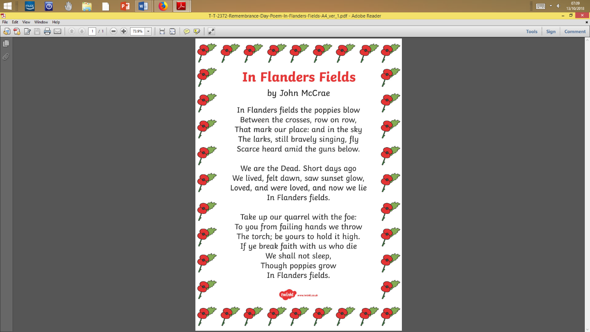
4. Can you contribute to the school blog about WW1? (NOT WW2!)

