
Eco Code
The children, staff and governors of St Julie will do their best to care for our common home, the Earth. We will:
Expect to reduce our carbon footprint
Care for our common home
Open our eyes to the beauty of creation

Care for the wildlife in our school grounds
Organise recycling events
Decide to make eco-friendly choices
Encourage our families to share our eco hopes

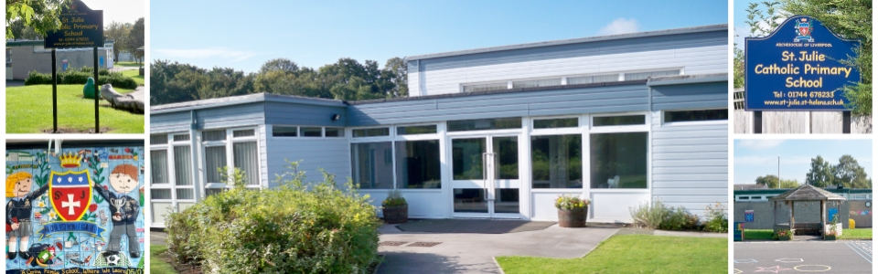
Caring for our common home

