St Julie Catholic Primary School - DT
DT – Summer Term | Year: 2 | Unit Title: Textiles – Templates and Joining

Can I design, make and evaluate a puppet to be used in Reception?

Vocabulary
design | A plan with ideas for a product.
glove puppet | A glove puppet fits over the hand, and the fingers operate its head and arms.
template | A shape drawn to assist in cutting out shapes.
Sew | To join pieces of fabric with stitches.
Seam | A row of stitches joining two pieces of fabric.
Appliqué | To attach a decorative fabric item onto another piece of fabric by gluing and/or sewing.
evaluate | To say what is good or needs improving with your design

What should I already know?

Explored and used different fabrics.
• Cut and joined fabrics with simple techniques.
• Thought about the user and purpose of products.


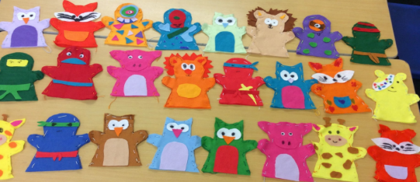
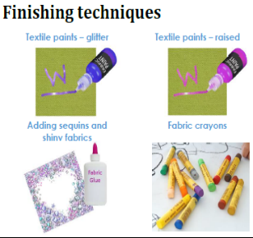
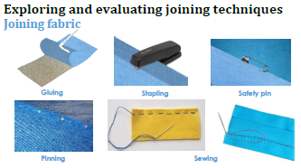
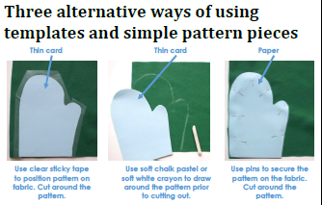
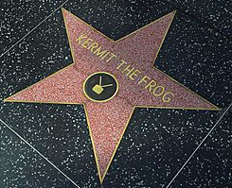
How do I create a puppet?
1, Can I investigate existing puppets, looking at fabrics, joining techniques, finishing techniques?

2. Can I make drawings of existing puppets and identify and label the fabrics, fastenings and techniques used?
3. Can I demonstrate use of a template, correct use of tools and some joining techniques finishing techniques?

4. Can I generate a range of ideas? Can I draw and label my own puppet design?

5. Can I make my puppet following the stages of assembly and applying the knowledge, understanding and skills I have learnt.

6. Can I evaluate my puppet against my design criteria?
Skills recap:
-Use of scissors and glue

DT Skills:
Understand how simple 3-D textile products are made, using a template to create two identical shapes.
• Understand how to join fabrics using different techniques e.g. running stitch, glue, over stitch, stapling.
• Explore different finishing techniques e.g. using painting, fabric crayons, stitching, sequins, buttons and ribbons.
Jim Henson
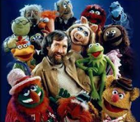
- He is American artist, animator, puppeteer, and moviemaker.
- Best known for his work with the Muppets, which he helped to create.
- His best-known puppet is Kermit the Frog.

