St Julie Catholic Primary School - DT
DT – Spring Term | Year: 2 | Unit Title: Food: Potato Salad and Rainbow Coleslaw

Can I design, make and evaluate a Potato Salad and Rainbow Coleslaw for a family picnic?
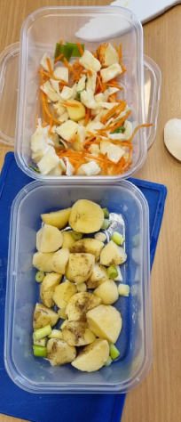

Vocabulary
slice | A thin piece of food cut from a larger portion.
grate | Cut food into tiny pieces by rubbing on a grater
peel | Remove the skin from fruit and vegetables.
healthy | Being fit and well
ingredients | Parts of a recipe or mixture
salad | a cold dish of fresh and/or cooked vegetables or  fruit.
claw grip | A common method used when cutting to protect fingers.
bridge hold | A common method especially used when cutting rounded foods.

What should I already know?
Making fruit salads in EYFS.
Making healthy garden salad in Year 1.
They will be familiar with the names of fruit and vegetables.
Prior Vocab:
design, make, evaluate.


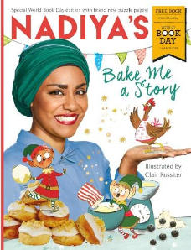
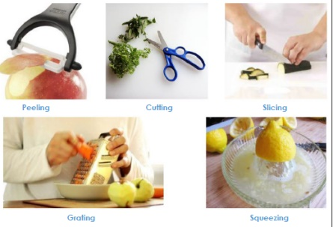
Skills recap:
-Designing for a purpose (Who is the product for?)
-Importance of personal hygiene and food handling
DT Skills:
- Design purposeful, functional, appealing products for themselves and other users based on design criteria.
- Select from and use a wide range of materials and components, including construction materials, textiles and ingredients, according to their characteristics.
- Explore and evaluate a range of existing products
- Evaluate their ideas and products against design criteria.

How do I create a potato salad and Rainbow coleslaw?
1 -Can I say what a root vegetable is? Can I sort vegetables that grow above and below ground?
2 -Can I explore, taste and describe a variety of root vegetables?
3 -Can I plan my potato salad and Rainbow coleslaw salad?
4 -Can I make a potato salad and rainbow coleslaw?
5 -Can I evaluate the salad making process?

Nadiya Hussein

Nadiya won the Great
British Bake Off 2015.

She is about to have
her 6th cook book
published called ‘Fast Flavours.’

She has had 3 cookbooks story books for children called Bake Me A Story.

Common methods when cutting foods
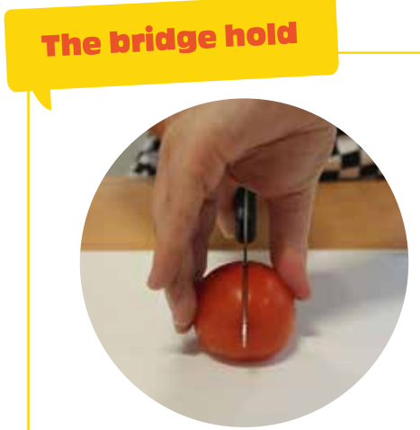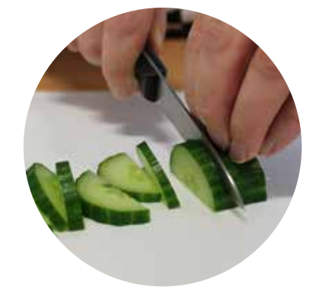
Claw grip Bridge hold

