St Julie Catholic Primary School - DT
DT – Autumn Term | Year: 2 | Unit Title: Mechanisms – Wheels and axles

Vocabulary
design | A plan for the construction of an object
vehicle | a thing used for transporting people or goods, especially on land, such as a car, lorry, or cart.
Axle | a rod on which one or more wheels can rotate, either freely or be fixed to and turn with the axle.
Axle holder | the component through which an axle fits and rotates.
Chassis | the frame or base on which a vehicle is built.
Dowel | wooden rods used for making axles to hold wheels
evaluate | To say what is good or needs improving with your design

What should I already know?
• Assembled vehicles with moving wheels using construction kits.
• Explored moving vehicles through play.
• Gained some experience of designing, making and evaluating products for a specified user and purpose.
• Developed some cutting, joining and finishing skills with card.
Can I design, make and evaluate a vehicle to get teddy across the classroom?



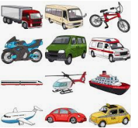
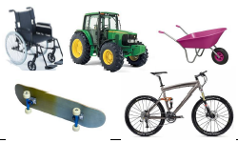

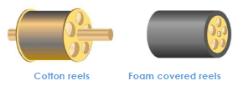
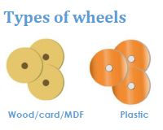
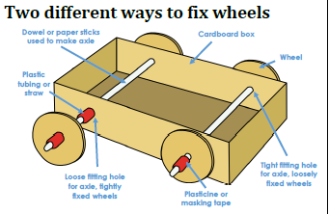
Skills recap:
-Using construction kits to make wheeled products
-Use of scissors and hole punches
-Joining card using different methods
DT Skills:
-Generate ideas based on simple design criteria and their own experiences, explaining what they could make.
-Develop, model and communicate their ideas through talking, mock-ups and drawings.

Henry Ford
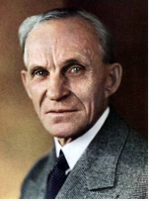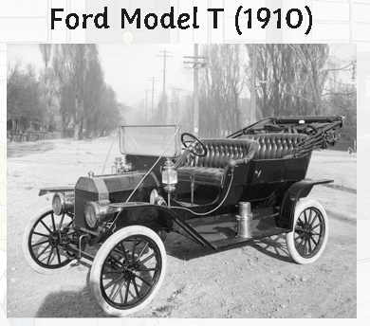
Henry Ford was American. He founded the Ford Motor Company on 16th June 1903.
As a young boy, people used to bring their broken watches to Henry for him to fix.
Ford is currently the leader in UK car sales

How do I create a wheeled product?
1, Can I explore different wheeled products, directly observing the number, size, position and methods of fixing wheels and axles?
2. Can I draw an example of a wheeled product, labelling the main parts?
3. Can I use construction kits with wheels and axles to make a product that moves?
4. Can I use samples of materials and components to assemble some examples of wheel, axle, axle holder combinations.
5. Can I draw and label my own designed wheeled product?
6. Can I make my wheel and axle product using their design ideas and criteria as an ongoing guide?
7. Can I evaluate my finished product, communicating how it works and how it matches my design criteria, including any changes I made.

