St Julie Catholic Primary School - Science
Topic:Seasonal Changes. | Year: 1 | Strand: Physics
Sticky knowledge
I know there are different types of weather.
I know there are changes across the 4 seasons.
I know weather patterns and temperature are related to the seasons.
I know day length and weather change during the different seasons.

What should I already know?
I know there is day time and night time.
I can talk about different types of weather.
I remember the seasonal changes observed on our Autumn, Winter and Spring walks.

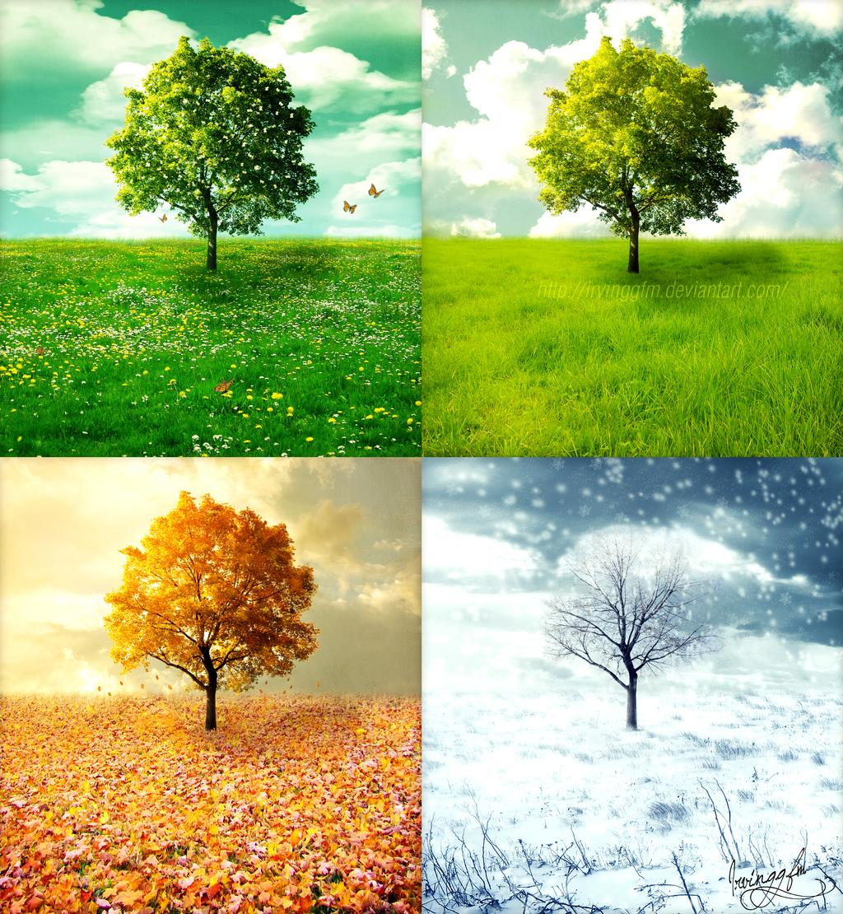

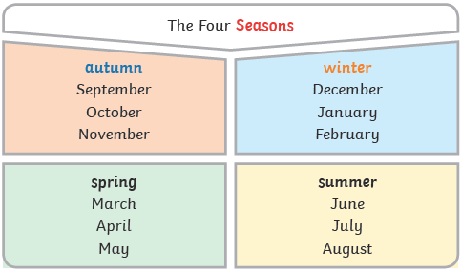

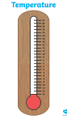

A thermometer measures the air temperature to show how warm or how cold it is.
Never look directly at the sun. Even with dark glasses it can damage your eyes.

Vocabulary
season | There are 4 seasons each year, winter, spring, summer and autumn.
daylight | Daylight is when it is light outside. Daylight changes with each season.

