
Autumn Term Newsletter
In September, St Julie’s began working towards achieving Cafod’s Live Simply Award, which provides an opportunity for Catholic communities to respond to Pope Francis’ invitation in Laudato Si’ (Care for our Common Home) to “Work with generosity and tenderness in protecting this world which God has entrusted to us.”
Our school website has more information about the award on the RE tab under the heading “Living our faith.” In this newsletter we will share with you our many actions this term.
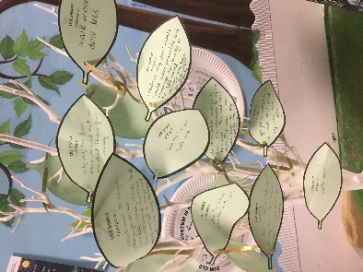
In September we held an assembly to launch our Live Simply initiative with staff, pupils and Governors pledging to:
- live simply
- live sustainably
- live in solidarity with others.

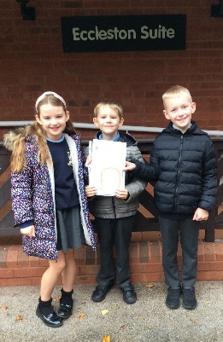
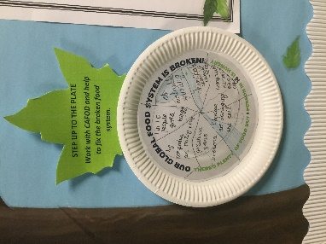
Minnie Vinnies Also in September we had a visit from the national head of Minnie Vinnies as we began our Minnie Vinnies group – the junior branch of the St Vincent De Paul society. The Minnie Vinnies is currently aimed at Year 3 and Year 4 who have been enthusiastic about their mission “to turn concern into action” by helping people in our local community. The children took wellbeing cards to the residents at Eccleston Court Nursing Home and have recently made them Christmas cards. They have also been thinking about the problems faced around the world with food production and supply in making their own plates in the Cafod “Step up to the plate” campaign.
Live Simply In our efforts to Live Simply, mental health and wellbeing has been a major focus:
- Staff mental health ambassadors have supported a variety of wellbeing activities for staff and pupils.
- Children are using ‘Zones of regulation’ each day to help them reflect on their well-being.
- Forest school supports our mental wellbeing and appreciation of the beauty of God’s creation.
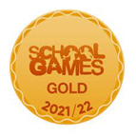
Physical health is promoted through our continued participation in St Helens School Games competitions. Children are encouraged to participate in a wide range of sports in school, after school clubs and inter-school events.

Live sustainably
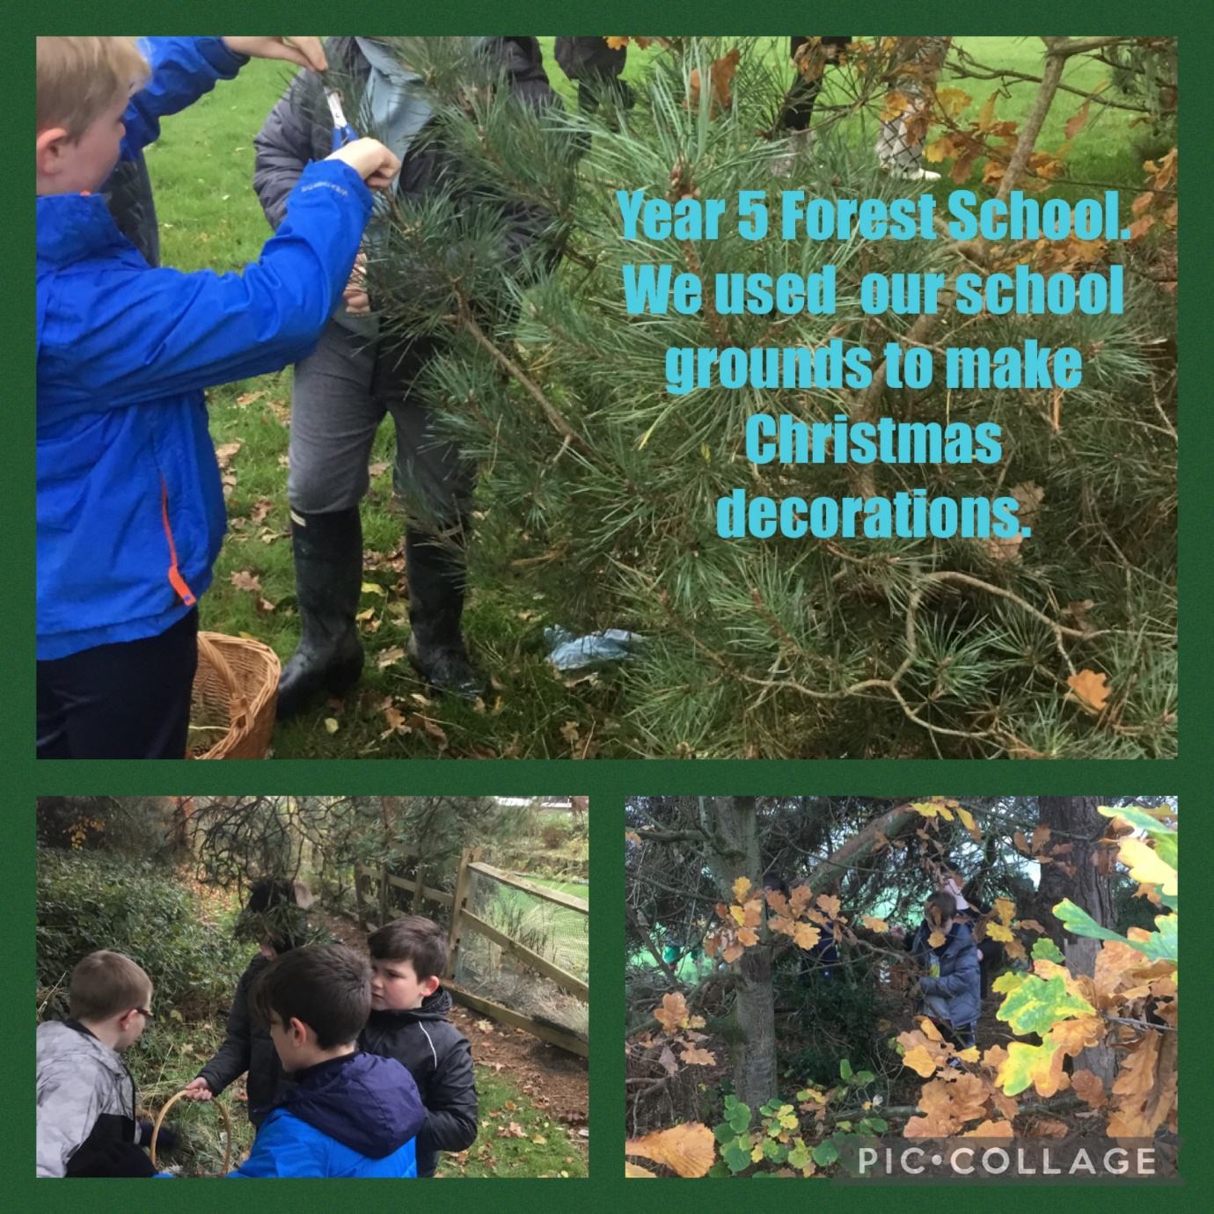

Eco club – Our KS2 Eco club and our Eco ambassadors take part in a range of activities including litter picking, school energy survey, making hedgehog shelters and bird feeders.
Meat free Monday – this aims to reduce meat farming which is linked to greenhouse gas emissions. Mrs Finney, our school cook, makes wonderful meat free meals every week which the children enjoy.

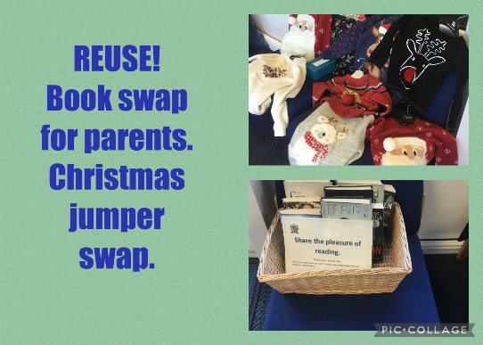
Recycling: We have paper and card recycling boxes placed throughout the school to separate out our waste that can be recycled. In the foyer parents can use our book swap to share the pleasure of reading. This year we have organised a store of pre-loved school uniform in age sizes that can be obtained from the school office. We also have a collection of pre-loved Christmas jumpers. Why not donate yours from this year and then next year we will have even more in stock for Jumper day 2023!
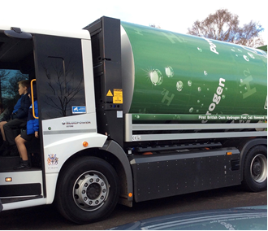
‘Go Green Team’ St Helens Chamber came into school to talk to Year 5 about the St Helens Go Green initiative. They discussed recycling initiatives and were taught about greenhouse gases and made their Net Zero pledges. St Julie’s was also visited by St Helens’ only hydrogen powered truck – an alternative to fossil fuels.

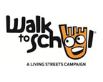
‘Living Streets ‘ Walk Once a Week: The WOW weekly challenge continues to encourage us to find alternate ways of getting to school without using greenhouse gas producing vehicles. Look in the bulletin to see how each class is doing – the winning class in announced at the end of each month. Children who take part receive a different badge each month which is made from recycled yoghurt pots!
Live in solidarity
School ambassadors help support our teachers and pupils in all areas of our learning. Maths ambassadors did a wonderful job recently helping our younger children share the ‘Marvellous Maths’ afternoons with parents and carers.
Faith in Action group The Chaplain from De La Salle, Sam, visited Year 6 to launch their journey on achieving the Faith In Action award. During the year the children will be reflecting on how they live out our St Julie’s Core Values and our mission of following in the footsteps of Jesus and recording the activities and actions they have taken. This will link closely with our Live Simply aims of living in solidarity within school and our local community. Year 6 regularly support Reception children on church visits and with their reading in the classroom. Our Year 6 buddies encourage the infants to play cooperative games at playtime.
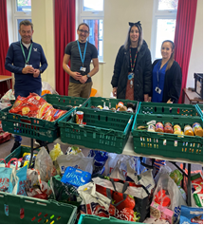
Harvest: In October we held our Harvest thanksgiving celebration in church. It was also a time of reflection as the children were encouraged to think about how it would feel if they didn’t have their favourite foods or even a meal to eat. Your generous donations of tinned and dried food products were delivered to the St Helens Foodbank and Teardrops.
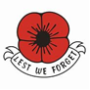
The Royal British Legion Poppy Appeal Thank you for supporting the Poppy Appeal – your donations during the remembrance month of November raised £222.90 this year.

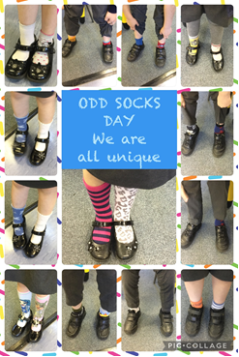
Anti-bullying week – wear Odd Socks to school
In November we started anti-bullying week with our Odd Socks Day in school and the children talked about how it is ok to be different and how we respect each other’s differences, living in solidarity with each other. The children shared stories that reminded everyone about how to be a good friend and to celebrate that we are all unique.
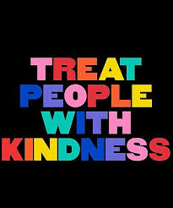
With this year’s theme for national Anti-Bullying Week 2022 being reach out to stop bullying, many Random Acts of Kindness were even more apparent around school. In assembly the children shared the small gestures they had made to each other through helping, sharing, taking turns and looking out for each other.
During Advent, the St Julie’s Kindness Advent calendar encouraged us to keep thinking of others and how we can live in solidarity through our everyday actions.

Children in Need

The children enjoyed wearing their spotty clothes and accessories and were able to talk about how they were raising money for children around the country who would benefit from support for lots of different reasons. As always, the children were thoughtful and caring for those around them. Thanks to your donations, £150.00 was raised.

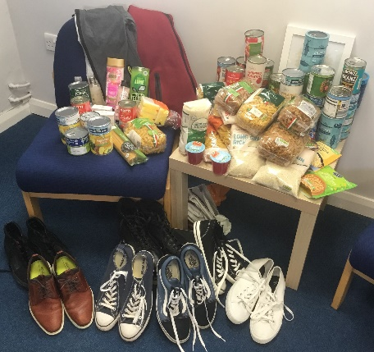

Your generous donations of tuna, tinned pineapples and tomatoes, pasta, rice and men’s shoes during Advent were gratefully received by the charity providing for refugees in our local community.

CAFOD fundraising In December we began our Advent fundraising for CAFOD with a Santa Dash. Each class was raising money for CAFOD and aiming to buy a World Gift. World Gifts are a way of changing the lives of families and communities overseas by providing resources that can enable self-sufficiency and development. A total of £265.95 was raised and the gifts bought were:


Reception: Emergency water and some chirpy chickens.
Year 1: Teach someone to read x 2 and a vegetable garden.
Year 2: Wonderful worms and a super soup kitchen.
Year 3: Chirpy chickens, a vegetable patch and happy queen bees x 2
Year 4: Chirpy chickens and wonderful worms.
Year 5: The goat that gives.
Year 6: Chirpy chickens and a vegetable garden.

You can see the many ways that your children are already achieving our aim to Live Simply but there is still much more that we plan to do in 2023.
If you have any suggestions or would like to share with us how you Live Simply at home, please email stjulies@sthelens.org.uk with the subject Live Simply.
I will send you a further newsletter in the Spring term.
Thank you for your support,
Mrs Hodgson.

