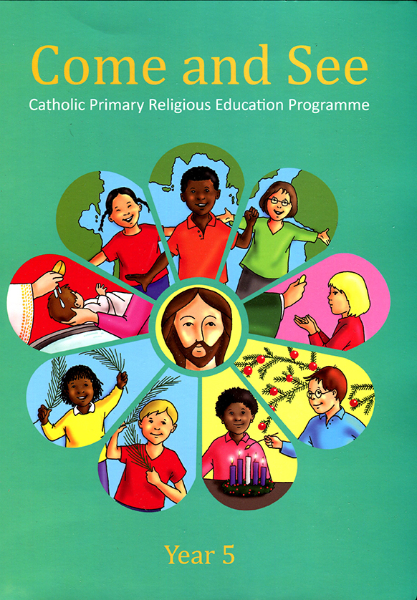
Science

How can I grow to be a happy, healthy me?

How does a tiny seed grow into a sunflower?

History & Geography

Why did the Great Fire of London spread so quickly?

Where do we live and how does it compare to Chembakolli?

Computing

3. Programming A – Robot algorithms
4. Data and information – Pictograms
Art
Artist – Paul Klee

Colour- Abstract Art – Eccleston landscape
DT

Can I make food for a family picnic?
Rainbow coleslaw and potato salad.
P.E
Games
Gymnastics
Dance

Music
Grandma Rap

Orawa

Trains
P.S.H.E
We Meet God’s love in the Community.
Physical - To describe ways of being safe in communtities.
P.S.H.E
What jobs do people do?
What helps us to stay safe?
Religion
Branch 3
Galilee to Jerusalem

Branch 4
Desert to Garden

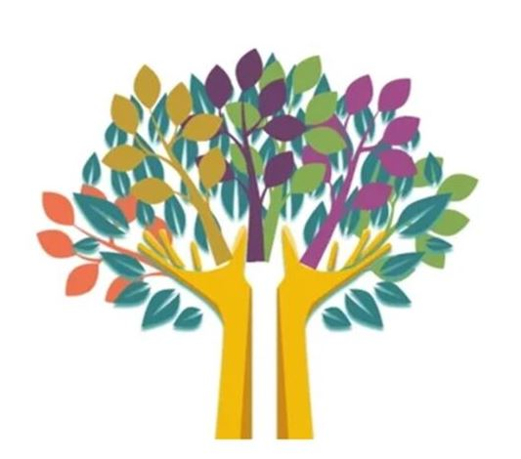
English
Fiction:

The Three Billy Goats Gruff
Jack and the Beanstalk
The Day the Crayons came home.
Vlad and the Great Fire of London
Non fiction:

Letters
Newspaper Report
Diary
Instructions
Poetry:

Free verse – If I were in charge…

Mathematics
Place Value
Count in 2’s, 5’s and 10’s.
Count in 3’s

Addition and Subtraction
Add and subtract two-digit numbers (not crossing 10/crossing 10)
(Concrete/pictorial/abstract methods)

Money
Make the same amount. Compare money and find total of two amounts

Multiplication and Division
2, 5 and 10 times tables . Divide by 2, 5 and 10. Odd and even number

Fractions
Recognise and find ½, ¼ 1/3 of a shape and amount.

Year 2 SPRING TERM LEARNING
YEAR 5 AUTUMN TERM LEARNING

