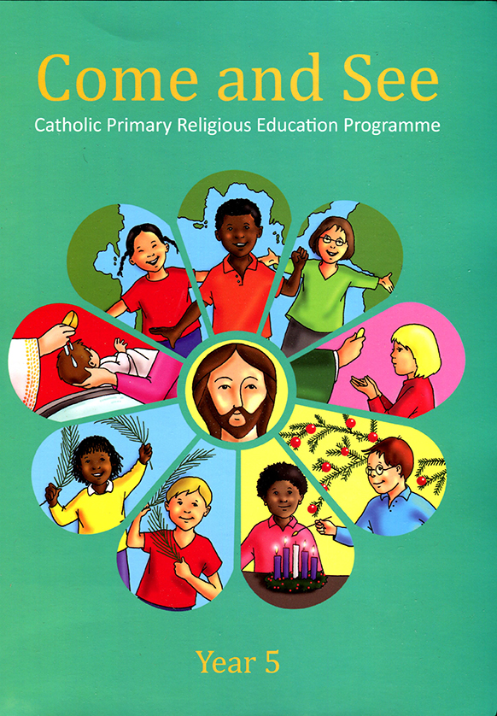
Music
Tony Chesnut
Carnival of the animals
Birdsong
P.E
Games
Gymnastics
Dance

DT

Can I design a moving vehicle to take Teddy across the classroom?
(Mechanisms)

Art
Artist - Rachel Dein

Sculpture – clay nature tiles

R.S.E
We Meet God’s love in the Community.
Social and Emotional - to recognise the joy and friendship of belonging to a diverse community.
P.S.H.E
What makes a good friend?
What is bullying?
Geography & History

Why are green spaces in Eccleston important?

Why do we celebrate Bonfire Night?

Who is Samuel Taylor and why was he important to Eccleston?
.

Computing

1. Computing systems and networks – IT around us
2. Creating media – Digital music
Science

How can we fix Miss Wood’s tent? (Materials)

How can I grow to be a happy, healthy me?

Religion
Branch 1 Creation and Covenant

Branch 2 Prophecy and
Promise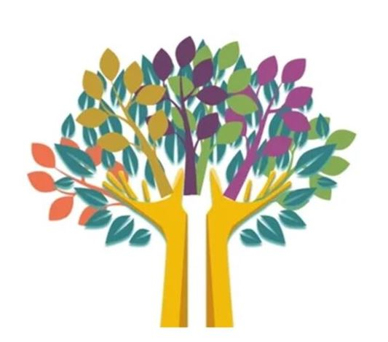
Mathematics
Place Value
Recognise, count, partition, compare, order and write numbers up to 10.

Addition and Subtraction
Fact families - addition and subtraction bonds within 20 then to 100 (tens). Add and subtract 1s and 10’s

Money
Recognise, count and select coins and notes. Make the same amount.

Multiplication and Division
Recognise, make and add equal groups. Make equal groups by sharing and grouping

Fractions
Fractions of shapes

Shape
2D shapes

English
Fiction:
The Jolly Witch
Flotsam
Traction Man
Man on the Moon
Non fiction:
Diary entry
Instructions
Recounts
Postcard

Poetry:
Traditional - The Owl and the Pussycat

Poetry: Traditional :The Owl & the pussycat, Edward Lear

Year 2 AUTUMN TERM LEARNING
YEAR 5 AUTUMN TERM LEARNING

