

Numeracy Calculation Policy
This policy has been largely adapted from the White Rose Maths Hub Calculation Policy with further material added.
It is a working document and will be revised and amended as necessary.
Updated September 2026

Y1 Addition + | Objective & Strategy | Concrete | Pictorial | Abstract
Y1 Addition + | Combining two parts to make a whole: part- whole model | 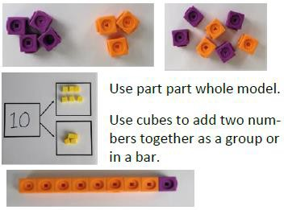 | 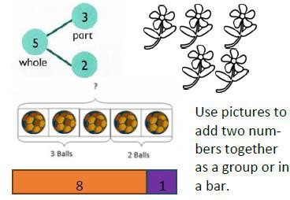 | 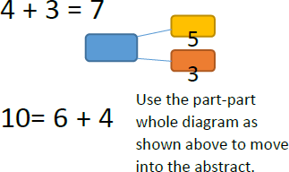
Y1 Addition + | Starting at the big- ger number and counting on | 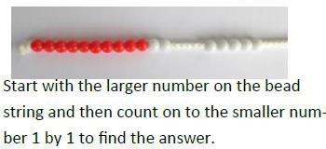 | 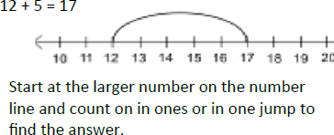 | 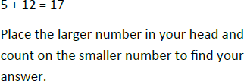
Y1 Addition + | Regrouping to make 10.  This is an essential skill for column addition later. | 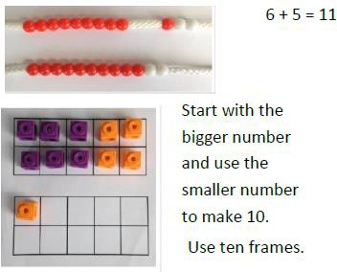 | 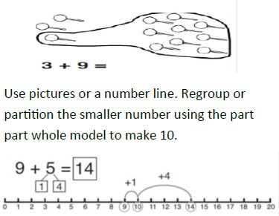 | 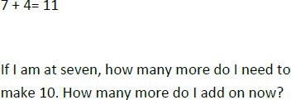
Y1 Addition + | Represent & use number bonds and related subtraction facts within 20 | 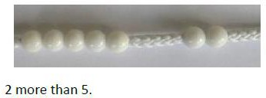 | 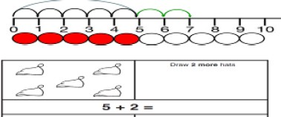 | 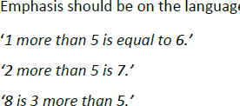

Y2 Addition + | Objective & Strategy | Concrete | Pictorial | Abstract
Y2 Addition + | Adding multiples of ten | 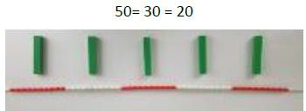  Model using base 10 and bead strings | 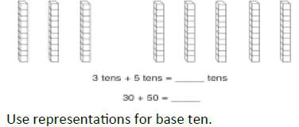 | 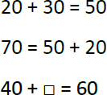
Y2 Addition + | Use known number facts  Part Part Whole Model | 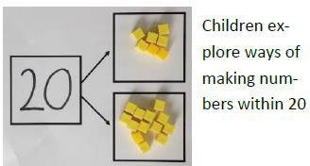 | 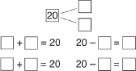 | 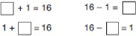
Y2 Addition + | Using known facts | 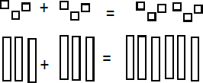 | Children draw representations of H, T and O  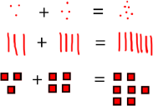 | 3 + 4 = 7  leads to 30 + 40 = 70
Y2 Addition + | Bar model | 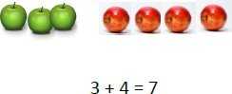 | 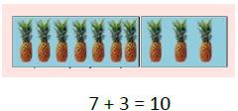 | 23 + 25 = 48
23 | 25
?

Y2 Addition + | Objective & Strategy | Concrete | Pictorial | Abstract
Y2 Addition + | Add a two digit number and ones | 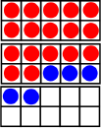  17 + 5 = 22  Use a tens frame to make ‘magic ten’  Children explore the pattern  17 + 5 = 22 27 + 5 = 32 | 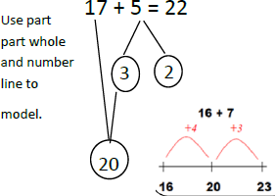 | 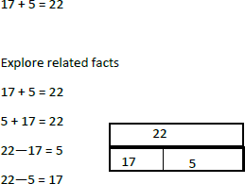
Y2 Addition + | Add a 2 digit number and tens | 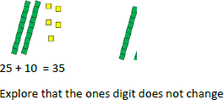 | 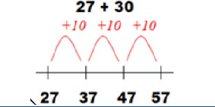 | 27 + 10 = 37  27 + 20 = 47  27 + □ = 57
Y2 Addition + | Add two 2-digit numbers | Model using base 10, place value counters and Numicom  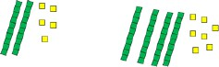 | 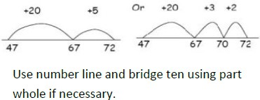 | Partition to add  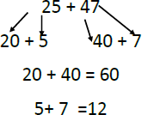
Y2 Addition + | Add three 1-digit numbers | 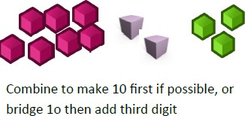 | 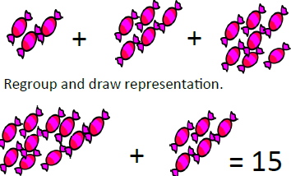 | Combine the two numbers that make/bridge ten then add on the third.  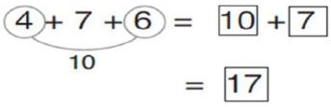

Y3 Addition + | Objective & Strategy | Concrete | Pictorial | Abstract
Y3 Addition + | Column addition: no regrouping or exchanges | 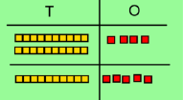  Model using base 10 or Numicom  Add together the ones first, then the tens.  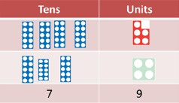  Move on to place value counters  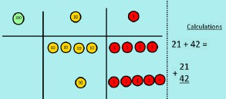 | Children move on to drawing the counters using a tens frame.  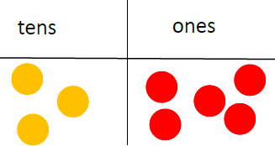        Or a place value chart | Add the ones first, then the tens and then the hundreds.  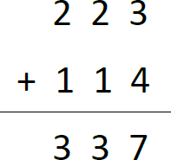
Y3 Addition + | Column addition with regrouping or exchanges | Exchange ten ones for a ten. Model using numicon and place value counters.  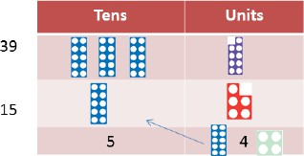  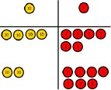 | 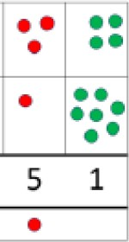  Children draw a representation of the grid to further support their understanding, carrying the ten underneath the line | 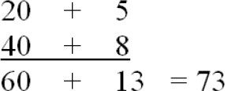  Start by partitioning the numbers.  Then move on to  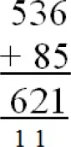  formal column to show the exchange.

Y4-6 Addition + | Objective & Strategy | Concrete | Pictorial | Abstract
Y4-6 Addition + | Y4 – add numbers with up to 4 digits | Children continue to use base 10 or pv counters to add, exchanging ten ones for a ten and ten tens for a hundred and ten hundreds for a thousand.  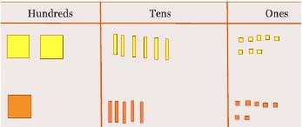 | Draw representations using pv grid.  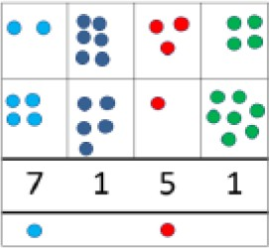 | Continue from previous work to carry hundreds as well as tens.  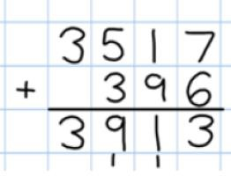  Relate to money.
Y4-6 Addition + | Y5 – add numbers with more than 4 digits.  Add decimals with 2 decimal places, including money. | As Year 4.  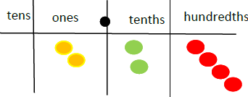  Introduce decimal place value counters and model exchange for addition. | 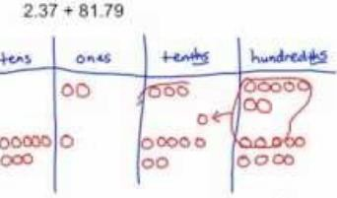 | 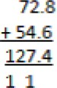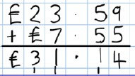
Y4-6 Addition + | Y6 – add several numbers of increasing complexity.  Including adding money, measure and decimals with different numbers of decimal points. | As Year 5 | As Year 5 | 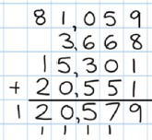  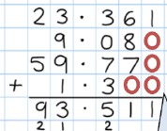  Insert zeros for place holders.

Y1 Subtraction - | Objective & Strategy | Concrete | Pictorial | Abstract
Y1 Subtraction - | Taking away ones. | Use physical objects, counters, cubes, etc to show how objects can be taken away.  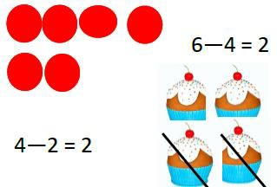 | Cross out drawn objects to show what has been taken away.  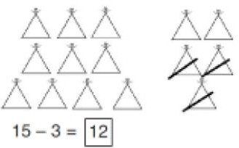 | 7 – 4 = 3  16 – 9 = 7
Y1 Subtraction - | Counting back. | Move objects away from a group.    Move the beads along the bead string as you count backwards.  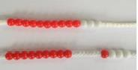 | Count back in ones using a number line.  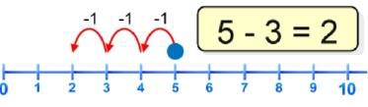 | Put 13 in your head, count back 4.  What number are you at?
Y1 Subtraction - | Find the difference. | Compare objects and amounts.  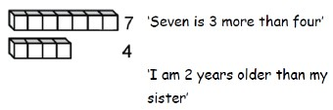  Lay objects to represent a bar model.  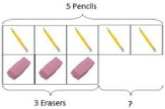 | Count on using a number line to find the difference.  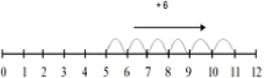 | Hannah has 12 sweets and her sister has 5. How many more does Hannah have than her sister?

Y1 Subtraction - | Objective & Strategy | Concrete | Pictorial | Abstract
Y1 Subtraction - | Represent and use number bonds and related subtraction facts within 20.  Part Part Whole models | Link to addition. Use PPW model to model the inverse.  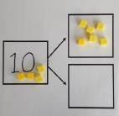  If 10 is the whole and 6 is one of the parts. What is the other part?  10 – 6 = 4 | Use pictorial representations to show the part.  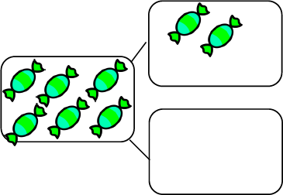 | Move to using numbers within the Part Part Whole model.  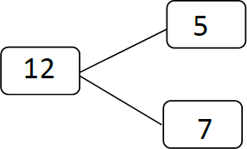
Y1 Subtraction - | Make 10 | Make 14 on the ten frame. Take 4 away to make ten, then take one more away so that you have taken away 5.  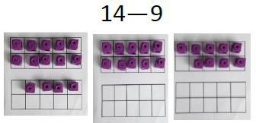 | Use a number line. Jump back 3 first, then another 4. Use ten as the stopping point.  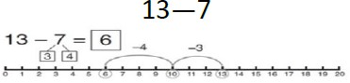 | How many do we take off first to get to 10? How many left to take off?  16 – 8 =
Y1 Subtraction - | Bar model | 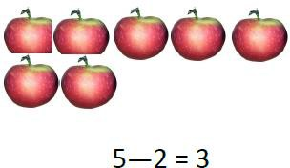 | 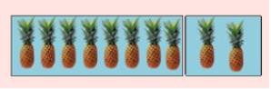 | 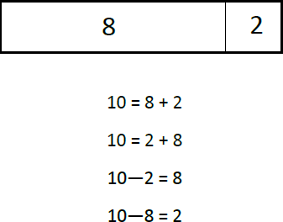

Y2 Subtraction - | Objective & Strategy | Concrete | Pictorial | Abstract
Y2 Subtraction - | Regroup a ten into ten ones | Use a PV chart to show how to change a ten into ten ones, use the term ‘take and make’  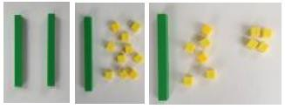 | 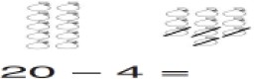 | 20 – 4 = 16
Y2 Subtraction - | Partitioning to subtract without regrouping  ‘friendly numbers’ | 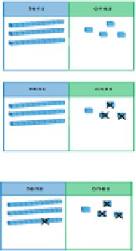  34 – 13 = 21  Use base 10 to show how to partition the number when subtracting without regrouping. | Children draw representations of base 10 and cross off.  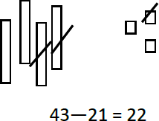 | 43 – 21 = 22
Y2 Subtraction - | Make ten strategy  Progression should be crossing one ten, crossing more than one ten, crossing hundreds. | Use a bead string to model counting to next ten and the rest.  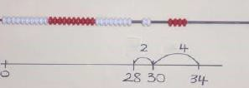 | Use a number line to count on or back to the next ten and then the rest.  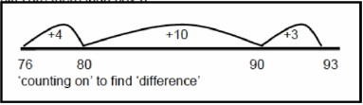  Some children can be confused with ‘counting on’ when subtracting therefore it is vital that children are taught to recognize that subtracting is ‘finding the difference’ so both  counting on or back are valid methods. | 93 – 76 = 17

Y3 Subtraction - | Objective & Strategy | Concrete | Pictorial | Abstract
Y3 Subtraction - | Column subtraction without regrouping  (friendly numbers) | Use base 10 or Numicom to model  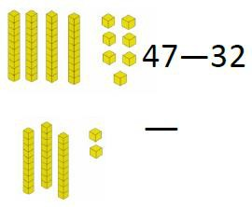 | Draw representations to show understanding  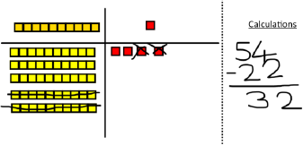 | 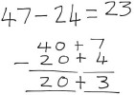  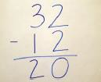  Intermediate step may be needed to lead to clear subtraction understanding
Y3 Subtraction - | Column subtraction with regrouping | Begin with base 10 or Numicom. Move to PV counters, modelling the exchange of a ten into ten ones. Use the phrase ‘take and make…’ for exchange.  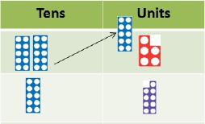 | Children may draw base 10 or PV counters and cross then off.  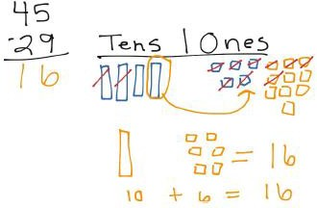 | 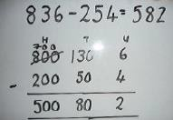  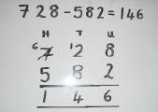  Begin by partitioning into PV columns.  Then move to formal method.

Y4-6 Subtraction | Objective & Strategy | Concrete | Pictorial | Abstract
Y4-6 Subtraction | Subtracting tens and ones.  Year 4: Subtract with up to 4 digits  Introduce decimal subtraction through context of money | Model process of exchange using Numicon, base 10 and then move into PV counters.  5,643 – 4,316 =  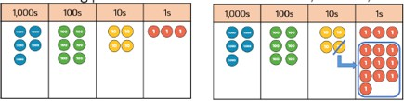 | Children to draw PV counters and show their exchange (see Year 3). | Use the phrase ‘take and make…’ for exchange.  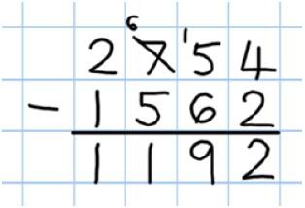
Y4-6 Subtraction | Year 5: Subtract with at least 4 digits, including money and measures. | As Year 4. | Children to draw PV counters and show their exchange (see Year 3). | 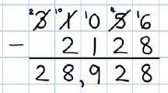  Use zeros for placeholders.  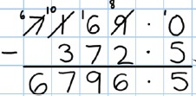
Y4-6 Subtraction | Year 6: Subtract with increasingly large and more complex numbers and decimal values. |  |  | 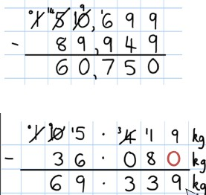

Y1 Multiplication | Objective & Strategy | Concrete | Pictorial | Abstract
Y1 Multiplication | Doubling | Use practical activities using manipulatives including cubes and Numicom to demonstrate doubling.  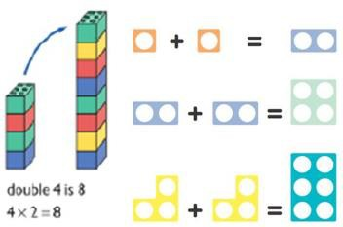 | Draw pictures to show how to double numbers.  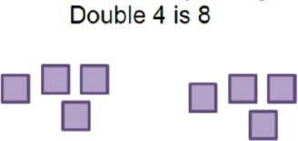 | Partition a  number and then 16  double each part before  recombining it 10 6  back together.  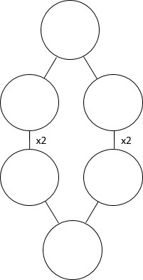  20 12
Y1 Multiplication | Counting in multiples | Count the groups as children are skip- counting, children may use their fingers as they are skip-counting.  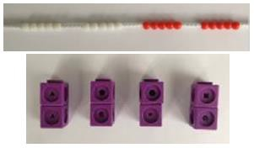 | Children make representations to show counting in multiples.    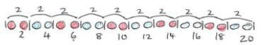 | Count in multiples of a number aloud. Write sequences with multiples of numbers.  2, 4, 6, 8, 10  5, 10, 15, 20, 25, 30
Y1 Multiplication | Making equal groups and counting the total | Use manipulatives to create equal groups.  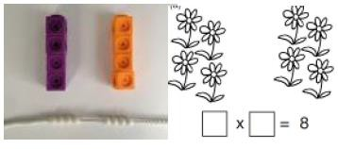 | Draw and make representations.  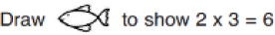 | 2 x 4 = 8

Y1 Multiplication | Objective & Strategy | Concrete | Pictorial | Abstract
Y1 Multiplication | Repeated addition | Use different objects to add equal groups.  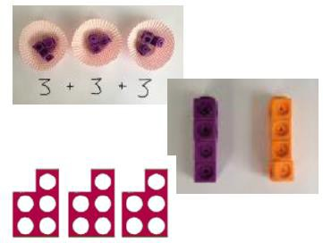 | Use pictorial including number lines to solve problems.  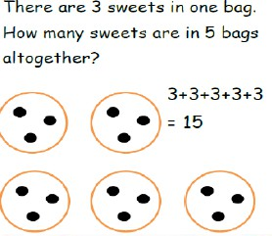   | Write addition sentences to describe objects and pictures.  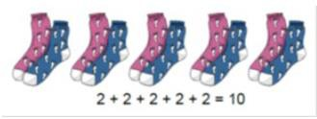
Y1 Multiplication | Understanding arrays | Use objects laid out in arrays to find the answers to 2 lots of 5, 3 lots of 5, etc.  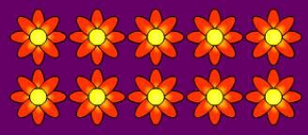 | Draw representations of arrays to show understanding.  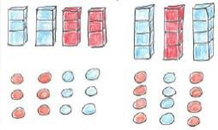 | 3 x 2 = 6  2 x 5 = 10

Y2 Multiplication | Objective & Strategy | Concrete | Pictorial | Abstract
Y2 Multiplication | Doubling | Model doubling using base 10 and PV counters.  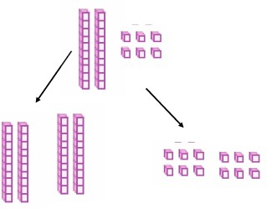  40 + 12 = 52 | Draw pictures and representations to show how to double numbers | Partition a number  and then double 16  each part before  recombining it back  together. 10 6  20 12
Y2 Multiplication | Counting in multiples of 2, 3, 4,  5, 10 from 0 (repeated addition) | Count the groups as children are skip- counting, children may use their fingers as they are skip-counting. Use bar models.  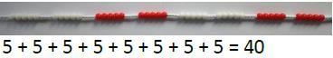  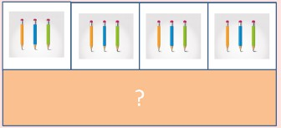 | Number lines, counting sticks and bar models should be used to show representation of counting in multiples.  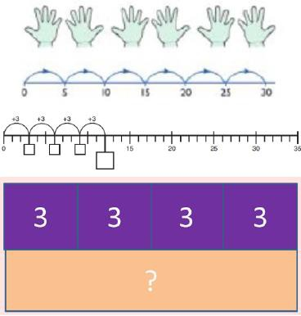 | Count in multiples of a number aloud.  Write sequences with multiples of numbers.  0, 2, 4, 6, 8, 10  0, 3, 6, 9, 12, 15,  0, 5, 10, 15, 20, 25, 30  4 x 3 = □

Y2 Multiplication | Objective & Strategy | Concrete | Pictorial | Abstract
Y2 Multiplication | Multiplication is commutative. | create arrays using counters and cubes and  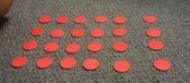  Numicom.  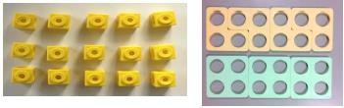  Pupils should understand that an array can represent different equations and that as multiplication is commutative the order of the multiplication does not affect the answer.  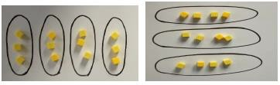 | Use representations of arrays to show different calculations and explore commutativity.  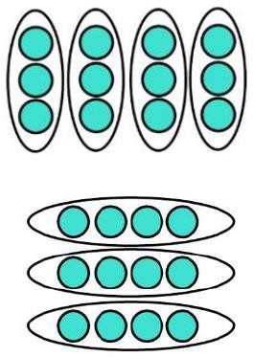 | 12 = 3 x 4  12 = 4 x 3  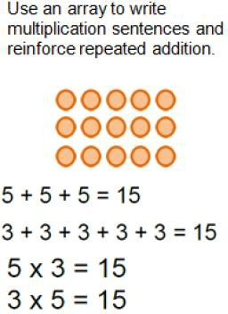
Y2 Multiplication | Using the inverse.  This should be taught alongside division so pupils learn how they work alongside each other. | 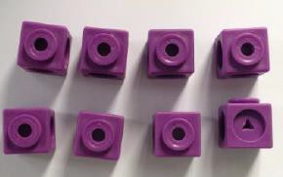 | 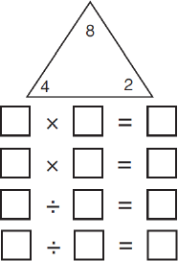 | 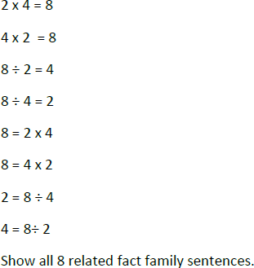

Y3 Multiplication | Objective & Strategy | Concrete | Pictorial | Abstract
Y3 Multiplication | Grid method | Show the links with arrays to first introduce the grid method.  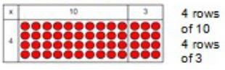  Move on to base 10 to move towards a more compact method.  Move on to PV counters to show how  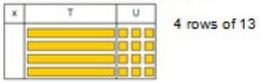  we are finding groups of a number. We are multiplying by 4 so we need 4 rows.  Fill each row with 126  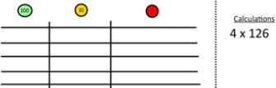  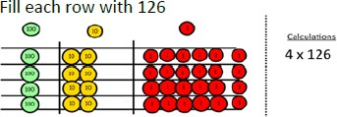  Add up each column, starting with the ones making any exchanges needed  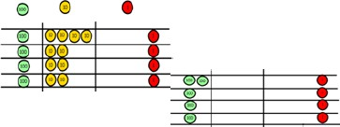  Then you have your answer | Children can represent their work with place value counters in a way that they understand.  They can draw the counters using colours to show different amounts or just use the circles in the different columns to show their thinking as shown below.  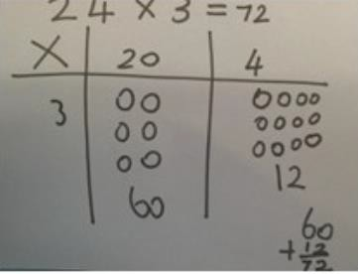  Bar model are used to explore missing numbers  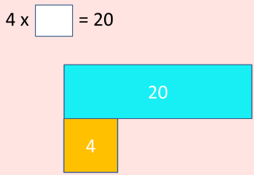 | Start with multiplying by one digit numbers and showing the clear addition alongside the grid.  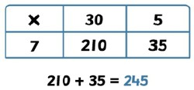  Moving forward, multiply by a 2- digit number showing the different rows within the grid method.  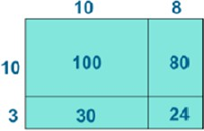

Y4 Multiplication | Objective & Strategy | Concrete | Pictorial | Abstract
Y4 Multiplication | Grid method recap from year 3 for 2-digits x 1- digit  Move to multiplying  3-digit numbers by 1-digit. (year 4 expectation) | Use place value counters to show how we are finding groups of a number.  We are multiplying by 4 so we need 4 rows.  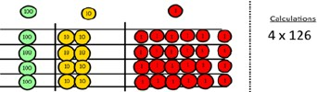  Fill each row with 126  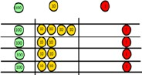  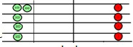  Add up each  column, starting with the ones making any exchanges needed. | Children can represent their work with place value counters in a way that they understand.  They can draw the counters using colours to show different amounts or just use the circles in the different columns to show their | Start with multiplying by one digit numbers and showing the clear addition alongside the grid.
Y4 Multiplication | Column multiplication | 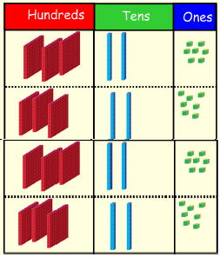  Children can continue to be supported by place value counters at the stage of multiplication. This initially done where there is no regrouping. 321 x 2 = 642  It is important at this stage that they always multiply the ones first.  The corresponding long multiplication is modelled alongside. |   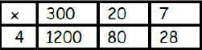  The grid method may be used to show how this relates to a formal written method.  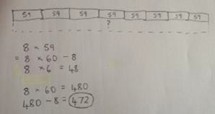  Bar modelling and number lines can support learners when solving problems with multiplication alongside the formal written methods. | 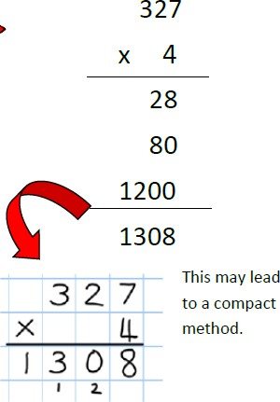

Y5-6 | Objective & Strategy | Concrete | Pictorial | Abstract
Y5-6 | Column multiplication for 3 and 4-digitd x 1- digit. | 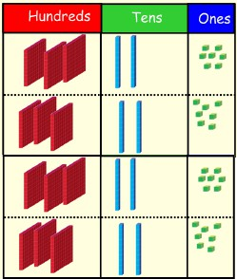  It is important at this stage that they always multiply the ones first.  Children can continue to be supported by PV counters at the stage of multiplication. This initially is done where there is no regrouping.  321 x 2 = 642
Y5-6 | Column multiplication | Manipulatives may still be used with the corresponding long multiplication modelled alongside. | 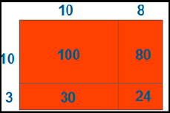 | 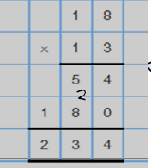    18 x 3 on the first row  (8 x 3 =24,  carrying the 2 for 20,  then 1 x 3)  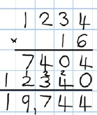  18 x 10 on the 2nd row. Show multiplying by 10 by putting zero in units first

Y6 Multiplication | Objective & Strategy | Concrete | Pictorial | Abstract
Y6 Multiplication | Multiplying decimals up to 2 decimal places by a single digit. |  |  | Remind children that the single digit belongs in the units column. Line up the decimal points in the question and the answer.  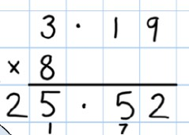

Y1 Division | Objective & Strategy | Concrete | Pictorial | Abstract
Y1 Division | Division is sharing | 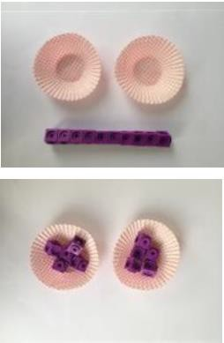  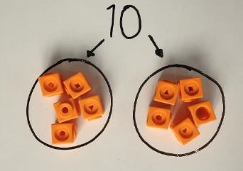  I have 10 cubes, can you share them equally in 2 groups? | Children use pictures or shapes to share quantities.  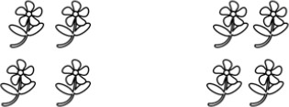  8 shared between 2 is 4  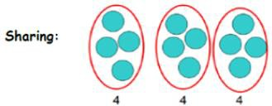  12 shared between 3 is 4 | 12 shared between  3 is 4

Y2 Division | Objective & Strategy | Concrete | Pictorial | Abstract
Y2 Division | Division as sharing | 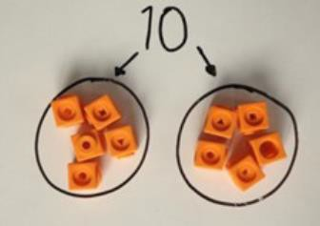  I have 10 cubes, can you share them equally in 2 groups? | Children use pictures or shapes to share quantities.  8 ÷ 2 = 4  Children use bar modelling to show and support understanding.  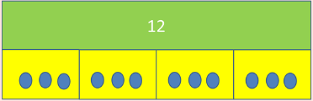  12 ÷ 4 = 3 | 12 ÷ 4 = 3
Y2 Division | Division as grouping | Divide quantities into equal groups.  use cubes, counters, objects or PV counters to aid understanding.  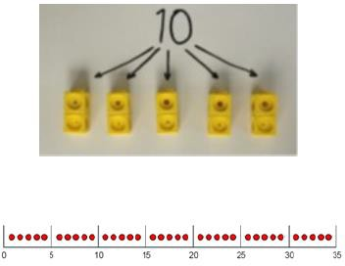 | Use number lines for grouping.  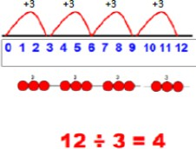  Think of the bar as a whole split into the number of groups you are dividing by and work out how many would be within each group.  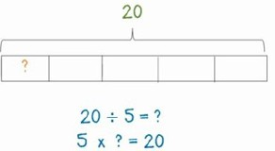 | 28 ÷ 7 = 4  Divide 28 into 7 groups. How many are in each group?

Y3 Division | Objective & Strategy | Concrete | Pictorial | Abstract
Y3 Division | Division as grouping | Use cubes, counters, objects or PV counters to aid understanding.  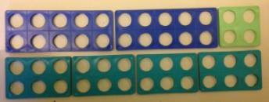  24 divided into groups of 6 = 4  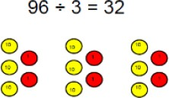 | Continue to use bar modelling to aid solving division problems.  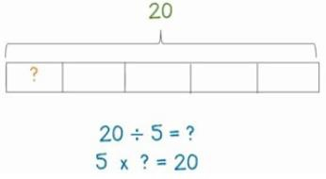 | How many groups of 6 in 24?  24 ÷ 6 = 4
Y3 Division | Division with arrays | 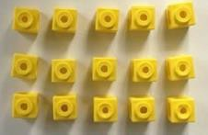  Link division to multiplication by creating an array and thinking about the number sentences that can be created.  E.g. 15 ÷ 3 = 5 5 x 3 = 15  15 ÷ 5 = 3 3 x 5 = 15 | Draw an array and use lines to split the array into groups to make multiplication and division sentences.  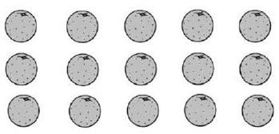 | Find the inverse of multiplication and division sentences by creating eight linking number sentences.  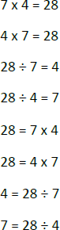

Y3 Division | Objective & Strategy | Concrete |  | Pictorial | Abstract
Y3 Division | Division with remainders | 14 ÷ 3 =  Divide objects between groups and see how much is left over.  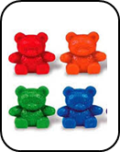  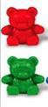 |  | Jump forward in equal jumps on a number line then see how many more you need to jump to find a remainder.  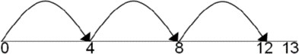  Draw dots and group them to divide an amount and clearly show a remainder.  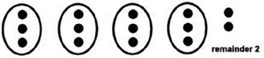  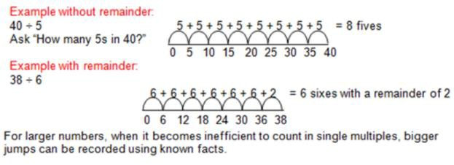  Use bar model to show division with remainders.  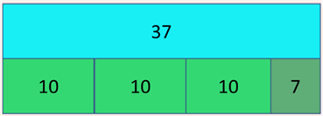 | Complete written divisions and show the remainder using r  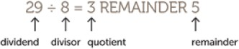

Y4-6 Division | Objective & Strategy | Concrete | Pictorial | Abstract
Y4-6 Division | Divide at least 3- digit numbers by 1-digit  Short division | 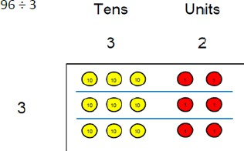  Use place value counters to divide using the bus stop method alongside 42 ÷ 3=  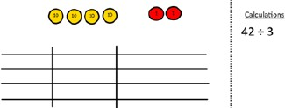 | Students can continue to use drawn diagrams with dots or circles to help them divide numbers into equal groups.  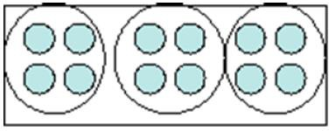  Encourage them to move towards counting in multiples to divide more efficiently. | Begin with divisions that divide equally with no remainder.  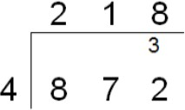  Move onto divisions with a remainder.  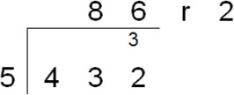  Finally move into decimal places to divide the total accurately.  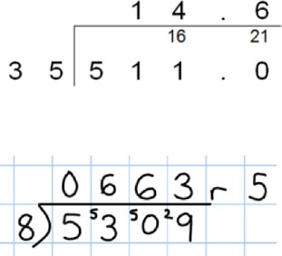
Y4-6 Division |  | Start with the biggest place value, we are sharing 40 into three groups. We can put 1ten in each group and we have 1 ten left over.
Y4-6 Division |  | 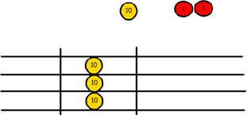
Y4-6 Division |  | We exchange this ten for ten ones and then share the ones equally  among the groups.
Y4-6 Division |  | 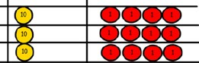
Y4-6 Division |  | We look how much in 1 group so the answer is 14.

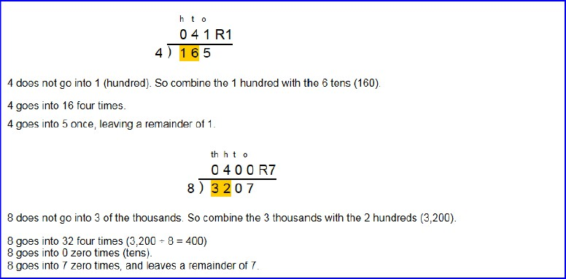
Long Division
Step 1 – a remainder in the ones
Y6 Division

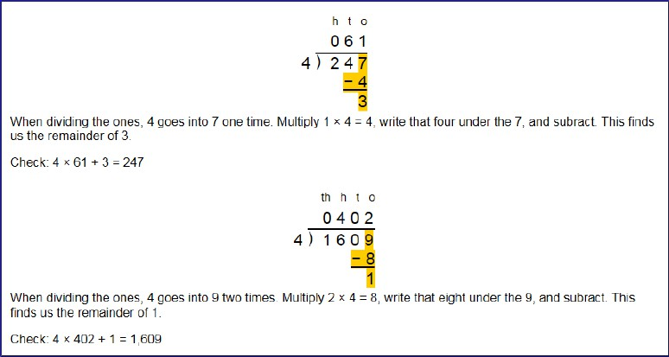
Long Division
Step 1 continued…
Y6 Division

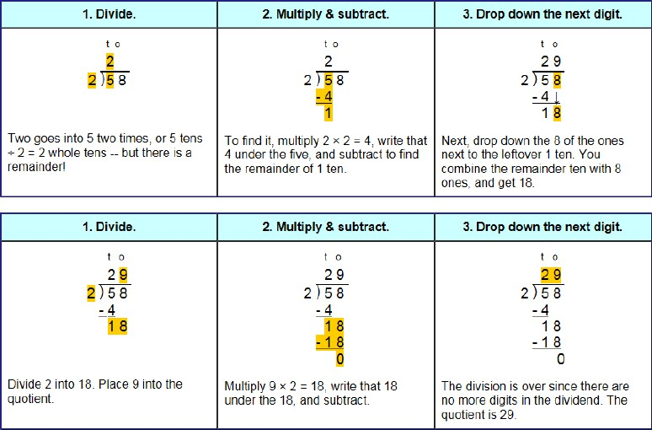
Long Division
Step 2 – a remainder in the tens
Y6 Division

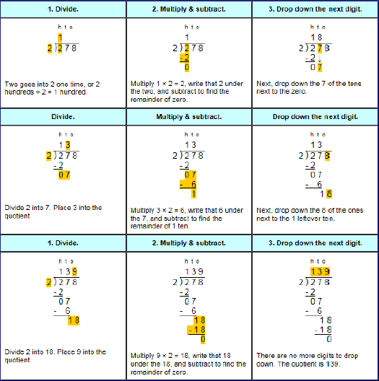
Long Division
Step 2 – a remainder in any of the place values
Y6 Division

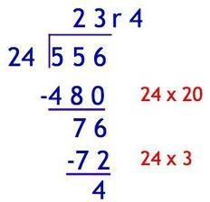
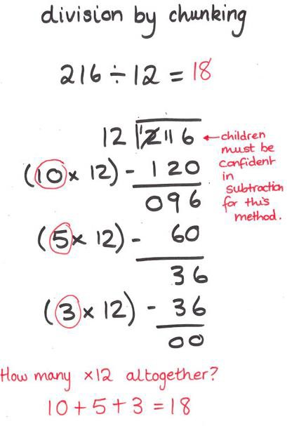
Long Division
Chunking method

Although the chunking method of
is a stronger algorithm to mathematically model or explain division, historically pupils made more errors using this method
Y6 Division
than the old ‘bus-stop’ method for
long and short division.

However, this method can be
useful to those children who are not
confident using short division when dividing by 2-digit numbers.

