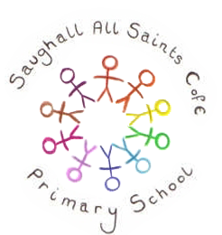
Reception Topic – Ourselves & Traditional Tales

Personal, Social & Emotional Development  - Can I get to know the people in my class?  - Can I explore my classroom?  - Do I know I belong to a community?  - Can I be kind to people who are new to our classroom?  - Can I express how I am feeling?  - Do I know that other people have feelings?  - School and classroom rules | Communication & Language  - Role play –Home corner – The Three Bears Cottage  - Responding to instructions  - Nursery Rhymes  - Re-tell familiar stories in their own words  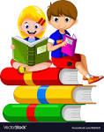 | Physical Development  - Gymnastics –travelling, jumping and rolling  - How exercise affects our bodies  - Healthy food choices and food hygiene  - Getting dressed/undressed  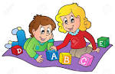  - Toileting routines/hand washing  - Building with a range of blocks
Literacy  Our teaching texts are:  Peace at Last and Three Little Pigs  We will also read:  - We are all Different  - Whatever Next  - How many sleeps  - The Tiger who came to tea  - Elmer the Elephant  - A range of traditional tales  Different forms of writing ~    - Lists  - Labelling  - Invitations  - Cards | Mathematics  - Subitising numbers to 5  - Counting to 10 and beyond  - Sorting  - Simple sequences/ordering  - More/less  - 2D shapes and their properties  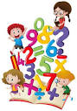  - Positional language | Expressive Arts & Design  - Self-portrait  - Painting portraits  - Experimenting with colour when painting.  - Singing familiar nursery rhymes and number songs  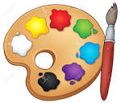
Understanding the World
As with all our topics, we use our children’s interests to form how our themes progress. Below are some of the areas we will be covering:
- Looking at ourselves. Celebrating our similarities and differences.
- Autumn changes
- People who help us: Talk about the lives of the people around us and their roles in society.
- Talk about what life was like for our parents and grandparents when they were children.
- Through class discussions, we will be looking at:
New beginnings
Who am I in school?
What other religions do we have in our class?
Helping other people
Me and my family
We will read a range of Traditional tales and compare them to our own lives: do they have a television / a car, etc.?
- The Three Little Pigs
- Goldilocks and the Three Bears
- Jack and the Beanstalk
- The Gingerbread Man
- Little Red Riding Hood
We will look at old toys that Baby Bear may have played with and compare to the toys we have.
Christmas:
- We look at how Christmas is celebrated around the world.
- We read the Christmas story to learn about Christians beliefs.

