
Saughall All Saints Primary School
Newsletter 22nd May 2026

We break up today for the half term holidays and wish you all a lovely break. Kindly note the children return to school on Tuesday 2nd June.
Attendance
The class winners for the highest attendance were:

11th – 15th May – Mrs Wright – 99.1%

Well done!

Overall school attendance 95.4%

Punctuality is important.
The gates are opened at 8.40 am for the school start time of 8.50 am. If your child/ren arrive after this time they must come to the office to sign in for their attendance mark.

Lateness may affect children’s overall attendance mark.
Arriving 5 minutes late every day adds up to over 3 days lost each year = 20 lessons missed.
Arriving 15 minutes late every day adds up to 2 weeks absence a year = 55 lessons missed.
Arriving 25 minutes late every adds up to 19 days absence a year = 123 lessons missed

Uniform

The September uniform order is still open on SCOPAY and will close on 12th June 2026. Any orders received after this date will not be processed and the next order will not be placed until October. We have added a baseball cap, a legionnaire cap and a reversable storm coat. Please note these items are not compulsory but are available to order if you wish.

Reception 2026 Intake Evening  If your child is starting school with us in September in Reception class, please come and meet us on Wednesday 10th June at 5pm.  We look forward to seeing you then. Please do bring your children along. | Whole School Open Evening  We will be holding a whole school open evening on Wednesday 1st July, 4- 7pm. This is an opportunity to come and meet your child’s new class teacher and have a look around school.  Everybody welcome.
Dinner and toast Money

All dinners and toast should be paid for in advance. Toast should be paid before Monday 9am to receive
toast for that week. If money is received after that time it will be for toast the following week.
Please read the dinner money policy attached for guidance.

Fundraising
The giant bunny Raffle that was held before Easter raised £124.70 for school funds. Thank you to Elsa and Corey for the kind donation of the bunny.
The worry worm keyrings made and donated by Mrs Rowland’s Mum raised £185.60 for the school. Thank you Mrs Weir for your support.
The Non- uniform day last week raised £196.50 for Christian Aid.
Thank you to everybody that donated.
Summer Reading 2026
We have signed up for Summer Reading 2026 so that all parents and carers can access free First News this summer by using this unique link: https://subscribe.firstnews.co.uk/summer-reading-2026/?fn=29CC2C2B
Please click the link, fill in a short form, and your login details will arrive by email on 9 July, ready for the holidays.
Once you've signed up, your child/ren will get:
- App or web access to the weekly First News newspaper and archive
- Daily news stories to read, listen to or watch
- Quizzes, polls, puzzles, and games
We’ve put together a ready-to-share note for parents, too – download it here.

School Governor Vacancies  We have two school governor vacancies and we will be able to provide more information after half term for anybody that would be interested. | Cars & Parking  We are receiving a number of complaints and concerns from local residents about parking.  Please can you ensure that you park your car considerately and do not block any driveways or pavements.  Please also be mindful that the weather is getting warmer and children and dogs should not be left in warm cars when you come to pick up your children.  Thank you for your co-operation.

Year 6 Residential

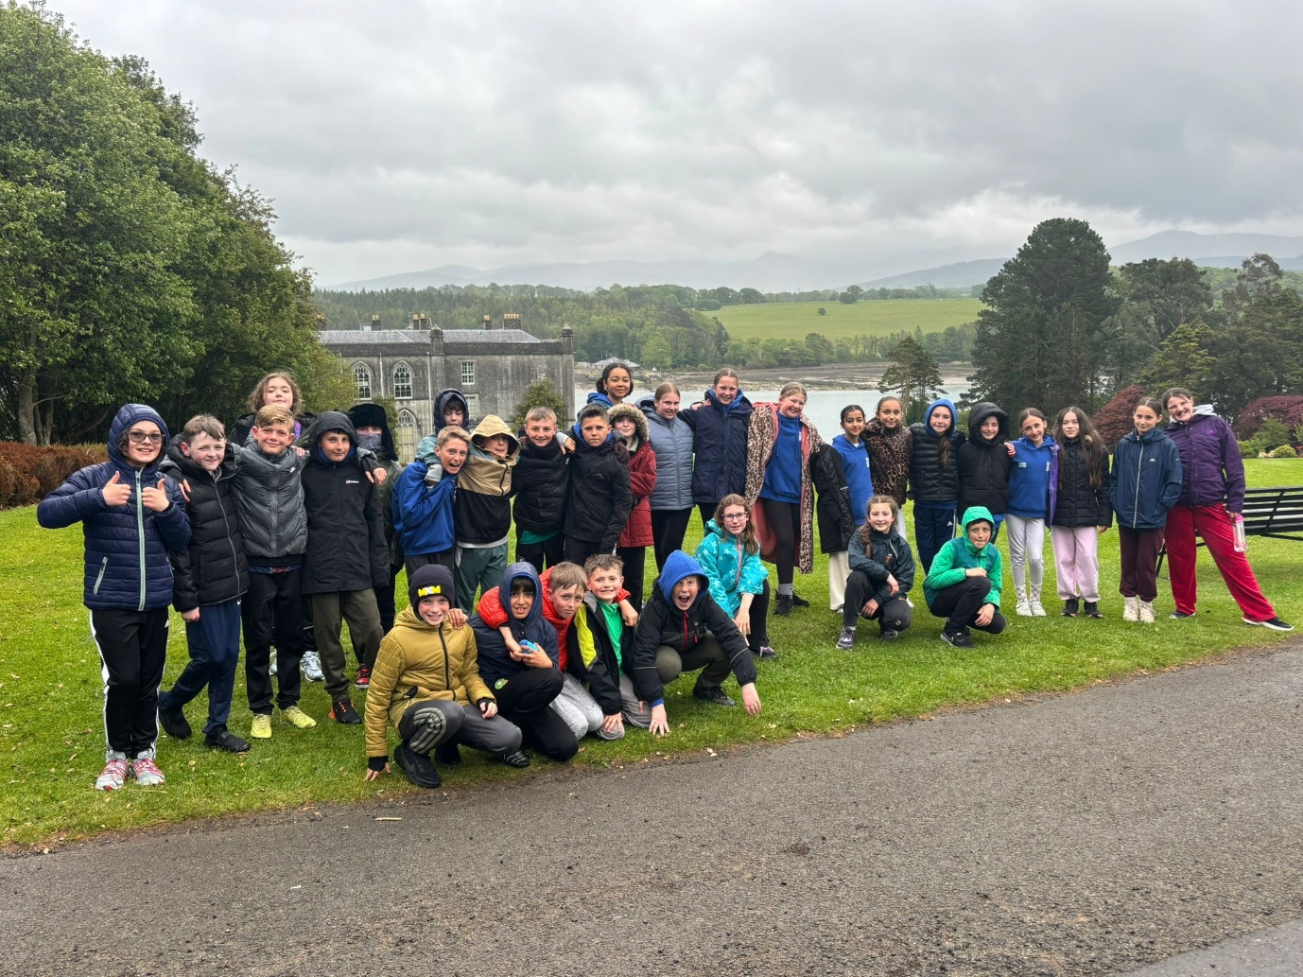

Year 6 have had an amazing residential trip to The Conway Centre.

‘We are delighted to share the fantastic news that we have once again been awarded with The Platinum School Games Mark Award. This is a Government-led award scheme launched in 2012, facilitated by the Youth Sport Trust to reward schools for their commitment to the development of competition across their school and into the community, and we are delighted to have been recognised for our success. We have now been a Platinum School since 2018.’

Dates for your Diary
2025/2026 Term Dates
School Opens for Pupils | School closes for pupils at the end of the day
 | Friday 22nd May 2026
Tuesday 2nd June 2026 | Tuesday 21st July 2026
Thursday 3rd September 2026

INSET DAYS
Monday 1st June 2026
Wednesday 22nd July 2026

Other Dates for your Diary (please also check the calendar on the website):

3rd June – Class Photographs
3rd June – Year 6 Cake sale
8th June – Sports Day – KS1 9.30am/KS2 1.15pm
8th -12th June - NO Clubs
10th June – Reception 2025 Intake Evening – 5pm
10th June -Year 6 Cake sale
11th June – Y3/Y4 Pentecost Service – Parents welcome
17th June – Year 6 Cake sale
29th June – 3rd July NO Clubs
1st July – Open Evening – 4-7pm
06th July – Last week of clubs
08th July – School shop
09th July – Y6 Leavers’ Service – Chester Cathedral – Pupils only
14th July – Y6 Leavers’ Productions – 1:45pm and 5.30pm
16th July – Leaver’s Evening – 3.30pm to 7pm – Year 6 Pupils only
21st July – Leavers’ Service in school – 9.30am Parents welcome
21st July – Children finish for the summer holidays.

