C.S.Lewis  The Lion, The Witch and The Wardrobe (or any from this author) 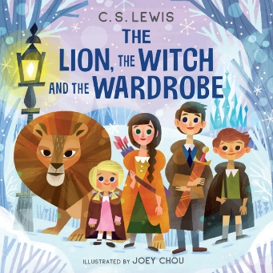 | J.K.Rowling  Harry Potter and the Philosopher’s Stone (or any from the series)  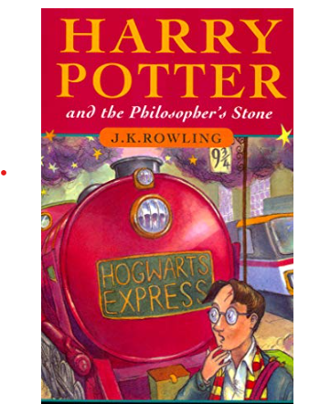 |  | Katherine Rundell  Any from her collection  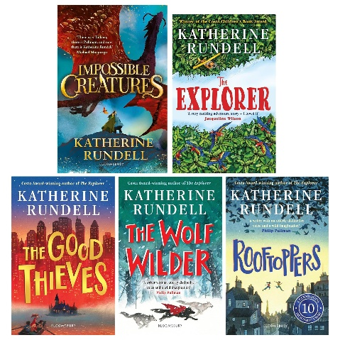
Rick Riordan  Percy Jackson and the Lightning Thief (or any from the series)  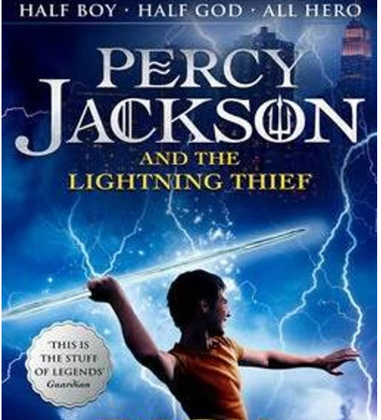 | David Walliams 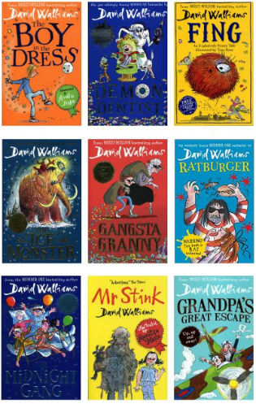 |  | Michael Morpurgo  Mr Nobody’s Eyes  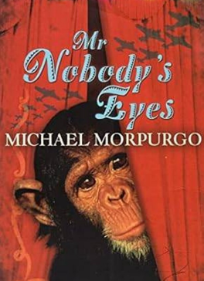  (or any of his books)
Lynne Reid-Banks  The Indian in the Cupboard 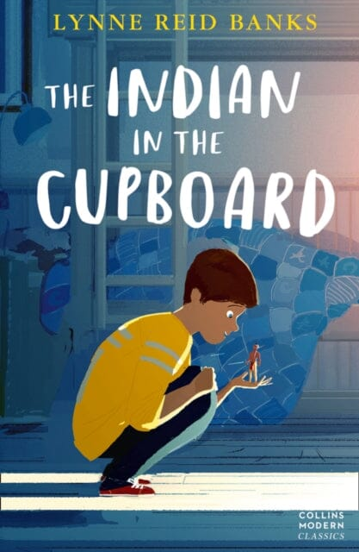 | Kirran Milwood  The Girl of Ink and Stars  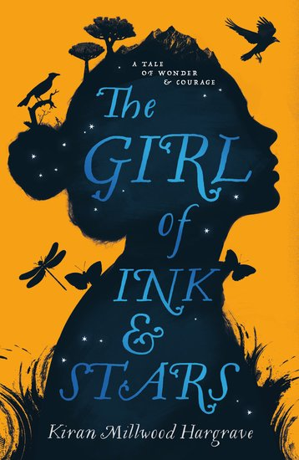 |  | Peter Bunzl  Cogheart, Shadow Sea, Sky Circus , Moonlocket etc.  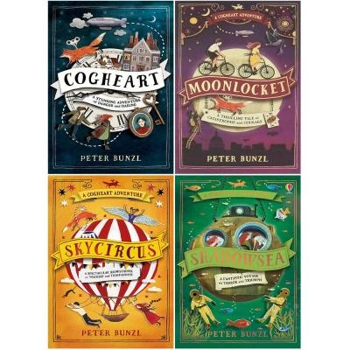
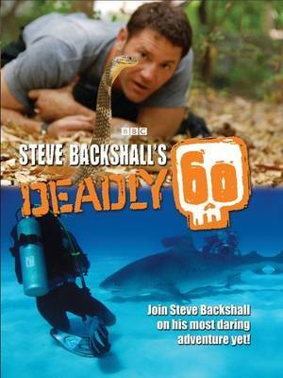  Steve Backshall  Deadly 60 |  | 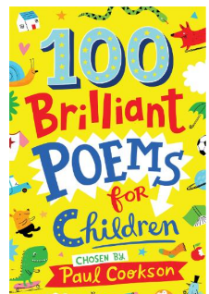  Paul Cookson  100 Brilliant Poems

Tom Becker  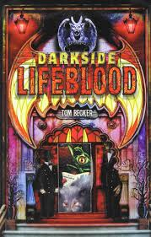  Darkside Series: Lifeblood | Libby Scott and Rebecca Westcott  Can you see me? A powerful story of autism, empathy and kindness  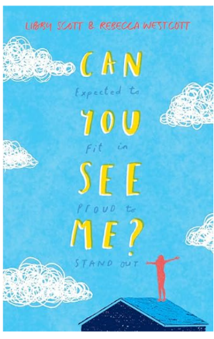 | Matthew Syed  You are Awesome: Find your Confidence and Dare to be Brilliant at (Almost) Anything.  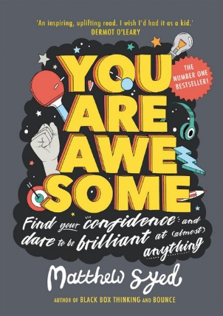
Michael Morpurgo  The Butterfly Lion (or any from collection)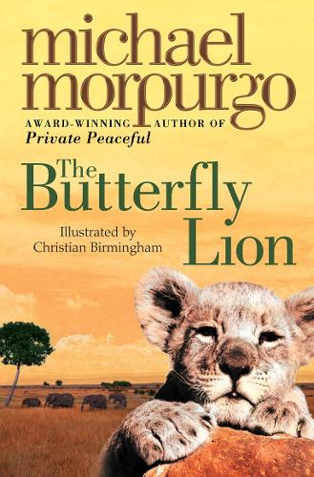 | Ben Brooks  Stories for Boys/Girls who Dare to be Different  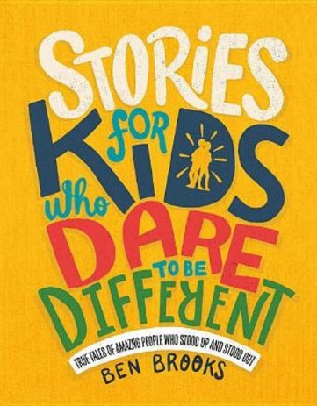 | Michelle Roehm McCann  Boys Who Made a Difference 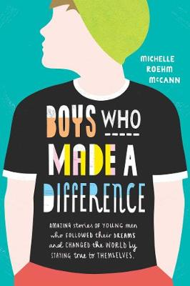
Michelle Roehm McCann  Girls Who Rocked the World  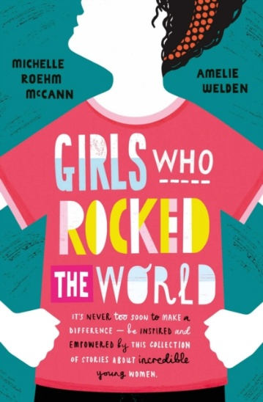 | Clive Gifford  The Book of Comparisons: Sizing up the World Around You 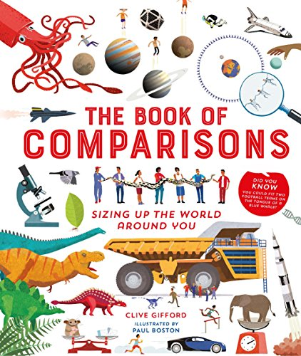 | Chae Strathie  So You Think You’ve Got it Bad: A Kid’s Life in Ancient Greece  