Enid Blyton  The Magical Faraway Tree (or any from collection)  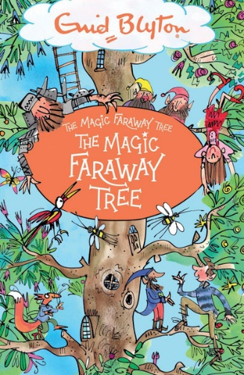 | J.K.Rowling  The Icabog (or any from collection)  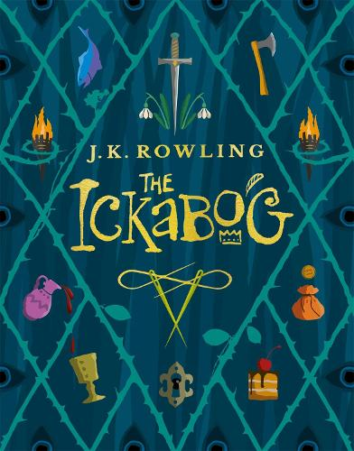 | Tom Fletcher  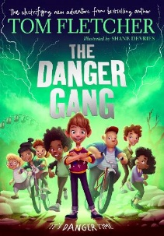  Danger Gang (or any from collection)
Dav Pilkey  Dogman (any from the series / author)  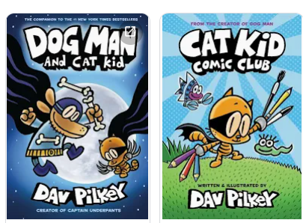 | Cressida Cowell  How to Train Your Dragon / Wizards of Once etc.  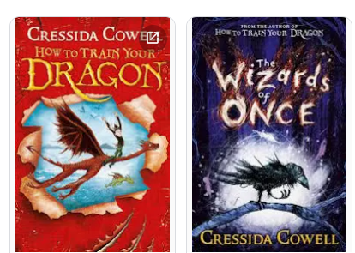 | Pete Johnson  How to Train Your Parents  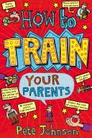
S.F.Said  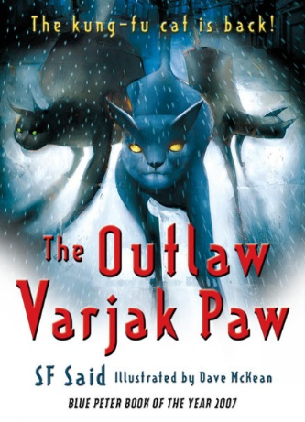  The Outlaw Varjak Paw | Ross MacKenzie  The Nowhere Emporium  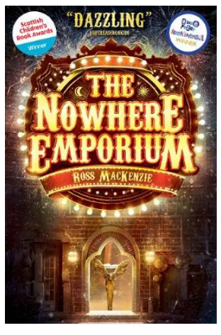 | Katherine Rundell (or any from collection)  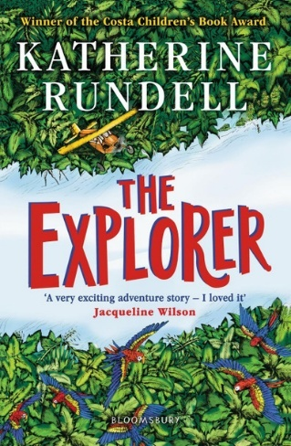

Chris Priestley  Freeze  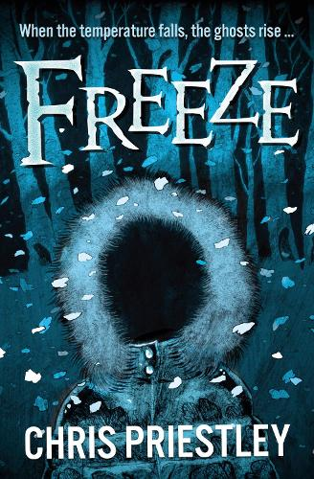 | Michael Dahl  Really Scary Stories  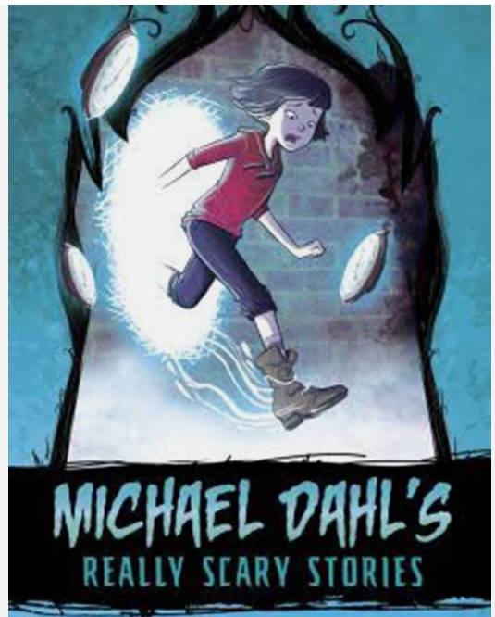 | Onjali Rauf  The Boy at the Back of the Class  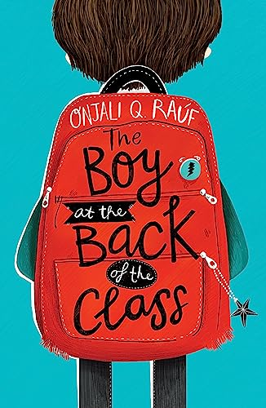
Michael Morpurgo  Why the Whales Came  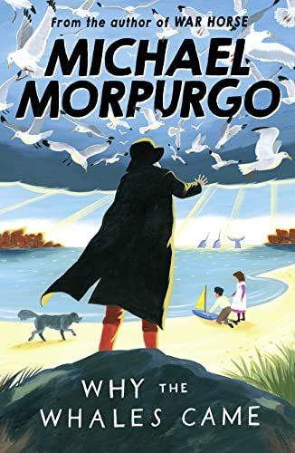 | Jack Tite  The Viking Voyagers  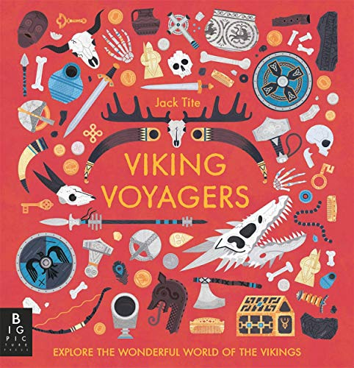 | Britannica All New Children’s Encyclopedia:  What We Know and What We Don’t  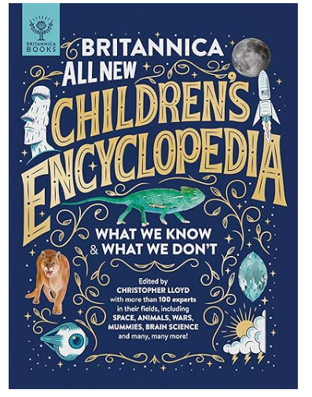
Anita Ganeri  Horrible Geography: Desperate Deserts  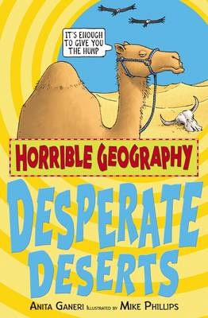  (or any from the series) | 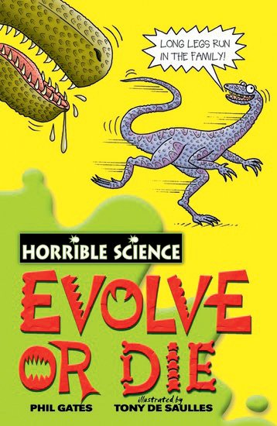  Nick Arnold  Evolve or Die  (or any from series) | Terry Deary  Horrible Histories  