Jeff Brown  Flat Stanley  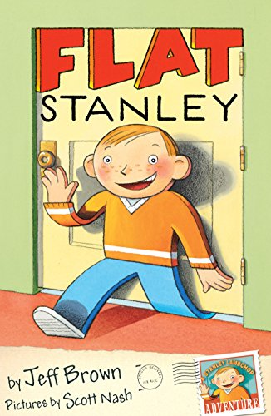 | Roald Dahl (any from collection).  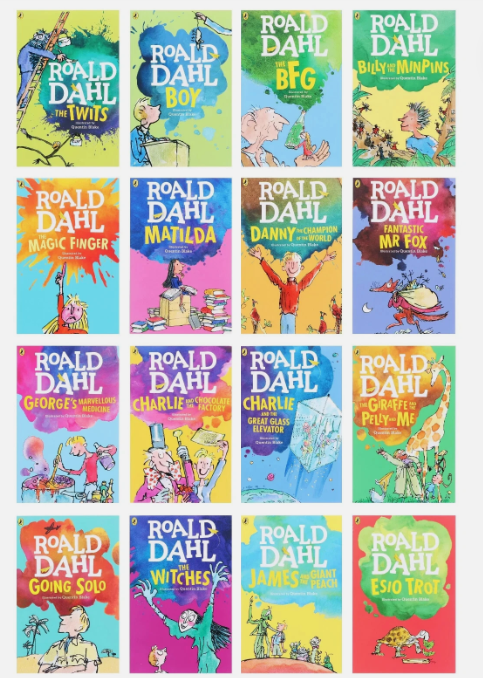 | Tom Fletcher (any of his chapter books) e.g. Danger Gang, The Creakers, Christmasaurus.  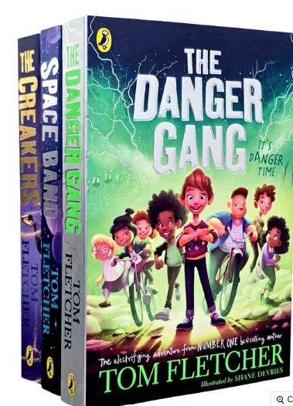
Liz Pichon  Tom Gates (any book from the series)  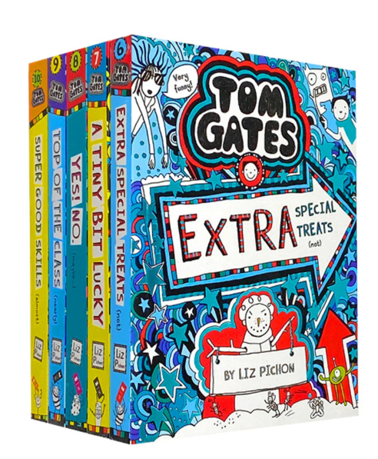 | Andy Stanton  You’re a Bad Man Mr Gum or (any book from the series)  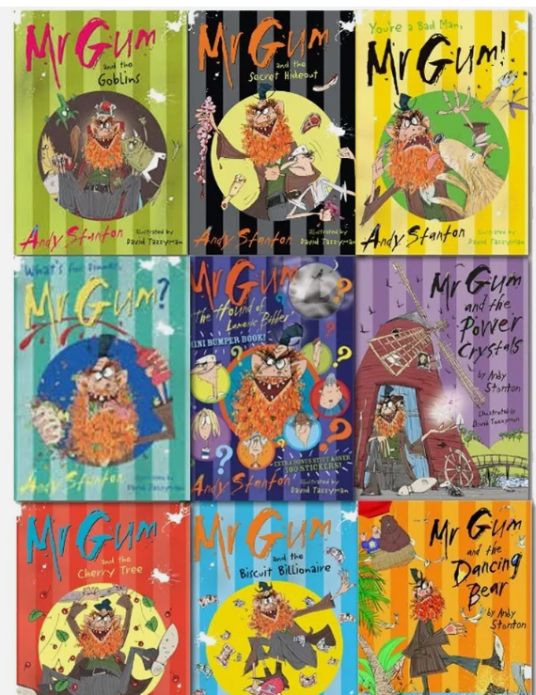 | Tamara Macfarlane  Amazing Esme (more in series but not yet in school)  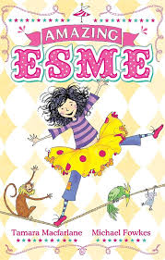
Andy Shepherd  The Boy Who Grew Dragons  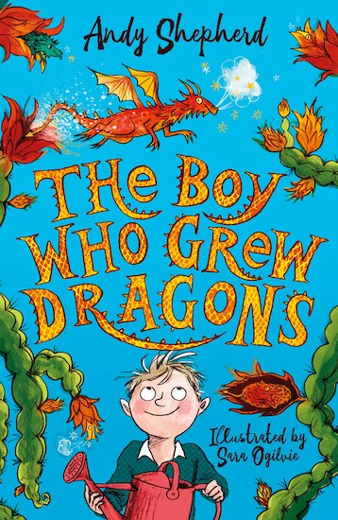 | Adam Blade  Beast Quest (Any book from the series)  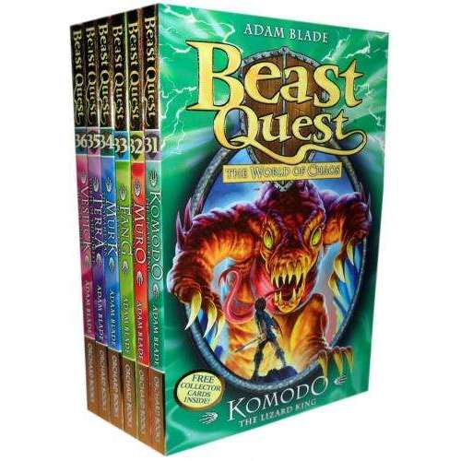 | Enid Blyton  Secrets at Mallory Towers (or any book from this author)  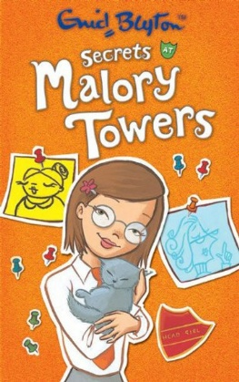

R.L.Stine  Goosebumps (any book from the series)  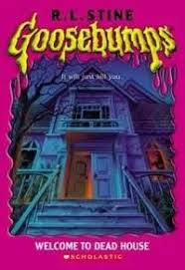 | Zana Fraillon  Wisp (a beautiful story about the life of a refugee)  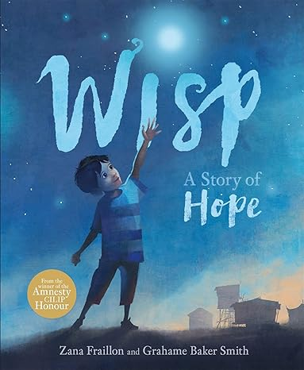 | Hannah Peckham  Conker the Chameleon  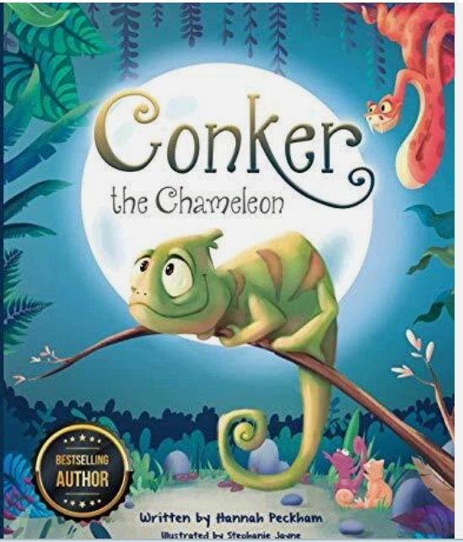
Martin Brown  Nell and the Cave Bear (Stone Age) 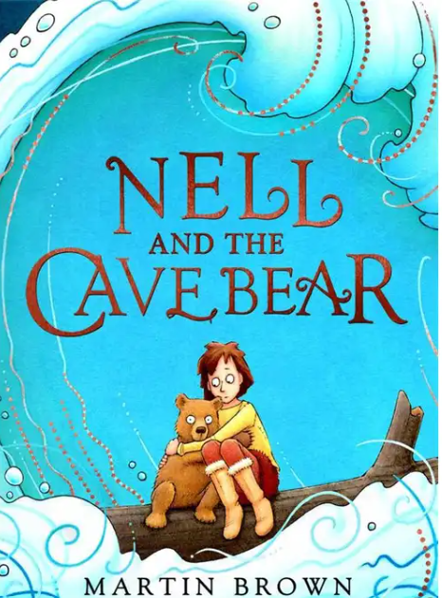 | Adam Hart Davis  A History of Key Inventions That Changed The World  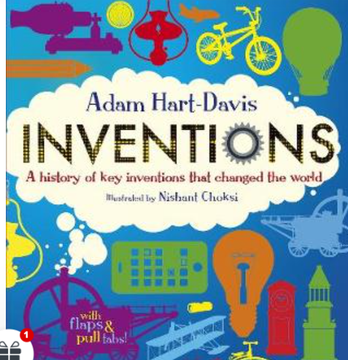 | Mike Barfield  A Day in the Life of a Poo, Gnu and You  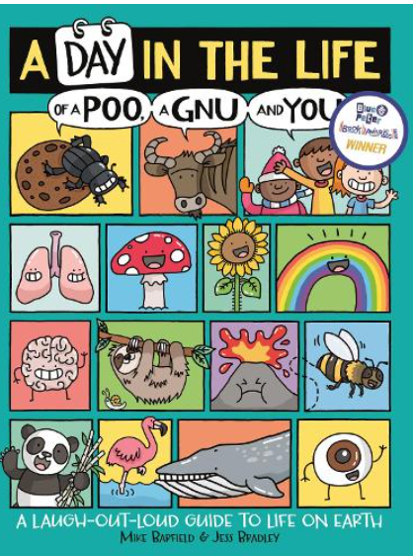
Matt and Tom Oldfield  Ultimate Football Heroes (any book from the series)  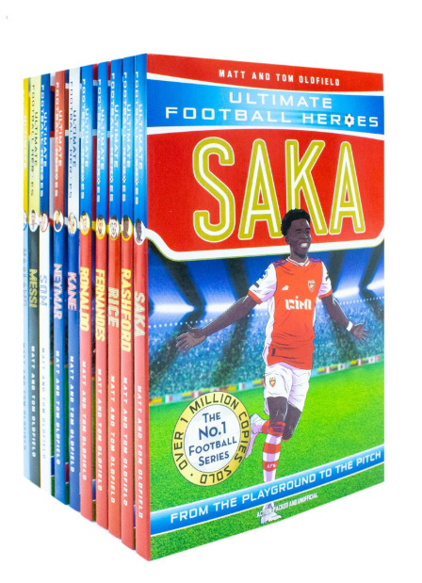 | Jess French  What a Waste: Rubbish  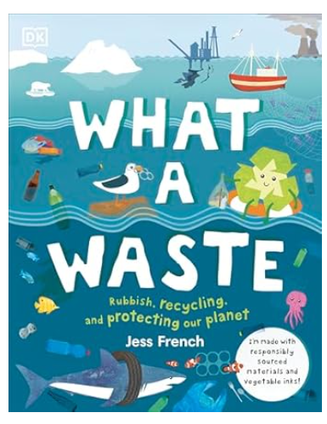 | Alex Wharton  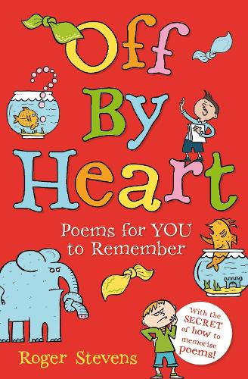  Daydreams and Jellybeans  (poetry)  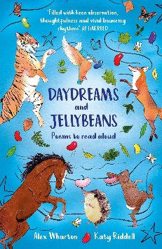  Roger Stevens  Off by Heart  (poetry)

