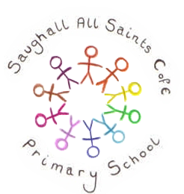
Saughall All Saints Primary School
Literacy  This half term, we will be enjoying Seal Surfer by Michael Foreman, a beautifully illustrated story about friendship, kindness and the impact that special relationships can have throughout our lives.  Through reading, discussion and writing activities, children will develop their vocabulary, explore a range of sentence structures and learn how to use prepositions to add detail to their writing. They will also deepen their understanding of the characters and their feelings, helping to strengthen comprehension skills.  At the end of the unit, the children will apply their learning to write a letter inspired by the story, showcasing their developing writing skills and creativity. | Mathematics  This term, our maths learning will focus on building confidence and fluency with number.  Year 3 children will develop their understanding of numbers to 1,000 by comparing, ordering and counting in multiples of 50. They will then move on to addition and subtraction, using both mental and written methods, and will learn strategies to check their answers through estimating and rounding.  Year 4 children will build on their place value knowledge by working with 4-digit numbers, exploring the value of each digit, rounding numbers, and counting in multiples of 6, 7, 9, 25 and 1,000. They will then apply formal written methods for addition and subtraction to a range of calculations and problem-solving activities. | Reading  In Reading this term we will begin by reading a selection of texts across a range of genres. We will focus on developing our comprehension skills such as predicting, retrieving information and inferring to get a true understanding of the text.  During the second half of the term, we will apply these skills to a book called ‘The promise’ by Nicola Davies. We will read the text and answer questions linked to it.  Each class also has a book that will be read daily for enjoyment.
RE  During the first half term we will be learning about Humanism, we will find out what Humanist believe and what it means to be Humanist. In the second half term we will be learning about Christianity, specifically looking at the names of Jesus and how these names have meanings. | PHSE  In PHSE this term the children will be looking at choosing rules to create a happy and safe classroom. Also during the term the children will have regular wellbeing lessons to build resilience and emotional intelligence and promote mental health awareness and support. | French  This half term in French we will be learning how to say hello and goodbye, the names of French colours, numbers 0-10 and how to say ‘my name is…’  In the second half term we will be learning how to say the days of the week and months of the year.
Additional information
To support your child's learning, a spelling list will be sent home at the beginning of each half term. Children should practise these words regularly, as they will complete a spelling test every Monday.
Once each term, children will receive a Learning Log task connected to our class topic. We hope families enjoy exploring these activities together.
Reading remains a key part of home learning, and we encourage children to read at least four times each week. Regular use of Times Table Rock Stars is also recommended to help develop rapid recall of multiplication facts.
Science 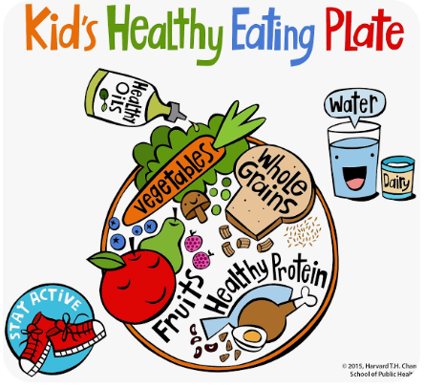
As a scientist I will be investigating:
- Healthy eating
- Different food types and categories
- What skeletons are.
- How muscles work

Artist
As an artist I will be learning:
- That artists can make animations by creating drawings which move in a sequence.
- How to make a simple ‘paper puppet’
- How to use our paper puppets to make animations and stories.

Geography
As a geographer I will be:
- Naming capital cities across Europe.
- Looking at the physical and human features for a region in Europe
- Investigating different types of settlements including villages, town and cities.
- Finding out about famous landmarks across Europe.
Musician 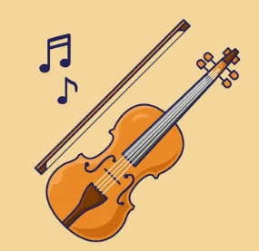
As a musician I will be learning:
- Year 4 - Children will learn how to play the violin, developing their understanding of rhythm, pitch and musical notation while building confidence in performing.
- Year 3 – Children will learn to sing song called ‘Let your spirit fly’ and play along using glockenspiels.

Computing
I will be learning:
- What a branching database is and how to create one.
- How to create physical and on-screen branching databases.
- How to create an identification tool using a branching database, which they will test by using it.
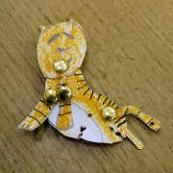
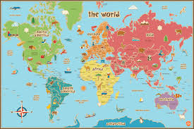

Design and Technology
As a designer I will be learning:
- To prepare and cook a variety of savoury dishes safely and hygienically
- How to use a range of techniques such as peeling, chopping, slicing, grating, mixing, spreading, kneading and baking.

PE 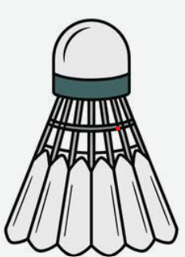 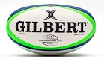
As a sports person I will be learning:
- Badminton - racket control, sending and receiving a shuttlecock, and improving coordination.
- Tag rugby – to develop passing, catching, teamwork and movement skills, while learning simple tactics and the importance of fair play.

