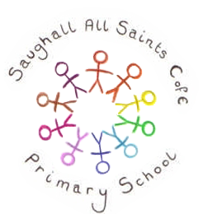
Saughall All Saints Primary School
Literacy  Where the Forest Meets the Sea by Jeannie Baker is used as our core literacy text to support non-chronological report writing in Year 3 and 4, with strong links to our rainforest topic. Through the detailed illustrations and factual ideas in the book, children learn about rainforest habitats, plants and animals, and the impact of human activity on the natural environment. Pupils gather information, group ideas under clear headings, and use subject-specific vocabulary to explain facts clearly. They then apply these skills to research and write their own non-chronological reports about rainforests, developing an informative style, accurate present tense, and well-organised paragraphs. | Mathematics  Year 3 will begin by developing a secure understanding of fractions, including partitioning, comparing, adding and subtracting fractions. As the term progresses, pupils will also explore money, time, shape and statistics, applying their mathematical knowledge to practical and problem-solving contexts.  In Year 4, children will start by learning about decimals, focusing on tenths and hundredths and making clear links to fractions and place value. They will practise dividing 1- and 2-digit numbers by 10 and 100, as well as comparing, ordering and rounding decimals. The year then continues with units on money, time and shape, before ending with work on statistics, position and direction. | Reading  This term, pupils will engage in an in-depth study of The Great Kapok Tree by Lynne Cherry as part of their reading comprehension work. Set in the Amazon rainforest, the text explores a rich community of animals and conveys important environmental themes, making it an excellent link to our wider topic learning. Through guided reading and focused discussion, pupils will develop skills such as inference, summarising, and understanding authorial intent. In addition, a range of complementary rainforest-themed texts will be used to further strengthen comprehension skills and expose pupils to different text types and vocabulary.
RE  We will be spending the whole term exploring Hindu Dharma, a new religion to most of the children. We will investigate what they believe about God, how they worship and how these beliefs impact the daily lives and choices of Hindus. | Computing  First, we explore the concept of sequencing in programming through Scratch. Children will be introduced to a selection of motion, sound, and event blocks which they will use to create their own programs, featuring sequences.  We then move on to create programs by using Logo, a text-based programming language. | PSHE  In PSHE, we will be learning about people around us including: Fairtrade, people who support us, connections and children’s rights.  SRE Units will be taught in the second half term looking at changes, the human life cycle, celebrating and marking key life events, as well as acceptable physical contact.
Additional information
This term, spelling instruction will focus on the Year 3/4 common exception words, contractions, the suffix –ous, and words where the long ‘i’ sound is spelt with a ‘y’.
Physical Education will take place every Wednesday, focusing on athletics, alongside an additional weekly session led by GULP (Give Up Loving Pop).
It is an exciting term for both year groups. Year 4 pupils will attend a three-day residential visit to PGL, while Year 3 pupils will create an interactive moving picture or book linked to their Rainforest topic. The national multiplication tables check will take place during the first two weeks of June.

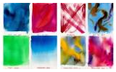
Scientist
As a scientist I will be investigating All Living Things:
- Recognise that living things can be grouped in a variety of ways.
- Explore and use classification keys to help group, identify and name a variety of living things in our local and wider environment.
- Recognise that environments can change and that this can sometimes pose dangers to living things.
Artist
As an artist I will be learning:
In art we will be looking at printing:

- Explore how they can use shape and colour in art, inspired by the work of Henri Matisse.
- Cut shapes directly into paper.
- Use printing and collage to create their own pieces of artwork.

Geography
As a geographer I will be learning about:
- The location of rainforests.
- The layers and climate of a rainforest.
- The Amazon.
- Life in the rainforest.
- How they can be protected.
French
As a linguist, in French I will be learning:
- Jungle animals
- Summertime
- Weather

Sports person
As a sports person I will be learning:
- A variety of athletics skills: throwing, jumping, running and baton changes.
- The rules and play of Diamond Cricket.
- Teamwork
- Long-distance running
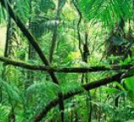

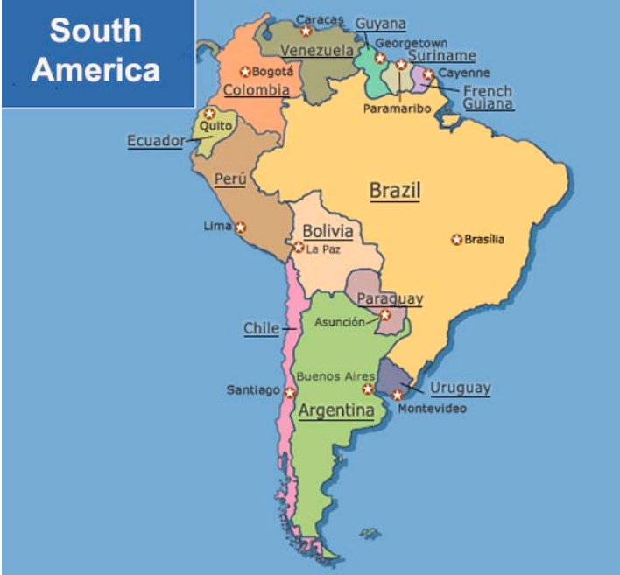
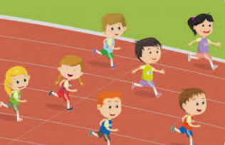
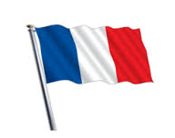
Rainforests: The Study of South America

