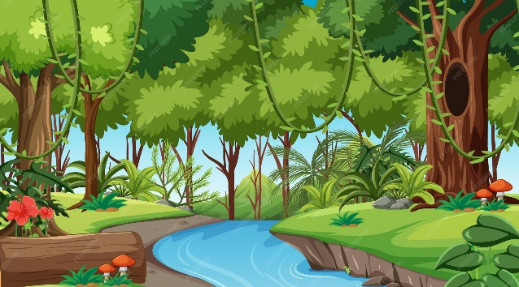
Year 3&4 Summer term Learning log task

Handed out on Wednesday 1st April 2026
Due in: Thursday 7th May 2026

Next term we will be learning about ‘Rainforests’ as part of our Geography topic.
For your learning log task, we would like you to research and collect information about rainforests and their importance. You could find out about the animals that live there, where rainforests are located and the threats to rainforests like deforestation.

You can present your work in whichever way you choose. You could produce a PowerPoint, a poster, a model, a fact file, a leaflet, some artwork etc. Be as creative as you wish!

You can find some useful website links on our class page, which is on our school website. Use this QR code or link to get you there:

https://www.saughallallsaints.cheshire.sch.uk/class/year-3-4-class-information-page
This task will support you with your topic work in class.

Have fun researching! We look forward to seeing and hearing what you find out.
Mrs Hughes, Mrs Hooper, Mr Fuller and Mr Dixon

