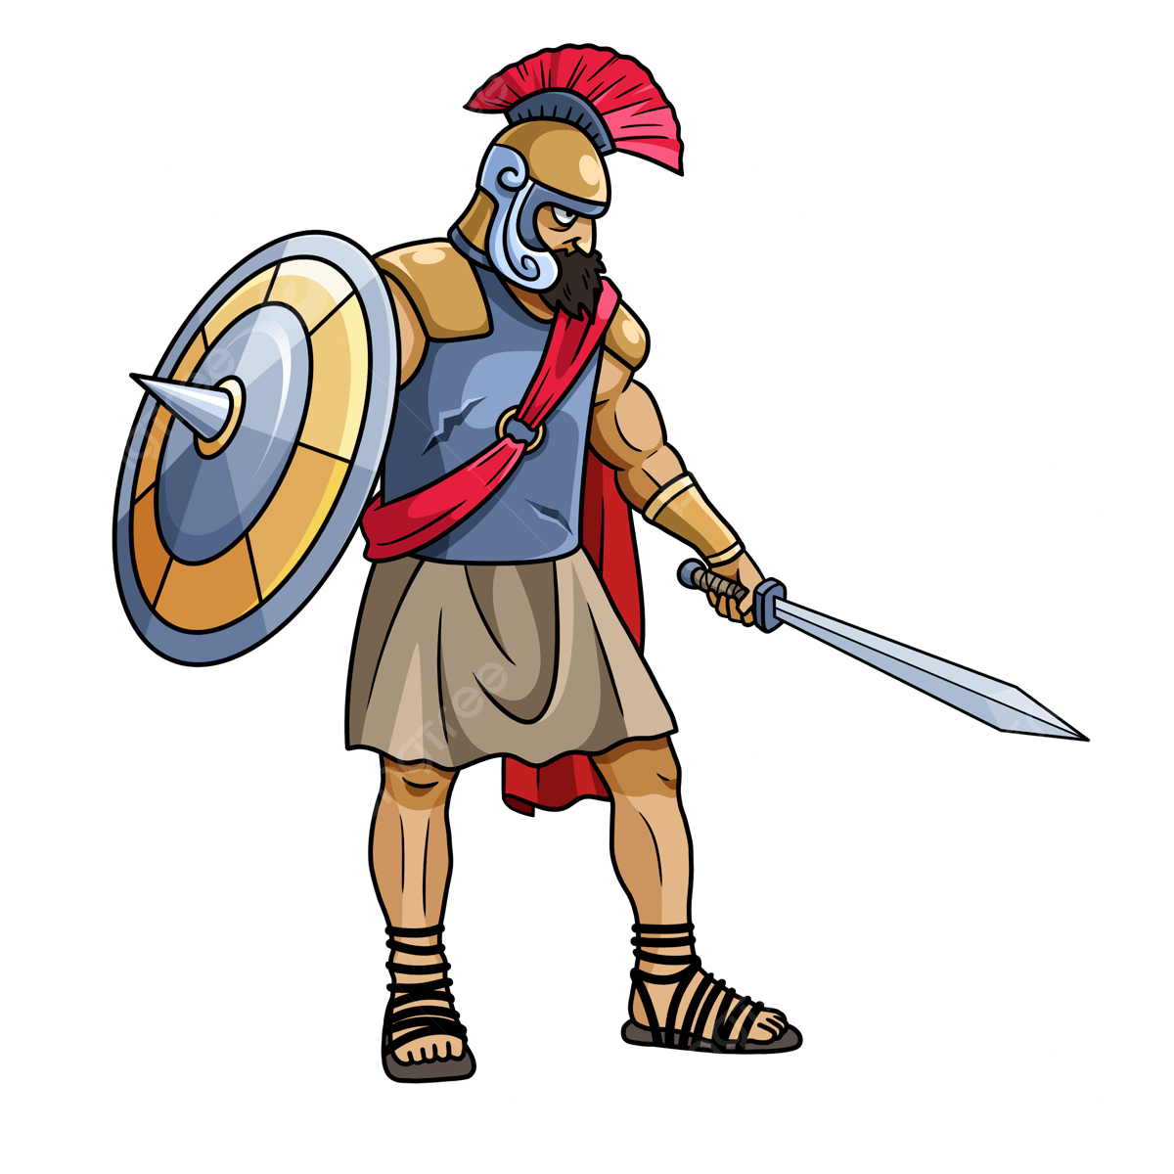
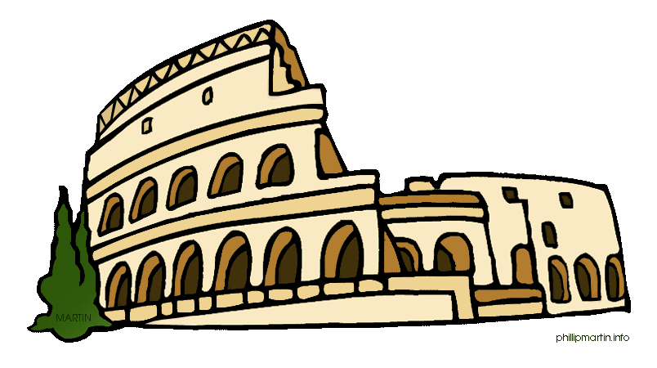

Year 3&4 Spring term Learning log task

Handed out on Thursday 8th January 2026
Due in: Thursday 5th February 2026

This term we will be learning about ‘The Romans’ as part of our History topic.
For your learning log task, we would like you to research and collect as much information about this time in history and the links to Chester.

You can present your work in whichever way you choose. You could produce a PowerPoint, a poster, a model, a fact file, a leaflet, some artwork etc.

You can find some useful website links on our class page, which is on our school website. Use this QR code or link to get you there:
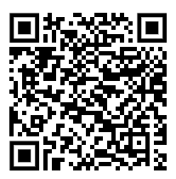
https://www.saughallallsaints.cheshire.sch.uk/class/year-3-4-class-information-page
This task will support you with your topic work in class.

Have fun researching! We look forward to seeing and hearing what you find out.
Mrs Hughes, Mrs Hooper, Mr Fuller and Mr Dixon

