

***Cursive handwriting made easy!***

Dear Parents,

We are part of the Letter-join handwriting scheme and any of our pupils wishing to practise their handwriting at home can log in to the Letter-join website on iPads and tablets as well as desktop and laptop computers. There you will find the same, easy-to-use handwriting resources as we use at school.

**How to log in to Letter-join**

Simply go to [www.letterjoin.co.uk](http://www.letterjoin.co.uk/) online or type ‘Letterjoin’ into Google/Safari/Chrome ~

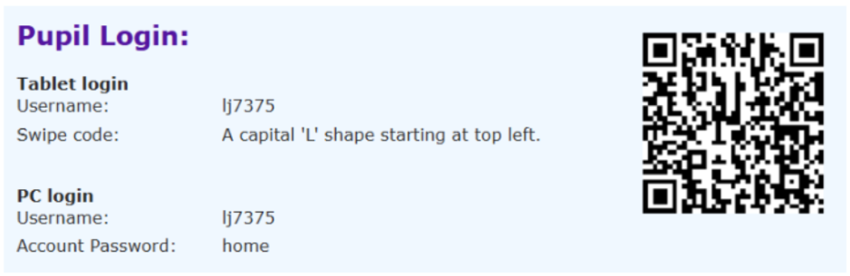

Once logged-in, you will be able to watch how to form all the letters of the alphabet using the same style that we use at school. You can then trace over the letters and words on your device or even print out the worksheets from your PC for real handwriting practice.

We are limited to the number of users who can log in to this account, so please only log in with this username for your own personal use.

Any further questions, please ask us at school.

Thanks for your continued support,

The Y3 and Y4 Team.