Robins Class Autumn Newsletter 2026

We are delighted to welcome you all back to school and hope that you have had an enjoyable break over the summer holidays. The children have already told us so much about what they have been up to! It is lovely to hear that you’ve all had some fantastic days out or some much needed getaways, as well as those relaxing and lazy days at home. We are really looking forward to getting to know the children a little better and making their learning experience a fun, exciting and happy one.
Here is a brief overview of what we will be covering this term; however, this is subject to change, I’m sure, once the children start inputting their ideas.
Mrs Bryan

Our topic this term is All About Me. We will be exploring our local community, Chester and

In Literacy, we will be looking at the texts Meesha Makes Friends and Nibbles the Book Monster . We will also be reading and sharing traditional tales and will look at how some of these stories have changed over the years into modern tales.
We will also focus on…
- Daily Little Wandle Letters and Sounds - Recap and applying sounds to support reading and spelling.
- Daily spelling (Y2 only)
- Reading Practice (twice a week)
- Grammar, punctuation and sentence structure – capital letters and full stops
- Narrative and character description

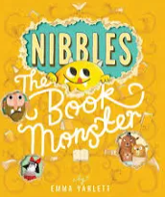

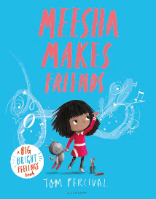

Please see attached common exception spelling sheets for Year 1 and Year 2.

These spellings will be part of spelling homework each week.


Computing
Introduction to Purple Mash
Online Safety
Creative Computing

Important Information
Reading: Two reading books will be sent out on a Monday to be returned the following Monday. Please reread books as this helps build confidence and fluency. Books should be brought into school every day.
Homework: This will be set on Tuesday to be completed by the following Monday. The children will recieve weekly spellings and a page from their Maths Practice Journals. Year 2 children will be given additional SPAG homework every other week. (More information will be given in the Meet the Teacher session).
PE: Wednesdays and Fridays (first half term) Tuesdays and Fridays (second half term). Please send your child into school on PE days in PE kit.
Religious Education

Christianity

What does it mean to belong?

Why is Christmas celebrated by Christians?

History
Changes within living memory – How has Tilston changed over the years?

Changes in homes and buildings

Neil Armstrong

Music
Hey You!
Rhythm in the way we walk and Banana Rap

PSHE
Relationship
What is the same and different about us?
What is special about us?
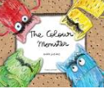

PE (Autumn 1)
Wednesday – multi-skills
Friday - Rugby
PE (Autumn 2)
Tuesday – Gymnastics
Friday - Fitness
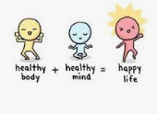
Geography
Local area 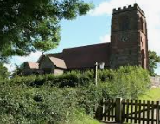
Tilston and Chester
Science
The Human Body
Five senses

Seasonal Changes—observations on changes and how/why it happens?
Planning, carrying out and evaluating investigations

MATHS
• Reading and writing numbers up to 100
- Place value of 2 digit numbers
• Counting on in 2s, 5s and 10s (Year 1s) 2s, 3s, 5s and 10s (Year 2)forwards and backwards.
• Number sequences and patterns
• Addition and subtraction practical and written methods
- 2D and 3D shapes

