**Kestrels**

**Autumn Newsletter 2025**

**Welcome Back!**  
We hope you all had a wonderful summer break and that the children are feeling refreshed and ready for an exciting new term of learning in the Kestrel’s class. We have a great range of exciting topics and interesting activities to look forward to this term.



**Homework**  
Homework will be handed out every **Monday** and will consist of:

* Spellings
* Grammar
* Maths

Homework is important - please ensure your child completes their homework and brings it back to school on the following Monday. Year 6 will begin to receive more specific, SATs related homework as we move through the term.

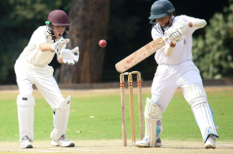



**Visits** - We are aiming to visit the **Safety Centre** at Lymm this term to learn about online safety, healthy eating and keeping yourself safe. There will also be the visit to the **Storyhouse** just before Christmas.

**PE Days**  
PE lessons will take place on:

* **Tuesday** – with a specialist Cheshire Cricket coach
* **Wednesday** – Fitness

Please make sure your child has their **full PE kit** in school on these days.

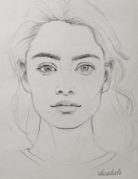

**PE** – The Kestrels will have a Cheshire Cricket coach for the first half term. In addition to cricket, the children will take part in hockey, tag rugby and fitness activities.

**Art** – The children will focus on improving their drawing

**Computing** – Coding and online safety.

**Music** – The children will be using the Charanga scheme to play different types of jazz.

**PSHE** – A focus on keeping healthy as we’re growing up.

**RE** – Kestrels will be studying how different religions show equality, justice and fairness.

**French** – Identifying the names of items found around your house.

**Design Technology** – Links closely with the PSHE, the class will look at healthy foods.

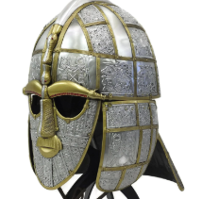

**Our Learning This Term**

* **Maths**: We will be focusing on place value followed by addition and subtraction. After half term we will be studying multiplication and division before moving on to fractions.
* **English**: The children will be studying the beautiful and thought-provoking text *Star of Fear, Star of Hope* by Jo Hoestlandt. After half term, Kestrels will be reading a conservation book ‘Can we save the Tiger by Martin Jenkins. All written work this term will be inspired by these books.
* **Science**: Our topic is **Light**. The children will explore how light works and take part in lots of exciting investigations. Later, we will study the different forms of renewable energy.
* **History**: We will be learning about the **Anglo-Saxons** and their lasting legacy on the culture and landscape of the British Isles.

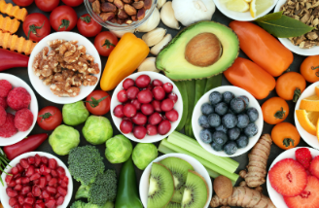

**We are looking forward to a wonderful term ahead, full of curiosity, creativity and learning!**