

Lache Primary School
Shared Reading Policy
January 2026

Lesson Structure
Pre Lesson Planning
- Text to be generated using TeachMate/ Copilot, linking to Pathways to Write novel, engaging history/geography topic or published texts.
- Texts should directly link to Pathways to Write genre; Mastery & Feature Keys.
- Weekly structure for Y2 – 3x Fiction, 1x Non-fiction, 1x Guided Read
- Weekly Structure for KS2 - 3x Fiction, 1x Non-fiction, 1x Class Novel
- During Poetry Week, focus poem will replace fiction sessions.
- Choose assessment focus/consider outcomes using content domains
- Consider teaching opportunities – spellings, phonological awareness, what new vocabulary can be taught, grammar, punctuation
- Ensure inclusion of year group grammatical features.
- Print – size and font in line with whole school policy.
- Numbered text for easy referencing

Main Body of Lesson - 30 minute session
Stage 1: Speedy Read, 2 minutes
- Identify vocabulary for children to practise reading fluency. This could be from today’s text, statutory spelling words, or phonics words in those classes who still have children that need to practise the fluency of these.
- Use Little Wandle practices to support the ‘my turn your turn’ revisiting of the words if pronunciation is inaccurate,
- To ensure pace, teachers ‘clarify’ meaning of unfamiliar words.

Stage 2: Fluency, 5 Minutes
- Number each line of text
- Teacher models reading aloud with pace, prosody and intonation.
- Discuss anything the children may need to notice- “You may have noticed that I paused at commas, so when we read aloud, we need to do that.”
- Children read the first paragraph aloud with the teacher. Teacher reads with them but if they are doing a good job alone then they can carry on without them. If children aren’t fluent, encourage them to practise that section aloud again.
- Children can also practise using the bank of fluency strategies we have below (choral reading etc)
Stage 3: Interrogate and Investigate, 15 minutes
- Give out text- each child has their own copy.
- Teacher discussion around vocabulary and comprehension of the text focus. Ensure when planning you think about what your focus is on- description, atmosphere, layout, cohesion.
- Pull out key vocab. Children highlight and write down synonyms and make notes around what the text means.
- Teacher to model annotating on the board
- “What does the animals were hidden mean? Why does anything hide?” Discuss then annotate text.
- “Find 3 things on lines 9 – 15 which show that the forest is eerie?”
- Teacher reads the next section to the children.
- Repeat Stage 3. Continue with teacher reading each section then repeating stage 3.
- Whole text extract should be no longer than 300 words.

Stage 4: Comprehension, 8 minutes
- Step 1: Retrieval based on first/second paragraph
- Step 2: Vocabulary
- Step 3: Inference
- Please ensure that you word the questions in a way that are similar to SATs/testbase assessments. Teachmate has this as a resource if you search for SATs.
- The first 2 columns will always remain the same- retrieval and vocabulary.
- The 3rd column's question focus should change weekly to focus on a new content domain each week (e.g. inference, summarise).
- Ensure that teacher live marks in this session and children fix in any errors.
- Address whole class misconceptions in this time from what you are seeing when actively marking.

Adaptations
- EAL or SEND may need pre-teaching (pre-read of the text)
- Children may only be given first or second paragraph then only answer retrieval questions.
- Widget symbols used alongside the first paragraph.

Whole Class Read (KS2)
Once a week, KS2 pupils engage in a whole class reading session based on the class book. The structure of this is outlined below. Class texts are read for 15-20 minutes, in the first session after lunch in KS2, which allows pupils to have good knowledge of the stories being read to them. Prediction is included daily through discussion of what could happen/why it could happen.

Stage 1: Retrieval, 5 minutes
- 10 questions based on the text in general and what has been read so far.
- Some of the questions can be repeated each week to ensure all pupils can access the learning and retain knowledge of key characters and plot.
- Pupils self-mark

Stage 2: Summary, 5 minutes
· Paired and whole class discussion based on key events that have happened in the text.
· Address misconceptions in understanding
· Ensure all pupils have knowledge of key events

Stage 3: Comprehension, 20 minutes
- Based on class and partner discussion with some independent responses.
- Using extracts/quotes from the text, provide opportunities for in-depth thinking and discussion around character inferences, language choices and key events.
- This takes the form of:
- Partner talk
- Individual thinking
- Solo work
Adaptations
- EAL or SEND may need pre-teaching (pre-read of the text)
- Children may only be given first or second paragraph then only answer retrieval questions.
- Widget symbols used alongside the first paragraph.
Repeated Reading Strategies
Choral reading is an instructional reading strategy where a group or an entire class reads a text aloud in unison, often led by a teacher or a more proficient reader. It acts as a fluency-building tool, allowing students to practice reading with appropriate speed, accuracy, and expression (prosody) in a low-stakes, supportive environment.
With the paired reading strategy, two students read together to improve their reading fluency. This method involves one student reading aloud while the other listens and provides support as needed. The roles are then reversed, with each student taking turns as the reader and the listener. Usually you will pair your more-fluent readers with your less-fluent readers, although children who read at the same level can be paired too.
Whisper reading is an educational strategy where students read aloud in a soft whisper, often using a "whisper phone" (a handheld, phone-shaped, plastic tube) to amplify their own voice directly into their ear. It builds reading fluency, comprehension, and phonemic awareness by providing immediate auditory feedback, allowing students to correct their own pronunciation and pacing without disrupting the classroom. Whispering may also be more comfortable for kids who feel anxious about reading out loud.
Readers Theatre in education is a, performance-based learning strategy where students read scripts aloud to build fluency, comprehension, and confidence without memorizing lines or using elaborate costumes. By focusing on vocal expression, intonation, and phrasing, students engage with literature in a collaborative, low-stakes, and motivating way.
Performance reading, or fluent oral reading, can be practiced when young students join in a repeated reading of a book with memorable phrases or sound effects and added gestures, or when older students plan how to read passages of a book with expression for an audience.

Content Domains
Column 1 and 2 remain the same during every session – read and retrieve and read and clarify. The 3rd column will change per session using the following content domains…

- read and infer (inference)
- read and comment (meaning as a whole)


- read and explain (author’s choice)
- read and compare (Y5/6 only- making comparisons)
Ensure that the content domains are used on rotation for both fiction and non-fiction sessions to that a varied curriculum is produced.
Use of AI
Artificial Intelligence such as Teachmate and Copilot are to be used to generate texts for class reading sessions linking to Pathways to Write novel, engaging history/geography topic (published texts may also be used). Texts should directly link to Pathways to Write genre; Mastery & Feature Keys to be considered. Using the below weekly structure…
- Weekly structure for Y2 – 3x Fiction, 1x Non-fiction, 1x Guided Read*
- Weekly Structure for KS2 - 3x Fiction, 1x Non-fiction, 1x Class Novel*
*published texts

We also use AI (such as teachmate and Copilot) to generate questions by selecting from the categories below…
- Read and comment (meaning as a whole)
- Evaluation of content, structure and quality
- Explain and explore
- Analysis and Evaluate
- Read and explain (author’s choice)
- Analysis and Evaluation (Generally says How does the author…….)
Select 6 questions even if you only need 2 so that you have a larger pool to select from.

Active Marking & AfL
During the session the teacher will move around the space and live mark the children’s work ensuring that any errors are fixed and that common misconceptions are identified to be addressed. Assessment for Learning is an approach that uses ongoing feedback to help students understand their progress and improve their learning using questioning, observation and discussion to check for understanding.

Reading for Pleasure
Alongside taking home an Accelerated Reader text children are also encouraged to take home a book to read for enjoyment. This can be any type of text and can be changed based on the child’s interest and enjoyment levels.

Accelerated Reader
Accelerated Reader is an online assessment program which we use to monitor children’s reading and comprehension progress, for children in Years 2-6, throughout the year. We do this by using the Star Reading Assessment.
Star Reading Assessments are completed termly in Autumn (Autumn 1) and Spring (Spring 1) and half termly in Summer (Summer 1 & 2). Children answer a series of online comprehension questions in which the questions adapt to children’s ability (if questions are answered right the questions become harder if questions are answered incorrectly the questions become easer). The children must take a minimum of 20 minutes to complete the assessment and cannot receive any help. The Star Reading Assessment informs the teacher of the child’s current reading age and their Zone of Proximal Development (ZPD) which corresponds with a colour and decimal place on a text. Texts are labelled and organised onto colours and decimal places to ensure that the text matches the child’s ZPD, this ensures that the child takes home a suitable texts for their home reading book. When a child has read through their text (minimum of 3 times for shorter texts and picture books) the child then completes an online Quiz. This is a series of questions (usually no more than 10) to gauge the child’s understanding and comprehension of the text, when completed the child can change their text to another of the same colour/decimal place. New texts are recorded in their reading record.

Class Texts & Author Studies
In Year 2 & KS2 each class has a class text, current plan is outlined below. Class texts are read for 15-20 minutes at the end of each day in Year 2 and directly after lunch in KS2, which allows pupils to have good knowledge of the stories being read to them. Prediction is included daily through discussion of what could happen/why it could happen. KS2 pupils engage in a shared reading session once a week based on their class text.
Author study refers to pupils exploring a writer and their texts. The goal is to help young readers notice patterns, understand how stories are crafted, and build a love of reading. Activities may include reading several texts by the same author or having different texts by the author available to share, spotting patterns, learning about the authors life and exploring illustrations. Classes with class texts will use the author of their class text as a focus for a half termly author study. Classes without class texts (EYFS & Year 1) have set authors in which they use as a focus for author study. Plan outlined below.
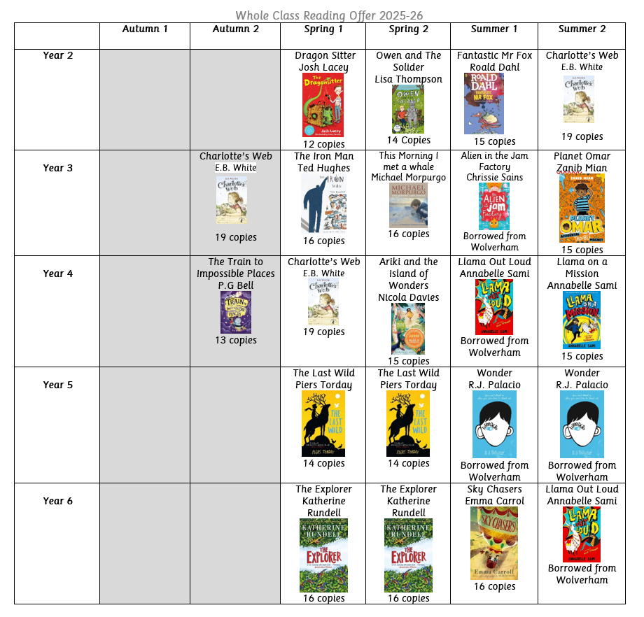

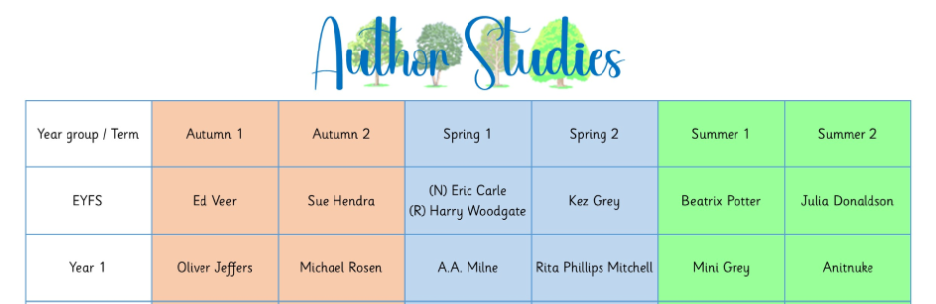
Reader4Life
Reader4Life is a schoolwide reading rewards system, children receive certificates in Celebration Assemblies based on their reading progress. Certificates are awarded for every 25 reads that a child completes (one read equates to one day rather than quantity in that day). Children also receive dojos for completing a whole week of reading (5 reads = x dojo’s) while walking towards their Reader4Life Certificates. Bronze is the first certificate on the reward system, if every child in a class achieves their Bronze Certificate then the class are rewarded with 30 minutes extra Golden Time!
Children who receive their Supersonic Certificate (200 reads) and/ or Infinity and Beyond (300 Reads) are awarded with a gift voucher at the end of the academic year and a party!


