Key vocabulary
light source | A natural or artificial source of light.
straight lines | Light travels in straight lines.
light ray | Each line of light travelling in a straight line from its place of origin.
reflect | To throw back light from a surface.
shadow | A dark area created where light from a light source is blocked by an object. The object blocking the light will be opaque or translucent.

Light travels in a straight line:
We can use an arrow to represent the path of the light.

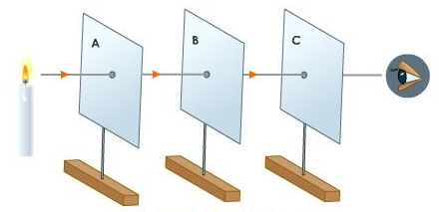
Light source
We see light from the light source when it enters our eyes.


© ECM Education Consultants 2019
Light – Year 6
Significant scientists
Abu Ali al-Hasan  (Alhazen)  (965-1040)  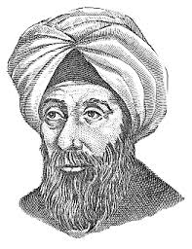 | Alhazan was an Iranian mathematician, astronomer and physicist. He was the pioneer of modern optics. He carried out experiments with pinhole cameras and candles and explained how the image is formed by rays of light travelling in straight lines.
Ben Jensen  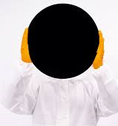 | Ben Jensen is an inventor at Surrey NanoSystems Ltd and developed Vantablack, a super-black coating that holds the world record as the darkest human-made substance.
shadow
Light may come directly from a light source.
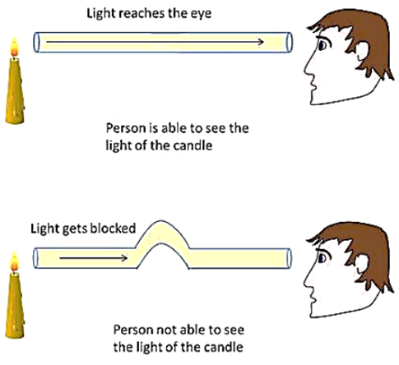
For objects that are not a light source, light must be reflected from the object into our eye for us to see the object:
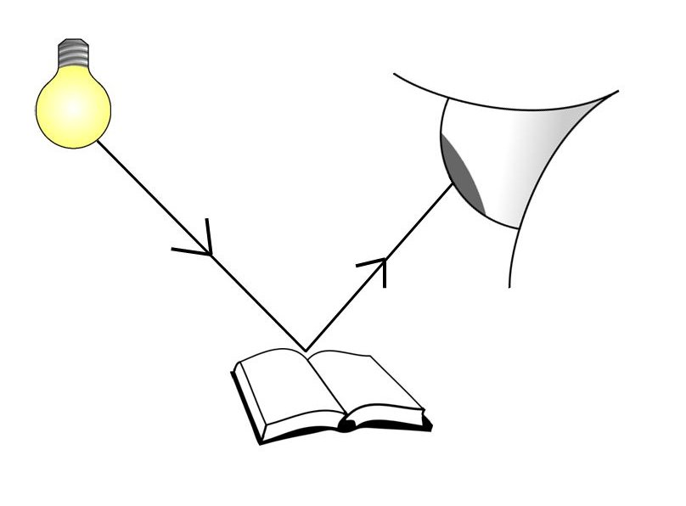
Shadows have the same shape as the objects that cast them:
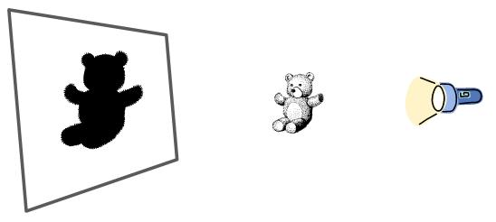
Light travelling in a straight line.
Opaque object blocking the light.

