Key vocabulary
thermal insulator | Does not allow heat to pass through it easily.
thermal conductor | Allows heat to pass through it easily.
electrical insulator | Does not allow electricity to pass through it.
electrical conductor | Allows electricity to pass through it.
dissolve | A solid that completely mixes in with a liquid and cannot be seen.
solution | A mixture of a liquid with a dissolved solid or gas.
soluble | Solids and gases that dissolve in liquids.
insoluble | Solids that do not dissolve in a liquid.
sieve | Separates solids of different sizes.
filter | Separates an insoluble solid that is mixed in a liquid.
evaporation | Separates a soluble solid and a liquid.
reversible change | Changes that can be switched back and are not permanent. E.g. dissolving, melting, freezing
non-reversible change | Changes that can not be reversed back to their original state. E.g. burning, rusting

Materials can be grouped together based on their properties. For example:
- hardness
- solubility
- transparency
- thermal conductivity
- electrical conductivity
- response to magnets
Properties and changes of materials – Year 5
Significant scientists
Spencer Silver  (born 1941)  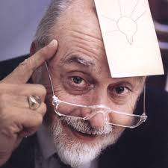 | Spencer Silver is an American scientist who together with Arthur Fry was the inventor of Post-it notes in 1974. At the time, he was working to develop new classes of adhesives.
Joe Keddie
Joe Keddie is a professor of Soft Matter Physics at the University of Surrey. He is interested in the fundamental processes of soft matter, especially polymer thin films and nanoparticles.

Reversible changes
Dissolving sugar in water to make a solution.
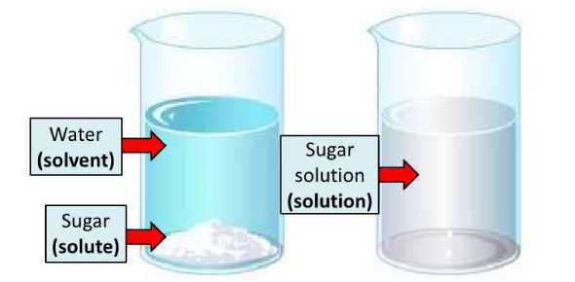
melting
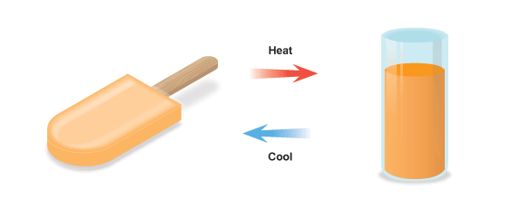
freezing
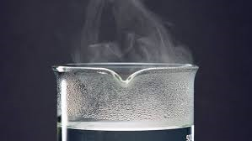  evaporating |  | condensing  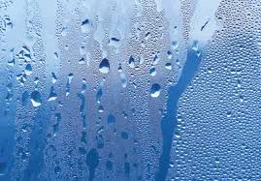
Separating materials
Sieving  separates the stones and twigs from the soil. | 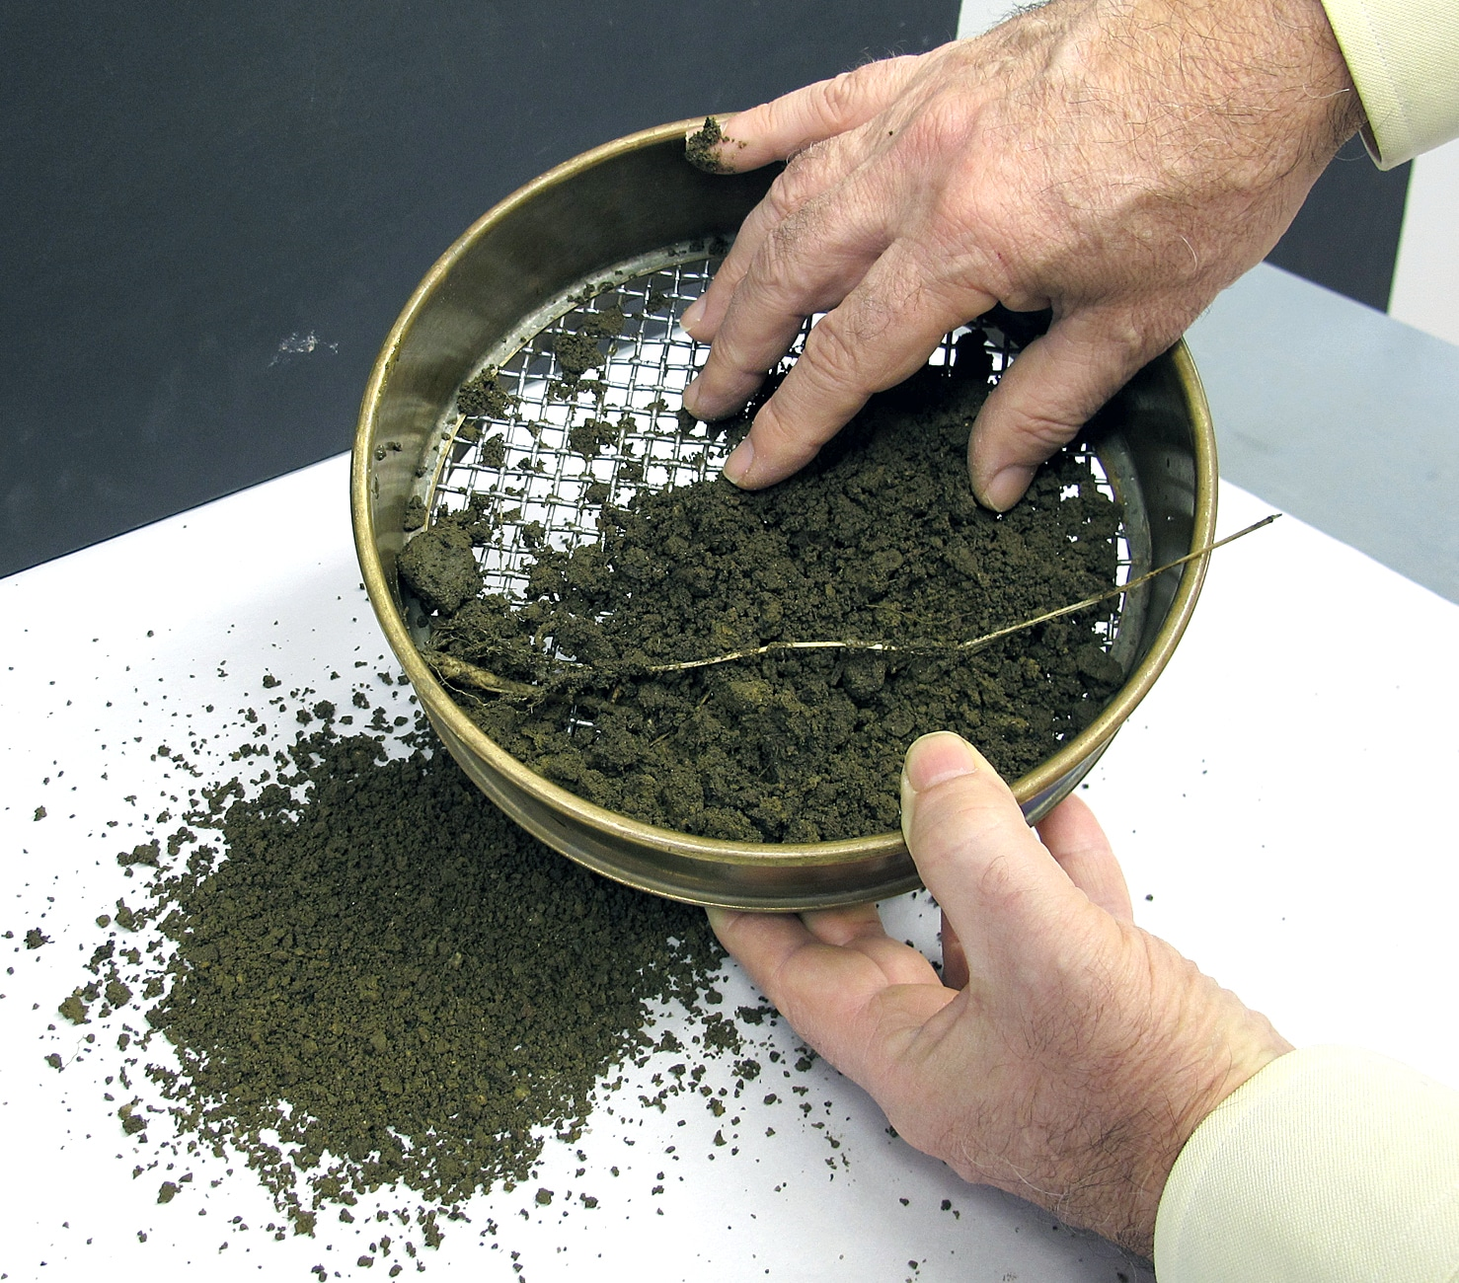
Filtering separates the sand from the mixture. | 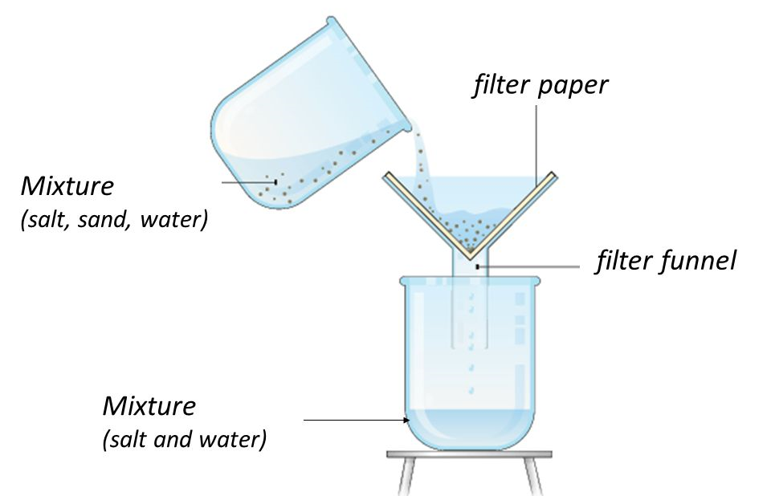
Evaporating separates the dissolved salt from the water. | 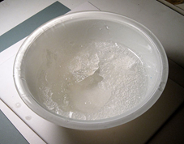

Non-reversible changes - these
result in the formation of new materials
Burning | 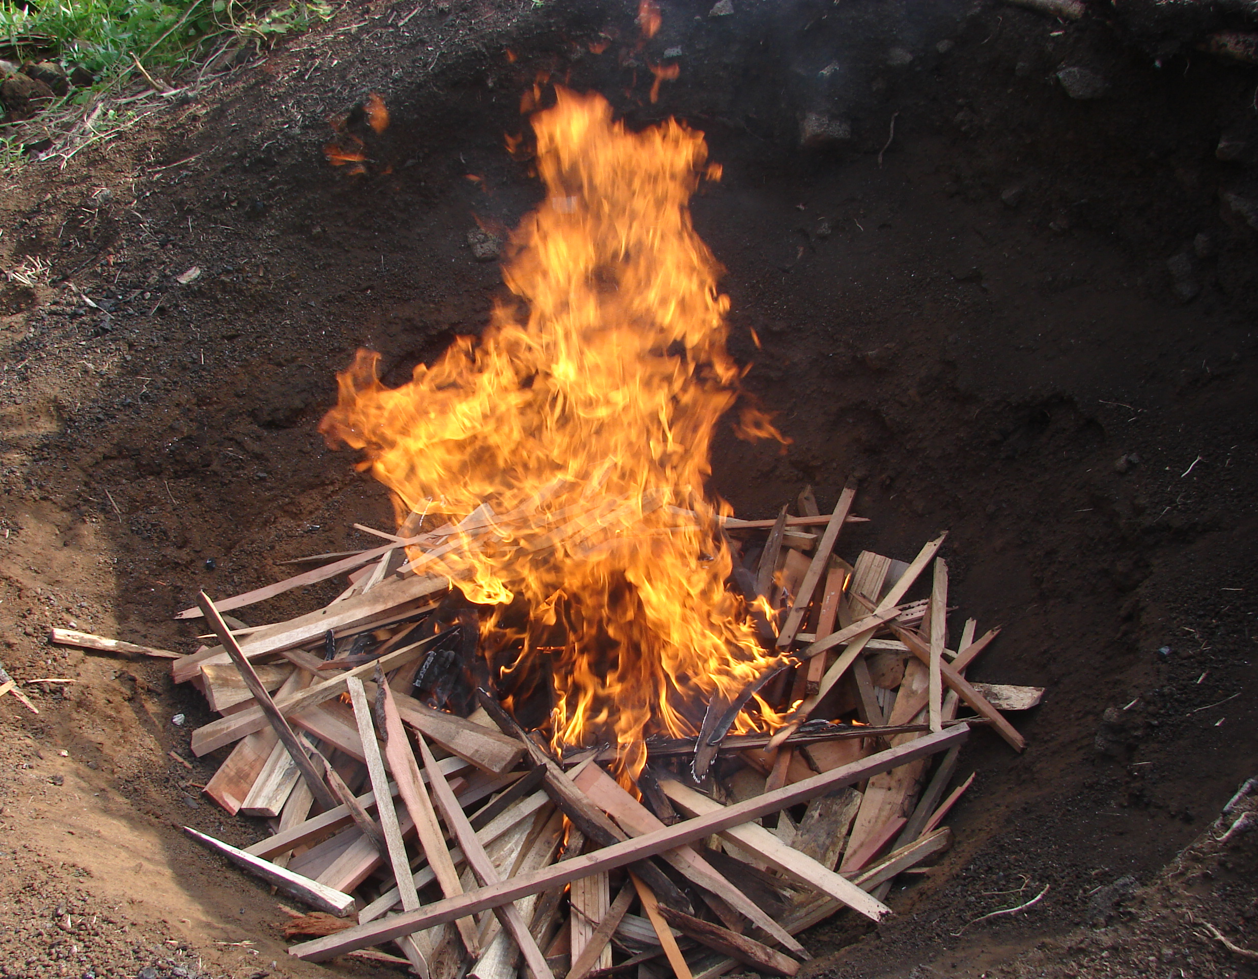
Mixing vinegar and bicarbonate of soda | 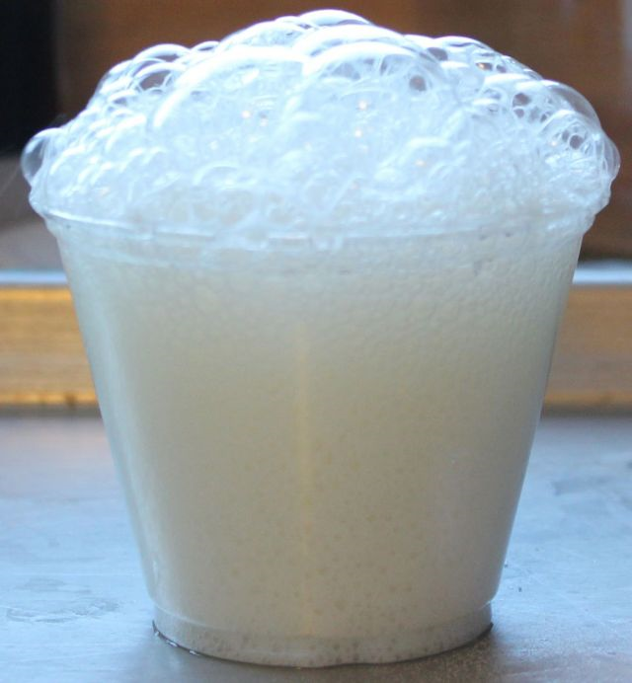
Rusting | 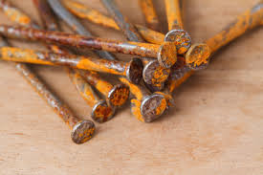

© ECM Education Consultants 2019

