Key vocabulary
roots | Anchor a plant in place. The roots also absorb water and nutrients from the soil.
stem/trunk | Transports water and nutrients around the plant. It also holds the leaves/flowers up in the air.
leaves | They use sunlight and water to produce the plant’s food.
photosynthesis | The way in which plants make food in their leaves.
pollen | This is a very fine powder that is produced by the male part of the flower.
pollination | When pollen is transferred to female parts of a flower. This can be done by wind or insects.
seed formation | Seeds can develop after pollination. They can be found in berries or fruits.
seed dispersal | Seeds can be dispersed in different ways, for example, wind, animals or water.
germination | When a seed sprouts a root and shoot.

How a plant takes in water
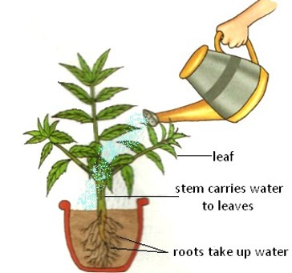
Plants – Year 3
Significant scientists
Joseph Dalton Hooker  (1817-1911)  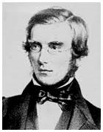 | Joseph Hooker was a doctor and travelled to many places. He was a plant collecter and botanist and brought many plants back to the UK. Joseph was interested in finding out why plants grow in the locations they do.
Professor Monique Simmonds  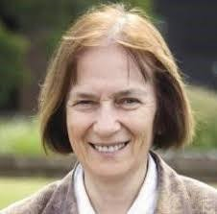 | Monique Simmonds is the deputy director of science at the Royal Botanic Gardens, Kew. She researches traditional and commercial uses of plants and fungi. Her work involves her promoting plant and fungal-based solutions to global challenges.
Plants need certain things to grow:

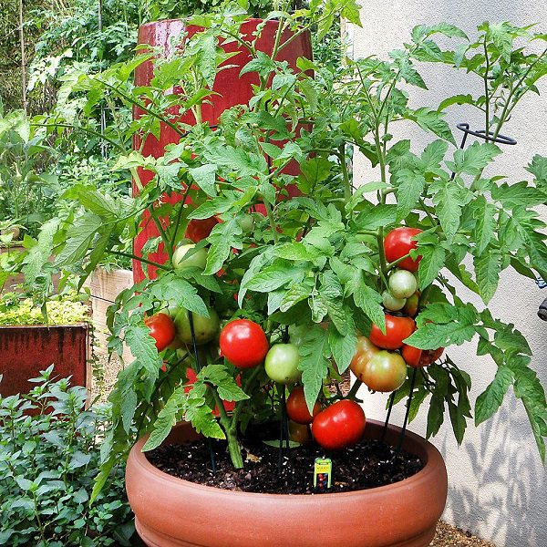
water
air
nutrients from the soil
room
light
Pollination
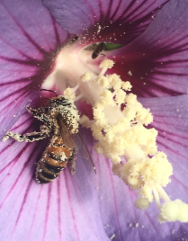 | Insects like bees and wasps transfer the pollen from the male part of a flower to the female part of other flowers.

Methods of seed dispersal

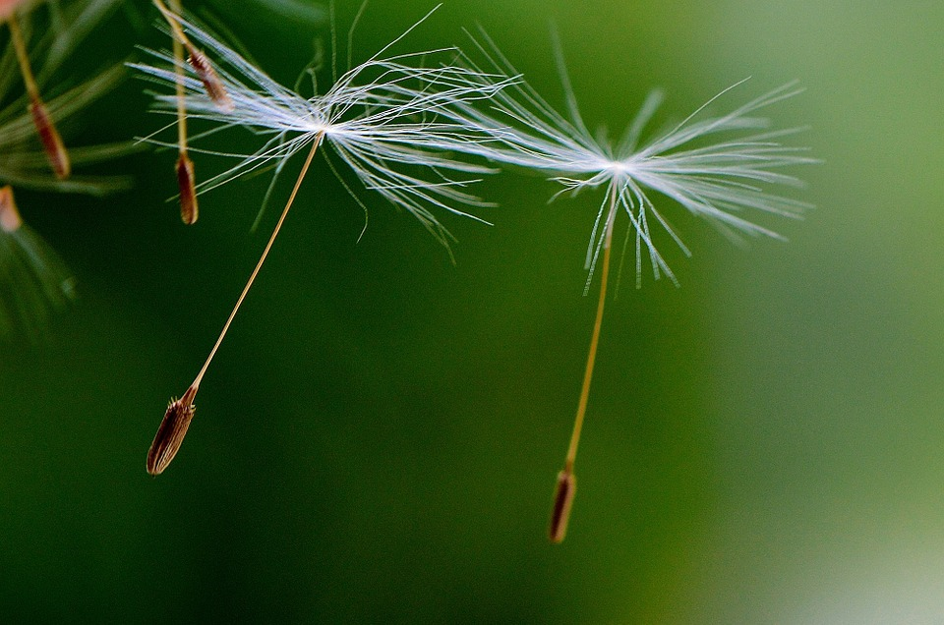 | 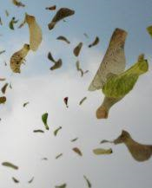  by wind

on animal’s fur
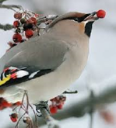 | by animal’s eating them
  in water | 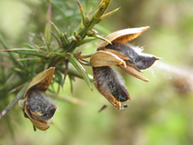  when the seed pod explodes


© ECM Education Consultants 2019

