Examples of habitats
woodland
Hedgehogs make a nest in leaves in woods.
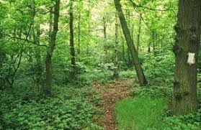
pond
Goldish can breathe in water.
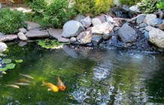
seashore
Crabs are omnivores and eat seaweed.
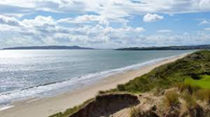
polar
Polar bears are carnivores and eat seals.
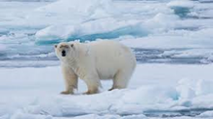
ocean
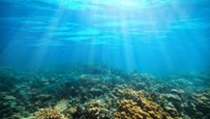
Stingrays live in saltwater.
rainforest
Spider monkeys find food high up in the treetops.
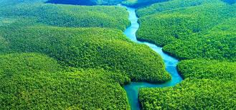
Living things and their habitats – Year 2
Key vocabulary
living | Living things are plants and animals.
living | 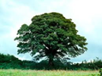 | 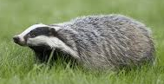
dead | Dead things include dead animals, plants and parts of plants and animals that are no longer attached.
dead | 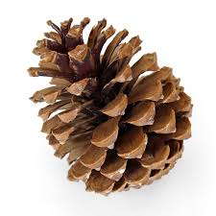 |  | 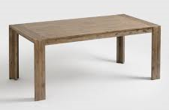
never been alive | Objects made of rock, metal and plastic have never been alive.
never been alive | 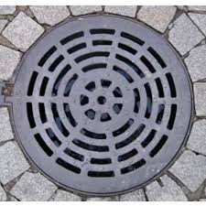 |  | 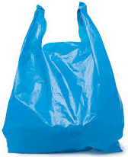
habitat | The place where an animal or plant lives and provides their basic needs – shelter, food and water.
micro-habitat | A very small habitat e.g. A log that woodlice live under.
food chain | These show how animals get their food from plants and other animals.

Examples of micro-habitats
in leaf litter  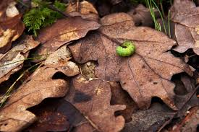  Caterpillars need leaves to eat. |  | under stones  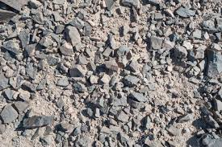  Woodlice can be found hiding under stones.
under logs  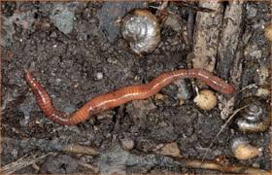  Worms prefer dark, damp places. |  | in shrubs  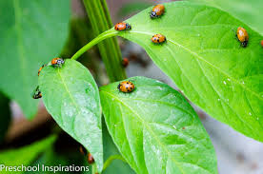  Ladybirds live in shrubs and trees.
Food chains

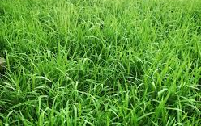  grass | 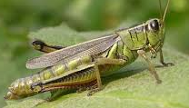  grasshopper |  | 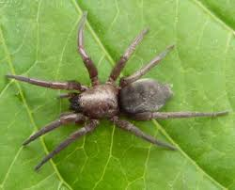  spider
The grass is eaten by the grasshopper.
The grasshopper is eaten by the spider.

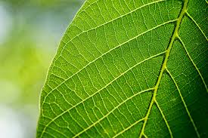  leaf | 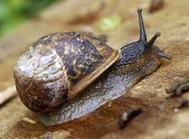  snail |  | 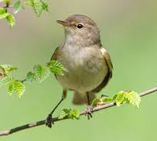  bird
The leaf is eaten by the snail.
The snail is eaten by the bird.

© ECM Education Consultants 2019

