

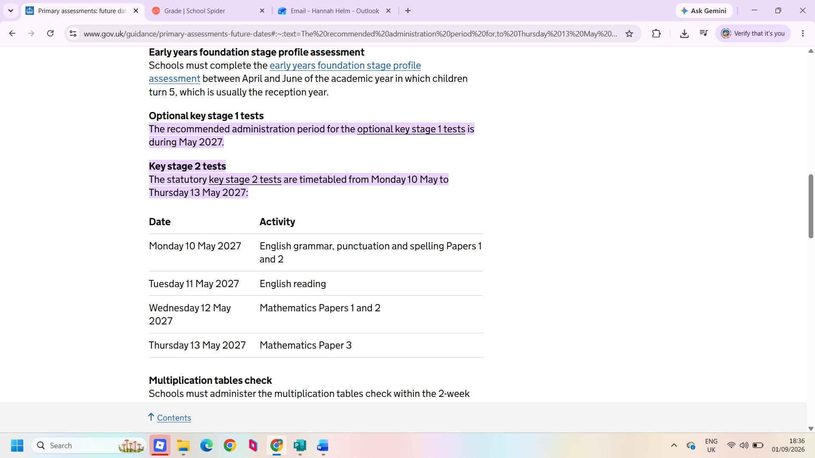
Year 6 SATs week this year is from Monday 10th May 2027 – Thursday 13th May 2027. As well as completing their homework, please support your child at home and encourage them to spend time after school revising for their tests – Maths, Reading and Grammar.

To revise, there are a number of things they can do. Firstly, they can use the CPG revision books that we lend to the children to take home nearer the exams. Secondly, they can use the internet to look up concepts they know or which they have found more difficult in lessons and make notes on these. Finally, they can consolidate the learning they have carried out that day in class by making notes and practising new skills.

Below is a list of recommended websites that could be used to support your child at home:

www.emaths.co.uk (Access to past SATs papers)
www.bbc.co.uk/bitesize
www.theschoolrun.com/year6

