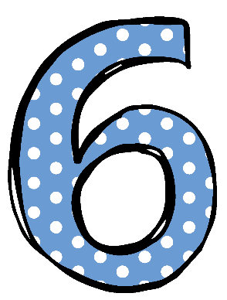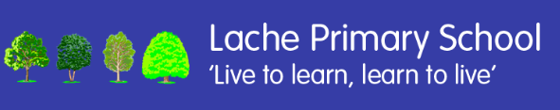

Welcome to Year

We are delighted to welcome our Year 6 cohort of 2026 to our class!

This year, the Year 6 children will be taught by Mrs Helm. I have taught in Year 6 for many years which means that hopefully I am fully prepared in helping your children to tackle what can be a challenging year. The SATs tests in May 2026 will take place the week beginning the 11th May. More information about SATs will be shared with you as we get later into the school year. We also have the wonderful Miss Newey joining us as our teaching assistant. Mrs Anstey will be covering the class during my PPA on a Thursday.

The children have all returned to school looking very smart in their school uniform- THANK YOU! Remember that we have lots of excellent quality uniform in school that can be bought from Mrs Coghill if you’re missing anything. This year, the children will have **PE on a Thursday** each week. On this day, they can come to school wearing their PE kit and school jumper.

Snack will still be available to purchase at break time. Children are also welcome to bring their own snack as long as it is healthy e.g. fruit, cereal bar or breadsticks. Children will need to bring in a water bottle with them each day.

Our ‘Reader 4 Life’ scheme and rewards are still continuing so please encourage your child to read at least 4 times a week and have their reading record signed.

Homework tasks will be set on a Friday and need to be returned by the following Thursday. The work given for homework will always be an extension of what we have been learning in class so the children should be able to access it independently.

Please ensure that you read the weekly newsletter on School Spider which will be posted on a Sunday as this is where I will share any changes or information for the coming week.

If you have any questions, don’t hesitate to contact us.

Mrs Helm