Year 5 |   ‘Live to Learn, Learn to Live’  Our Weekly News |  | 01.09.25
English  This term, we will begin by studying ' Queen of the Falls' by Chris Van Allsburg which is a true story about Annie Taylor - the first person to cross the Niagara Falls in a barrel.  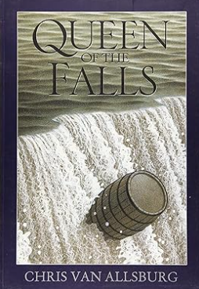 | Spelling  This week the class will be continuing to follow spelling strategies.  The spelling focus will be the Statutory Word List for Year Five, including definitions of words from the word list and our Word of the Week. |  | Other Subjects  Computing: In Autumn 1 the children will be learning about Computer Systems and Networks  PE: This term the class will be practicing hitting and fielding Athletics, (Rounders and Cricket).  Geography: This term our Geography topic is 'Amazing North America' and the children will be learning all about the different countries in North America, locating them on a map, identifying human and physical features and comparing them to their local area.
Science  Our first science topic this term is Forces in which the children will learn about gravity, friction, air and water resistance as well as carry out engaging and inspiring investigations. | Maths  Our Maths topics this term will be place value, addition and subtraction, multiplication and division and fractions. |  | Talking Points  If you can, please take 5 minutes to talk to your child about ……………..
Reminders  PE Kit is needed for Wednesday afternoon.  Please remember to read with your child his week, completing the Reading Diary and sending it back into school. |  | Dates For Your Diary

