Year Two Home Based Learning
Week 9- Monday 18th May 2020
Welcome to Week 9,

I hope you have had a good week and are keeping well. Thank you to everyone who joined in with our Zoom on Friday and took part in our Year 2 quiz, I thought you all did very well as there were some tricky questions! Thank you to everyone who is adding and commenting on the class Padlet it is lovely to see you and look at examples of the work you have been doing.

Padlet
Keep posting on Padlet, it’s lovely to see what you have been doing! I have set up a new Padlet as it was so full of your lovely contributions that it was getting very slow. The new details are: https://padlet.com/satkinson16/ib0n0x30mhmlix2e
To post on it you need to click on the red circle with the white add sign.
Watch out for more ideas on here, I will post any interesting links or activities I come across.

Zoom
I will hold another Zoom meeting next week. In order to keep the login as secure as possible Mr Priddey will email it to you the evening before so please look out for it! I will also advertise it on Padlet too.

BBC Bitesize
Please continue to use the BBC Bitesize Website for alternative activities. You could have a go at anything on here that catches your eye.
https://www.bbc.co.uk/bitesize/levels/z3g4d2p

If you want to contact me I will be checking my emails satkinson@sandiway.cheshire.sch.uk and I will do my best to respond promptly.
Reading | Read daily. How much reading are you doing? You should be reading every day.  It is great to see you have been accessing Bug Club. I am monitoring the use of Bug Club closely. This last week 20 children (disappointing) logged onto Bug Club and completed quizzes- well done all of you. Make sure you answer the questions fully; I love reading your answers. I will check who has been using it well and will give you a special mention on Padlet at the end of the week.  Watch Newsround and find out what is happening in the world. What did you find out? Is there anything you need help understanding?  This week I would like you to do a reading comprehension. You will find this on the Year 2 Page. It is about Garden Birds and there are three versions. I would like you to do the 2* or 3* version.
Phonics/spelling tasks | In Year 2 we need to be able to write and spell correctly words with suffixes ing, ed, ful, ness and ment. So this week I’d like you to learn to spell the following words, you could use the spelling activities sent out in Week 6.  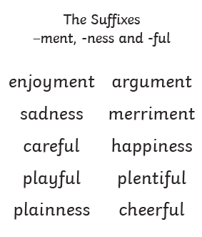  Write a sentence using each one. Use your best handwriting and really focus on making your letters sit on the line, with clear ascenders and descenders.  In the spelling quiz on Friday we wrote words ending with ing. Make a list of 10 verbs and add ing and ed to the end of them. Then write sentences using each one making sure you also include an adverb.
Writing | I have included a picture of a wolf (page 5). Have a good look at the picture what else can you see?  - Write a character description of the wolf.  Make sure you include different sentence openers, expanded noun phrases and interesting vocabulary.  - Imagine this is a picture from your story book. It could be the beginning, middle or end. Write the story this picture is taken from. You could base it on a story you know that contains a wolf or you could make up the story.  Again, make sure you include different sentence openers, expanded noun phrases and interesting vocabulary. You could make it into a book and add extra illustrations. Enjoy!  I have added the Year 2 expectations for writing below. When you have completed your story check to see how many you have included. If you have missed some edit your work to improve your writing further.  Writing Expectations in Year 2 (Taken from the document on the Year 2 Page)  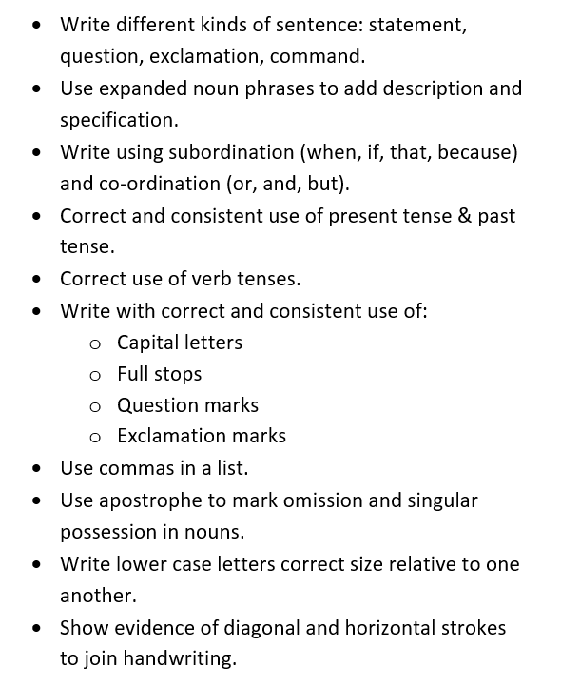
Maths | https://resources.whiterosemaths.com/wp-content/uploads/2020/05/Year-2.pdf  - This week we are revisiting multiplication and division. There are videos for you to follow and I have also added worksheets to the Year 2 page.  - I have also added extra Multiplication and Division questions for more challenge.  - There is a home learning pack with a range of different activities.
Science | In Year 2 we need to find out about and describe the basic needs of animals, including humans, for survival (water, food and air), by identifying the ways that different animals meet their basic needs.  I would like you to think about a pet you have at home or a pet you would like to have and think about their needs. Then design a home for your pet including information on their needs and how you have provided for them. (I have also included a page providing support with this.)  See sheet on Year 2 Page.
Computing | Coding  Well done to everyone who had a go at coding this week. Remember when you have finished save your work.  Logon to Purple Mash. I have set you some coding activities on your 2do.
PE/exercise | 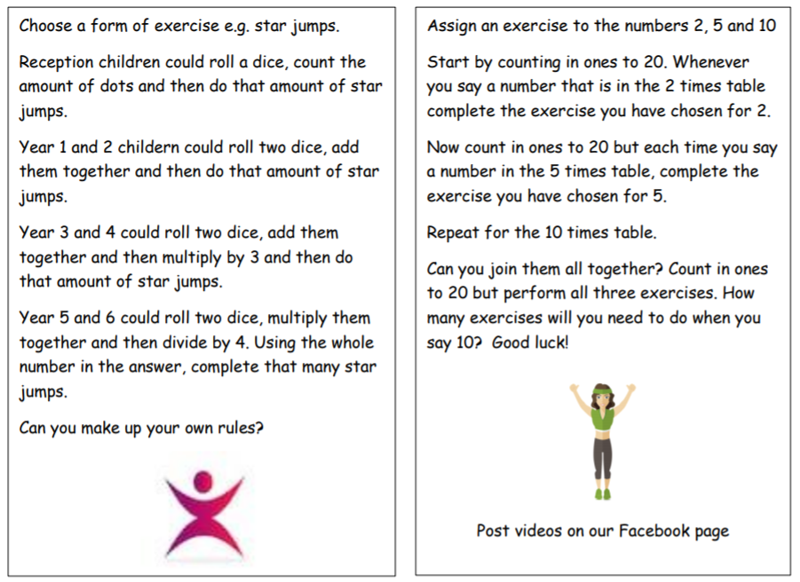
Additional reosources/websites | Classroom Secrets Learning Packs - These packs are split into different year groups and include activities linked to reading, writing, maths and practical ideas you can do around the home.  Twinkl - to access these resources click on the link and sign up using your own email address and creating your own password. Use the offer code UKTWINKLHELPS.  The Scouts Lots of great activities  https://www.scouts.org.uk/the-great-indoors/
Act of Kindness |   What can you do to be kind?  Help set the table?  Tidy your room?  Design and make a family quiz to entertain?
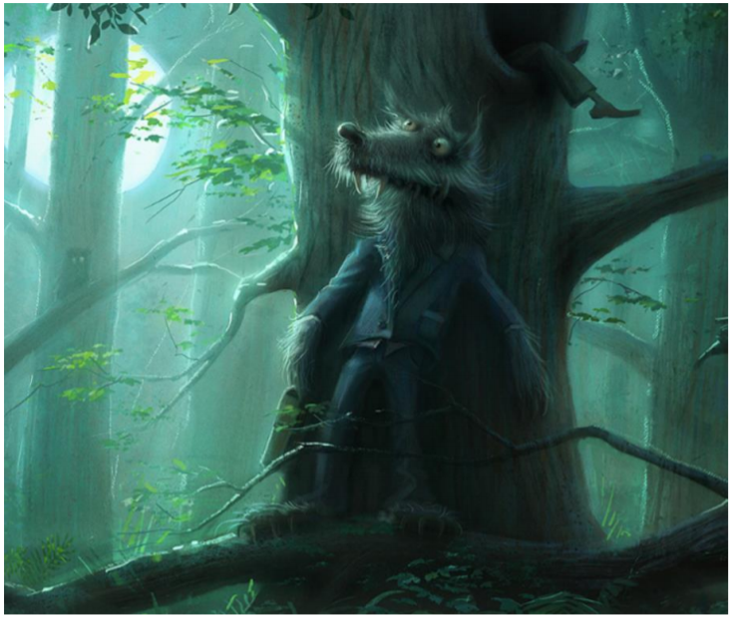

In the deepest darkest forest Mr Wolf waited patiently…

