Can I use Speech punctuation accurately?
1.  This is my favourite book!   | 2.  Do you want to play football with me?   | 3.  Don’t talk to strangers!   | 4.  I had a cheese sandwich for dinner.  
Lucy exclaimed, “this is my favourite book”!
  5.  I hope you are listening to my instructions. |   6.  I like playing in defence. |   7.  You need complete bed rest. | 8.
 |  |  | Santa told the elves, “Hurry up, or we’ll be late”!

Now have a go at writing your own short comic strip. It could be about anything. Here is an example of a Garfield comic strip.
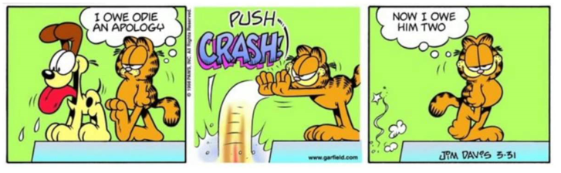

Now, have a go at writing out your comic strip in sentences, using the rules of writing speech.



