Year Two Home Based Learning
Week 6- Monday 27th April 2020
Welcome to Week 6,
Thank you to everyone who joined in with our Zoom meeting last Wednesday. It was lovely to see you all. There is no pressure to join in on Zoom, just popping in to say hi for a few minutes is great. We love it because Mrs Whitney and I get to see all your lovely smiling faces!

Keep posting on Padlet, it’s lovely to see what you have been doing!
https://padlet.com/satkinson16/gbfjjhomepv0

Watch out for more ideas on here, I will post any interesting links or activities I come across.

I am hoping to hold a Zoom meeting on Thursday at 11am. In order to keep the login as secure as possible Mr Priddey will email it to you on Wednesday morning. We have also made sure all the settings are as secure as possible.

Last week the BBC started lessons for you on BBC Bitesize, I hope you have been enjoying them.
From Monday 27th April Letters and Sounds will be streaming live phonics lessons on YouTube. Although these are aimed at Year 1 children I think they would be very useful revision for all of you! By the end of Year 1 we have learnt all 44 phonemes that are in the English language. During Year 2 we refine our knowledge of these, building on our knowledge and adding spelling patterns and rules. It will be great if you could watch as many as you can. The sessions for Year 1 start at 10:30.

BBC Bitesize
https://www.bbc.co.uk/bitesize/levels/z3g4d2p
Letters and Sounds Phonics
https://www.youtube.com/channel/UCP_FbjYUP_UtldV2K_-niWw/featured?disable_polymer=1

If you want to contact me I will be checking my emails satkinson@sandiway.cheshire.sch.uk and I will do my best to respond promptly.
Reading | Read daily. This is probably the most important thing you can do.  Can you complete a reading challenge (see website)?  It is great to see you have been accessing Bug Club. I am monitoring the use of Bug Club closely last week 21 children logged onto Bug Club and completed quizzes- well done all of you. Make sure you answer the questions fully; I love reading your answers. It would be great if we could get everyone using it.  It was great to see all the different books that you are reading during our Zoom meeting. You could write a recommendation for a book and post it on Padlet.  Watch Newsround and find out what is happening in the world. What did you find out? Is there anything you need help understanding?
Phonics/spelling tasks | Login to our favourite phonics website: Phonics Play  www.phonicsplay.co.uk  username: march20  Password: home  You can revisit all the Phase 5 and 6 games that we have used in school.  Use the Activity Cards on Page 5 and 6 to practise your spellings.
Writing |   On Bitesize this week you can find out about the famous astronaut Neil Armstrong.  We would have learnt about Neil Armstrong as part of our Time Travel Topic.  https://www.bbc.co.uk/bitesize/articles/zj93bdm  There are videos to watch and activities to do.  You could compare Neil Armstrong with Tim Peake’s experience of Space.  I have also attached some space writing paper or you could design your own!  https://www.natgeokids.com/uk/discover/science/space/neil-armstrong-facts/
Maths | Below is a link to the White Rose Maths site. From next week this site is also aligned to the BBC Bitesize lessons.  This week we are exploring length. I have also attached these maths sheets to our class page.  https://whiterosemaths.com/homelearning/year-2/  Arty Maths- something a bit different!  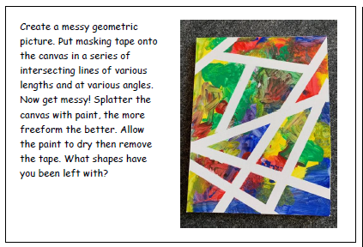
PE/exercise | Let’s get active!!  Vale Royal School Sport Partnership have got some great sport challenges to get you moving. They have a challenge for everyday and have made cool videos to show you what to do.  https://valeroyalschoolsport.org/home-learning-archive/  Can you spot Mr Finney in some of the videos?  Maybe you can keep a record of how many you can do in a minute.
Additional reosources/websites | Classroom Secrets Learning Packs - These packs are split into different year groups and include activities linked to reading, writing, maths and practical ideas you can do around the home.  Twinkl - to access these resources click on the link and sign up using your own email address and creating your own password. Use the offer code UKTWINKLHELPS.  The Scouts Lots of great activities  https://www.scouts.org.uk/the-great-indoors/

