Year Two Home Based Learning
Week 5- Monday 20th April 2020
Welcome to Week ,5 I hope you’ve all had a lovely Easter. Keep posting on Padlet, it’s lovely to see you all!
https://padlet.com/satkinson16/gbfjjhomepv0
Watch out for more ideas on here, I will post any interesting links or activities I come across.

I am hoping to hold a Zoom meeting on Wednesday at 2pm. In order to keep the login as secure as possible Mr Priddey will email it to you on Wednesday morning. We have also made sure all the settings are as secure as possible.

As it is the beginning of the Summer Term the BBC are starting to provide online lessons for everyone. You might find some of these useful and interesting. I’ve had a look at the plans and they are looking good. New lessons will come online each morning at 9am. Follow the link below
https://www.bbc.co.uk/bitesize/levels/z3g4d2p


If you want to contact me I will be checking my emails satkinson@sandiway.cheshire.sch.uk and I will do my best to respond promptly.
Reading | Read daily. This is probably the most important thing you can do.  Can you complete a reading challenge (see website)? It is great to see you have been accessing Bug Club, apologies if you ran out of books, I have updated this and will keep a closer eye on it. Glad to see your reading so much!  The majority of you are accessing Bug Club daily which is great.  Don’t forget there are more books on Collins Connect. Link on Year 2 website.  Watch Newsround and find out what is happening in the world. What did you find out? Is there anything you need help understanding?
Phonics/spelling tasks | Login to our favourite phonics website: Phonics Play  www.phonicsplay.co.uk  username: march20  Password: home  You can revisit all the Phase 5 and 6 games that we have used in school.  Top Marks  https://www.topmarks.co.uk/english-games/5-7-years/words-and-spelling  Some great spelling games  https://www.topmarks.co.uk/english-games/7-11-years/spelling-and-grammar  Try this game it may challenge some of you that are more confident readers.  This poem on Page 4 has been written in the present tense. Can you rewrite it in the past tense?  Remember:  - Sometimes the past tense word is completely different. E.g run and ran  - After a short vowel sound double the consonant.  - If the word ends in e, drop the e and add ed  - Change a Y to an i and add ed  - Just add ed
Writing | This activity links back to our first topic on Castles. I have added the vocabulary we used on page 3 as I thought you might find helpful.  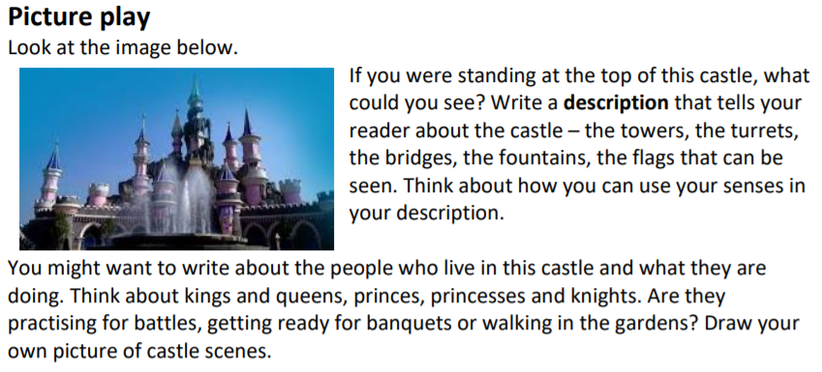
Maths | Below is a link to the White Rose Maths site. From next week this site is also aligned to the BBC Bitesize lessons.  https://whiterosemaths.com/homelearning/year-2/  Keep working on your times tables!  Focus on knowing your 2’s,5’s and 10’s really well. Learn your 3’s if you are amazing at these!  Some games to help you:  Super Movers  https://www.bbc.co.uk/teach/supermovers/times-table-collection/z4vv6v4  Top Marks  https://www.topmarks.co.uk/maths-games/5-7-years/times-tables  ICT Games  https://www.ictgames.com/mobilePage/bunny/index.html
PE/exercise | Let’s get active!!  Vale Royal School Sport Partnership have got some great sport challenges to get you moving. They have a challenge for everyday and have made cool videos to show you what to do.  https://valeroyalschoolsport.org/home-learning-archive/  Can you spot Mr Finney in some of the videos?  Maybe you can keep a record of how many you can do in a minute.
Additional reosources/websites | Classroom Secrets Learning Packs - These packs are split into different year groups and include activities linked to reading, writing, maths and practical ideas you can do around the home.  Twinkl - to access these resources click on the link and sign up using your own email address and creating your own password. Use the offer code UKTWINKLHELPS.  The Scouts Lots of great activities  https://www.scouts.org.uk/the-great-indoors/

Castles Vocab
Portcullis  Ramparts  Battlements  Murder holes  Curtain wall  Crenels  Merlons  Drawbridge | Moat  Arrow slits  Dungeon  Parapet  Keep  Motte  Trebuchet  Battering ram

