Year Two Home Based Work
For the week beginning 23rd March 2020
Welcome to our first home based learning week- I hope you are all well. Please see the suggested timetable also on the Year 2 page.
Please spend some time over the course of the week on the following.
Red= New work that has not been covered in class
Any other work is using and applying what the children have already learnt in class.
If you want to contact me I will be checking my emails on satkinson@sandiway.cheshire.sch.uk and I will do my best to respond promptly.
There is no requirement to send me evidence of your work although it will be lovely to see any pieces you are really proud of.
Reading | Read at least three times and if possible daily. Paper books, Bug club and library books. I have added some reading ideas for to the website, how many can you complete this week?  Write a character description based on one of the characters you are reading about in one of your most recent books.  Include the title and author of the book and think about how you can present your work.  (Include the character’s personality and appearance. Can you use conjunctions because, and, but, so that and when). Make sure you reread your writing and check it makes sense.  Adults, have a chapter book on the go and try and read a chapter a day. We have loved reading Amelia Jane by Enid Blyton.
Writing | Go back and review spellings covered since September (your last test is in the back of your homework book) and ensure you are confident in spelling these words. I have also added the next 200 words for extra challenge!  You could make your own word search or make a squiggly pattern and fill it with your spellings just like we do in class. Grown-ups can you do the squiggle, try to keep it simple!
Maths | Time:  We were just about to start learning about Time.  - Be confident to read the time to o’clock, half past (Year 1) quarter past and quarter to  - Notice how the hour hand moves, at half past it is half way between the numbers. Where is it at quarter past?  In Year 2 we only do analogue NOT digital  There are lots of games on the following website that you may find useful to practise these skills  https://www.topmarks.co.uk/maths-games/7-11-years/measures  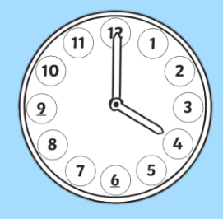  Telling the Time in Words is a good game we use.  If you have paper or card, you could have a go at making your own clock with moveable hands (see template).  Revisit addition of two 2 digit numbers.  e.g. 53+45=  50+40=90  3+5=8  90+8=98  28+45=  20+40=60  8+5=13  60+13=73  0r  +8  +20  45 65 73  You can make these as easy or as hard as you like. You could generate numbers by using a spinner or an adult could think of some for you.
Topic/ Creative work | 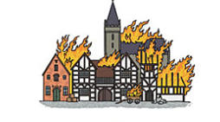  We have just started learning about the Great Fire of London.  What caused the fire and where did it start?  What can you find out about it? I have put some information on the website to help you but you could also research on the internet or go to the library if that is still possible!  This week I would like you to write an illustrated account of how and where the fire started and why it spread so quickly across the city of London. Think about your presentation.

