Can you read the sentences and match them to the pictures?

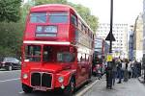





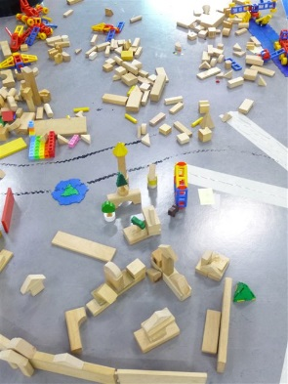
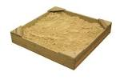

Naughty Bus Sentences

I am a London Bus.
I ran away and went to London.
I went on holiday to Wales.
I squashed the orange.
I smashed up toy town.
I hid in the sandpit.

