Year 2
Geography
Tuesday 6th January 2026
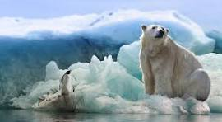
Exploring the Polar Regions and the Equator
Task:
Using the BBC Bitesize links, watch the video clips, then:
- Read the facts
- Take part in each quiz
- Use the next page to write a fact list from your learning today (you can use bullet points for your list or create a fact page with pictures too).
- For the Equator link, you just need to watch the video - there is a separate sheet with the song words and facts for you to look at and help you.

BBC WEB LINKS:
What is a polar habitat?
https://www.bbc.co.uk/bitesize/articles/z3sr4wx
The Geography of Antarctica
https://www.bbc.co.uk/bitesize/articles/z4whsk7#zwmybqt
The Equator
https://www.bbc.co.uk/teach/class-clips-video/articles/zkk6t39

My Polar Facts

