
Home Learning 1 – Early Years
The Importance of Play
Play underpins the EYFS. It also underpins learning and all aspects of children’s development. Through play, children develop language skills, their emotions and creativity, social and intellectual skills. For most children their play is natural and spontaneous although some children may need extra help from adults.
Play takes place indoors and outdoors and it is in these different environments that children explore and discover their immediate world.
It is here they practise new ideas and skills they take risks, show imagination and solve problems on their own or with others.
Adults provide time and space and appropriate resources. These might include clothes, boxes, buckets, old blankets that will inspire play and fire children’s imaginations. They observe play and join in when invited, watching and listening before intervening.
We have attached the ‘What to expect when document’ form the department for education 2015, to give you a guide on children ages and stages of development.
- We have also attached potty training guidance if you would like to consider potty training at home.
- School readiness- please see attached document to help prepare your children for school if starting Reception class in September.
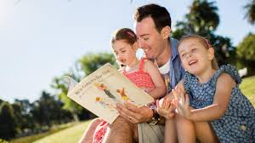
Sharing stories- Experience shows that children benefit hugely by exposure to books from an early age.
Right from the start, lots of opportunities should be provided for children to engage with books that fire their imagination and interest.
Enjoying and sharing books leads to children seeing them as a source of pleasure and interest and motivates them to value reading.

See letters and sounds phase 1 activities document. Most of these you will be able to find objects around your house to engage in these with your child/children.
Here are some ways that you can support learning at home that link to the EYFS learning requirements through everyday tasks and within the home routine.

- Develop children’s independence (Poor own drink, using knives and forks, getting dressed, buttering toast,)
- Exploring the outdoors
- Using sticks in the garden for mark making in the mud
- Help at Home – matching socks when doing the washing
- Physical exercise – you tube Sticky kids and Boogie Mites, ask Alexa to play Sticky kids/ Boogie mites
- Nursery rhymes and songs – Share nursery rhymes and songs daily – See rhyme cards
- Explore rhythm using pots and pans from your kitchen to make music.
- Develop cutting skills – See handout
- Maths support for early years – Use language such as tall, short, big, small, heavy and light. (maximise bath time), explore shapes within the environment e.g- square table, circle plates, rectangle door. Use number and counting throughout the day at any given opportunity e.g counting stairs as you climb them.
- Colour hunt – see handout
- Mark Making – crayons, pencils, paint, sticks in mud, water and brushes on dry paths, paint rollers with water, flour play, ribbons attached to a stick to make marks in the air.
- Den building – Bed sheets, pillows, clothes pegs, material.

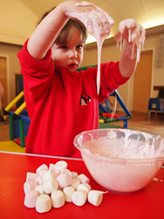
Pink slime
Pink marshmallows in a bowl. Squirt of washing up liquid. Whizz in the microwave until they begin to melt. Cool a bit so as not to burn any fingers. That's it!
If you use white marsh mallows you can add food colouring to change the colour of your slime.

Things in Jelly
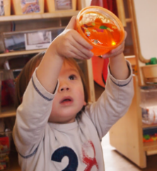
I know that jelly is a regular favourite, but it never fails to get great results. We tried putting jelly into various other containers of different sizes, ice cube trays, freezer bags and even a rubber glove, which made for a very squishy handshake! In the pots of jelly, add other 'items' for the children to look at and fish out. These caused a great deal of interest

Action/finger songs are great for promoting an awareness of a 2-year-olds own body in space (proprioception). These could be:

- 5 little ducks went swimming one day
- 2 little dickie birds sitting on a wall
- 5 fat peas in a pea pod pressed
See links to nursery rhymes and songs

Whole body songs are a great combination of physical and language development. For example:

10 (or 5!) in the bed,
3 little monkeys bouncing on the bed
I’m a dingle dangle scarecrow
Oranges and lemons

Physical Development
At this age children are beginning to be able to control their bodies, but they may still need a hand with some things, such as balancing on a plank of wood, climbing to the top of the climbing frame, kicking a ball. They are likely to be very interested in anything messy or tactile. This is good for their sensory development and very easy to provide.

For example:

Gloop – a mixture of cornflour and water, which is solid when squeezed but then dissolves into liquid once the pressure, is removed. Incredibly messy, great fun.

Cloud dough – an 8:1 mix of plain flour and baby oil, which turns the flour into a substance like wet sand, mouldable but easily disintegrated.

Useful links for you to access at home

https://littlebinsforlittlehands.com/25-playful-learning-preschool-activities/

https://famly.co/blog/inspiration/10-creative-early-years-maths-activities/

Tummy Time - https://www.todaysparent.com/baby/baby-development/how-to-do-tummy-time-with-your-baby-8-fun-activities-to-try/

http://www.earlyyearsresources.co.uk/blog/2018/02/sensory-play-activities-and-ideas/

