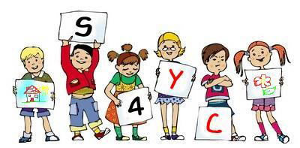
Preschool / Nursery
‘All About Me’

(Photograph/drawing)

My name is:

I was born on:

I go to:
(Name of setting)

People Who Are Important To Me

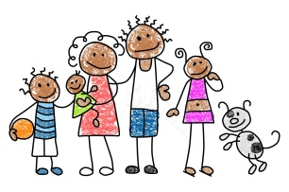 My family 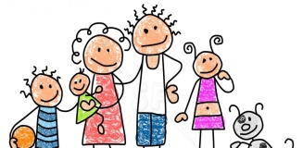

- My special friends

- Other people who are important to me

Include the names of family members and the ages of siblings.
Other people who are important to me could be a childminder, Portage Home Visitor or Speech and Language Therapist (people I see regularly)

Pictures of People Who Are Important To Me

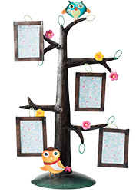

Parents/carers may like to contribute photos e.g. of family and friends, child care providers.
Things I would like you to know about me

Things I like



Things I don’t like
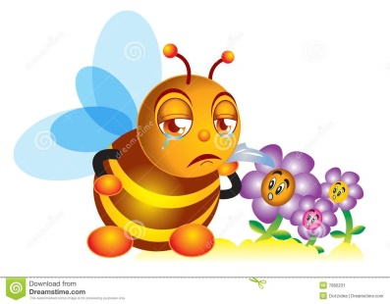

Things I can do

I can wash myself

I can go to the toilet by myself

I can put my coat on

I can dress myself

I can eat with a knife and fork

- My family and I celebrate
(The cultural and religious events I take part in)

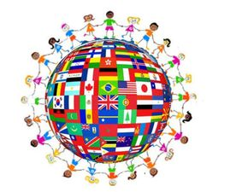

- My favourite toys

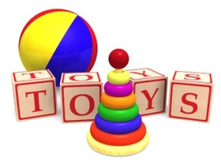

- my favourite rhymes and stories
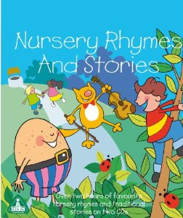

- I need help with

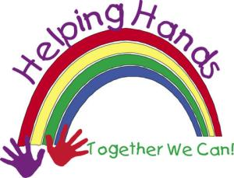

- Special things I need
(dietary requirements, Healthcare Plan)



- My favourite food is:

- If I’m upset, I …
(e.g. I rarely cry unless I’m hurt, I don’t like to be cuddled if I get upset)

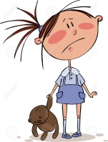

- I am happy when

- I get cross when

- I feel worried when

- When I’m at home I like to

- My special skills
(Such as an additional language)

- My experience of being away from my family
(Childminder or crèche)

- My special words/sign language
(Special words, signs or symbols I use to communicate my needs – list)

