100 Books To Read In Year 5 and 6
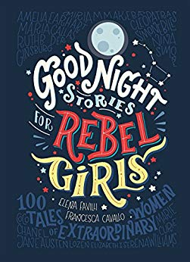
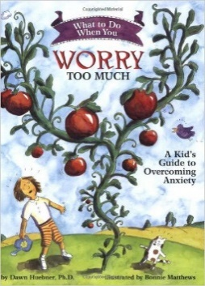
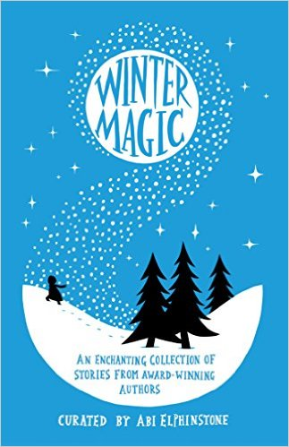
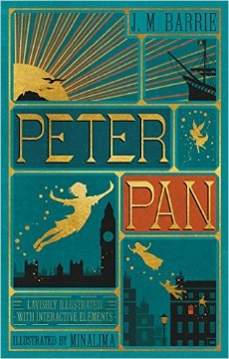
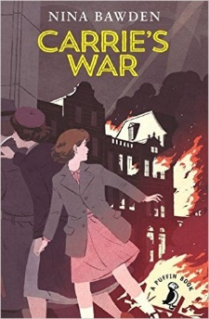
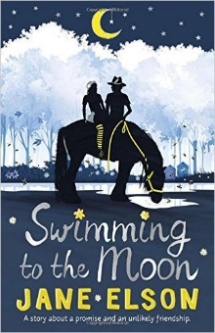
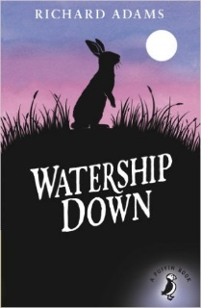
Skullduggery Pleasant
Derek Landy
The Wonderful Wizard of Oz
L Frank Baum
The Miraculous Journey of Edward Tulane
Kate DiCamillo
Carrie’s War
Nina Bawden
The Goldfish Boy
Lisa Thompson
101 Poems for Children
Carol Ann Duffy

Liz Pichon
Howl’s Moving Castle
Diana Wynne Jones
There May Be A Castle
Piers Toarday
The Invention of Huge Cabret
Brian Selznick
What to Do When You Worry Too Much
Dawn Huebner
Winter Magic
Stories by Various Authours
Peter Pan
JM Barrie
Swimming to the Moon
Jane Eslson
Watership Down
Richard Adams

Goodnight Stories For Rebel Girls
Elena Favilli and Francesca Cavallo
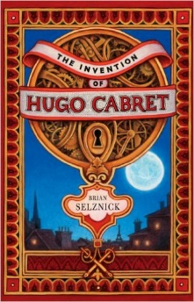
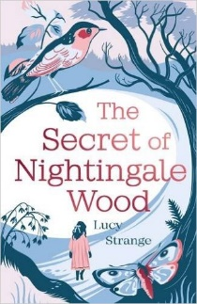
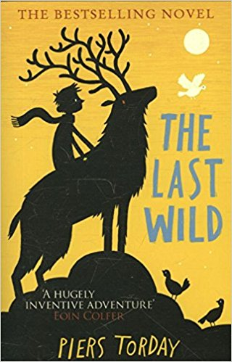
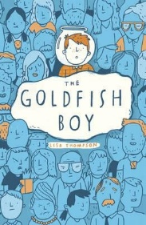
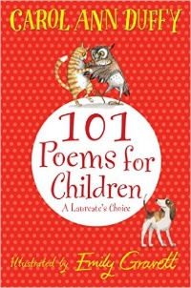
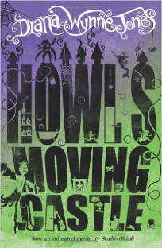
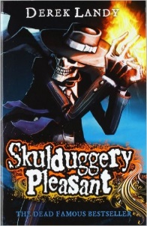

The Secret of Nightingale Wood
Lucy Strange

