100 Books To Try And Read In Year 5 and 6
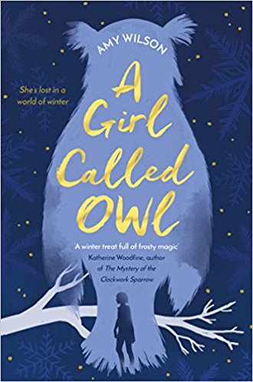
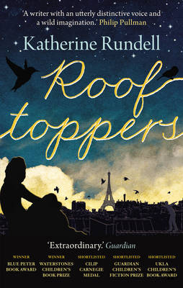
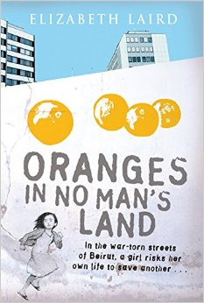
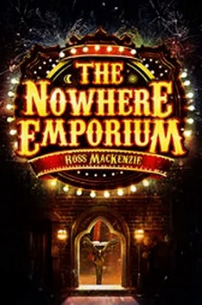
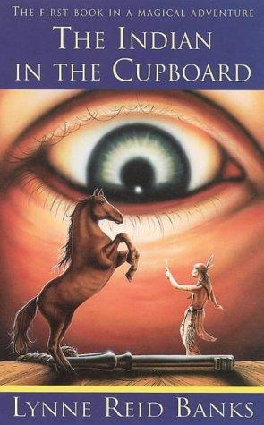
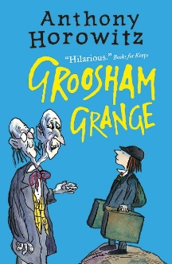
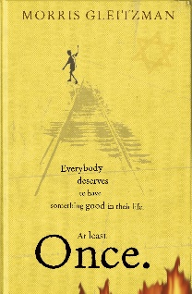

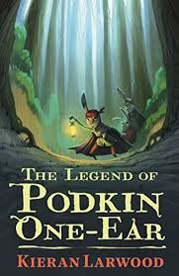
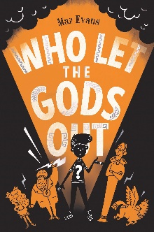
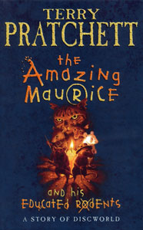
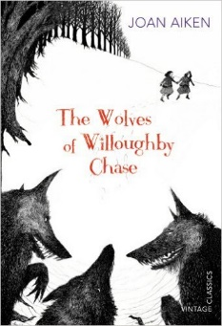
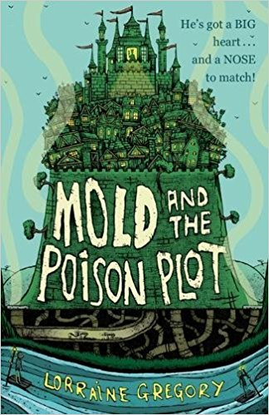
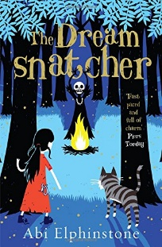
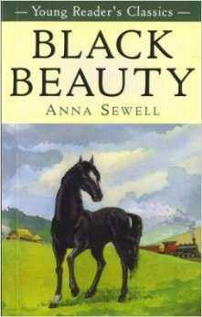
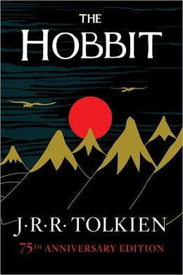
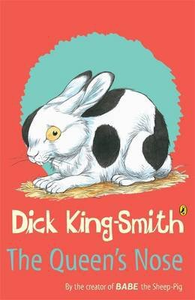
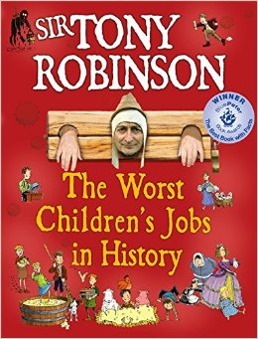
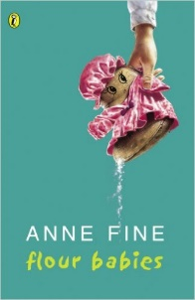
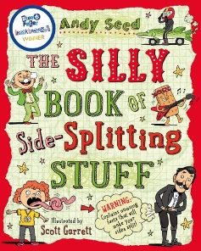
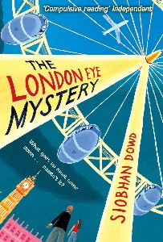
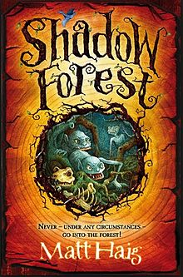
Who Let The Gods Out?
Maz Evans

The Amazing Maurice and his Educated Rodents
Terry Pratchett
The Wolves of Willoughby Chase
Joan Aiken
The Silly Book of Side-Splitting Stuff
Andy Seed
Black Beauty
Anna Sewell
The Hobbit
JRR Tolkien
The Queen’s Nose
Dick King-Smith
The Worst Children’s Jobs In History
Tony Robinson
The Indian In The Cupboard
Lynne Reed Banks
Flour Babies
Anne Fine
Mold and the Poison Plot
Lorraine Gregory
The Dreamsnatcher
Abi Elphinstone
The London Eye Mystery
Siobhan Dowd
The Legend of Podkin One Ear
Kieran Larwood
Shadow Forest
Matt Haig
A Girl Called Owl
Amy Wilson
Rooftoppers
Katherine Rundell
Oranges in No Man’s Land
Elizabeth Laird
The Nowhere Emporium
Ross Mackenzie
Groosham Grange
Anthony Horowitz
Once
Morris Gleitzmann

