100 Books To Read In Year 5 and 6
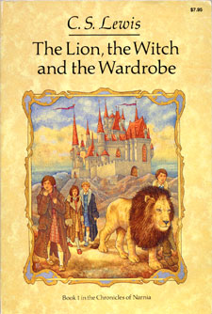
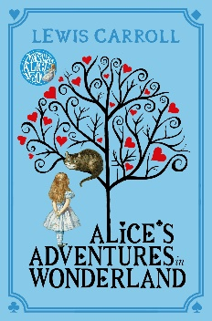
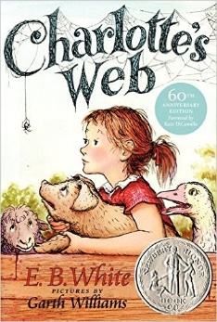
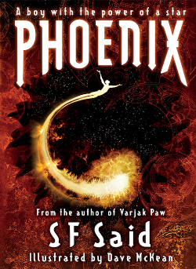
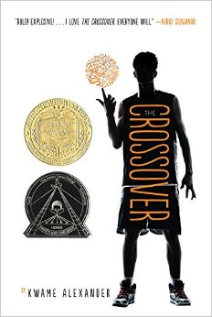
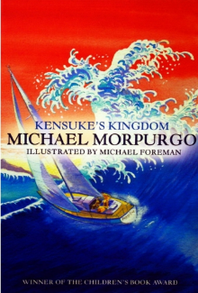
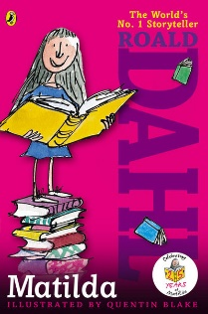
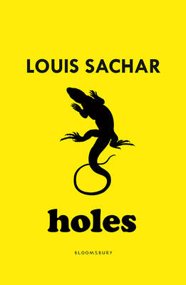
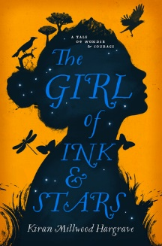
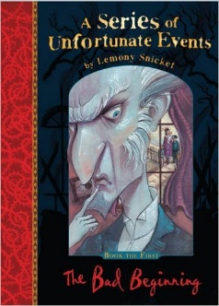
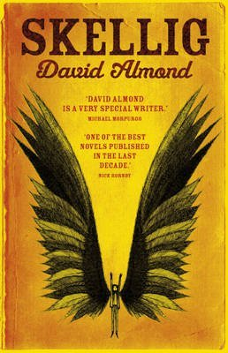
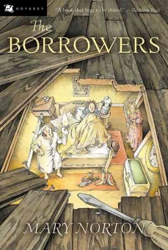
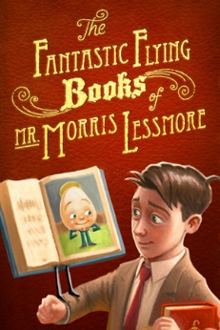
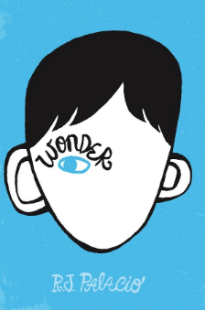
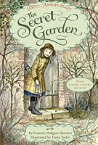
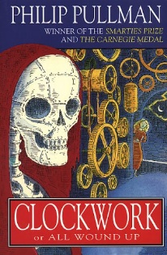
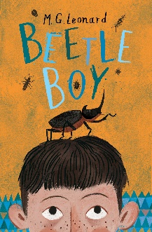
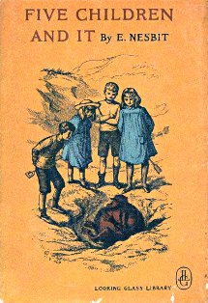
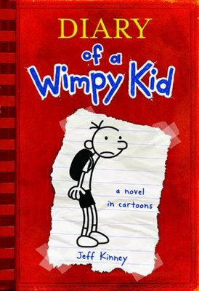
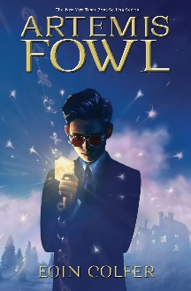
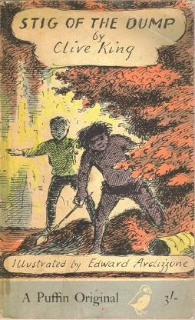
Holes
Louis Sachar
The Girl of Ink and Stars
Kiran Millwood Hargraves
A Series of Unfortunate Events
Lemony Snickett
Skellig
David Almond
The Fantastic Flying Books of Mr Morris Lessmore
William Joyce
The Borrowers
Mary Norton
Wonder
RJ Palacio
The Crossover
Kwame Alexander
The Secret Garden
Frances Hodgson Burnett
Clockwork
Phillip Pullman
Beetle Boy
M G Leonard
Five Children and It
E Nesbit
Diary Of A Wimp Kid
Jeff Kinney
Artemis Fowl
Eoin Colfer
Stig Of The Dump
Clive King
The Lion, The Witch and The Wardrobe
C S Lewis
Alice’s Adventures In Wonderland
Lewis Carroll
Charlotte’s Web
E B White
Phoenix
S F Said
Kensuke’s Kingdom
Michael Morpurgo
Matilda
Roald Dahl

