100 Books To Read In Year 5 and 6
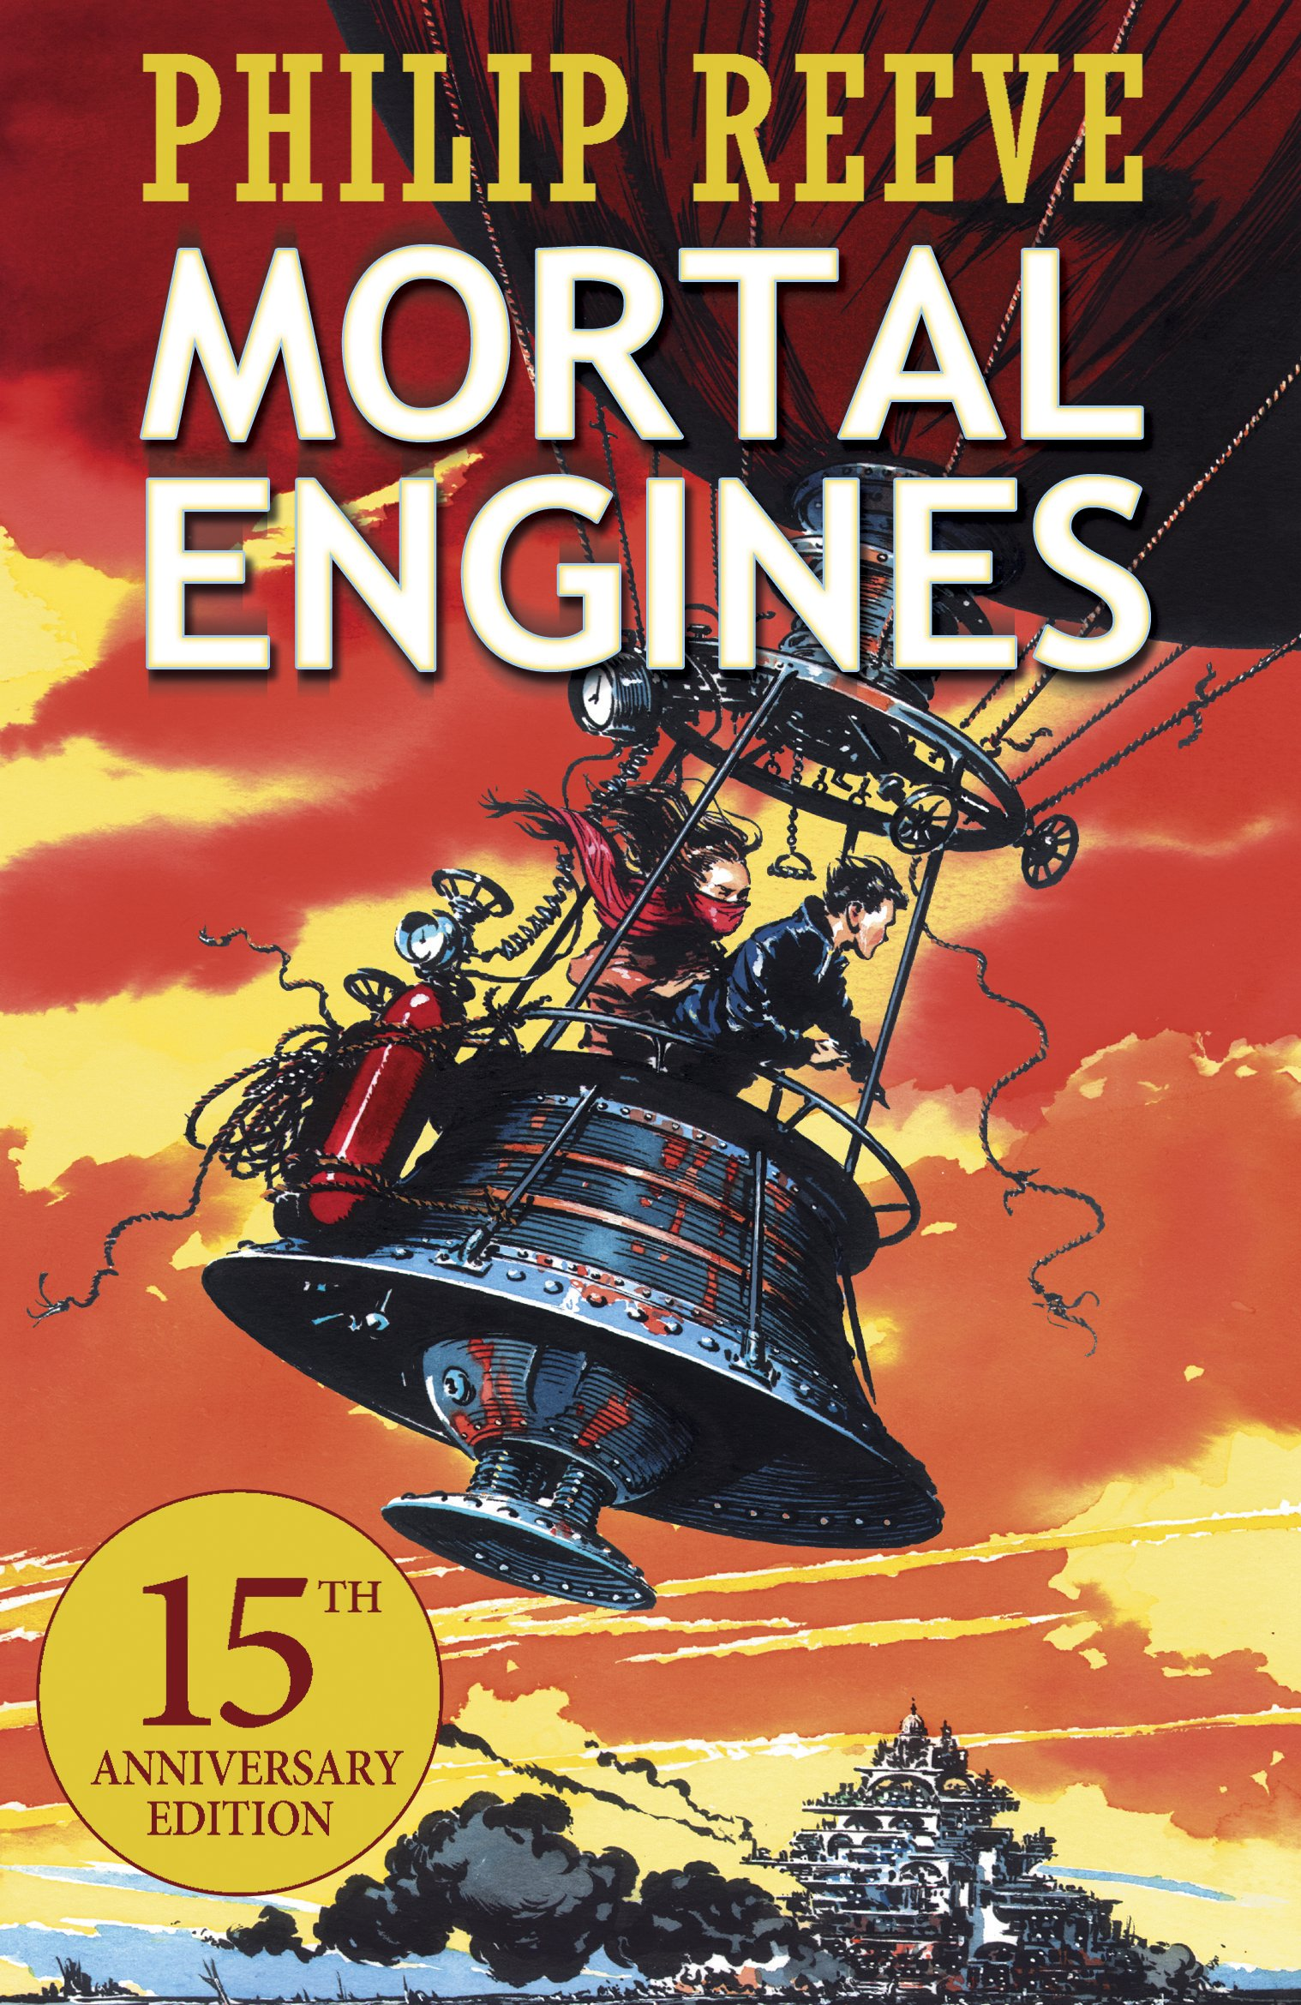
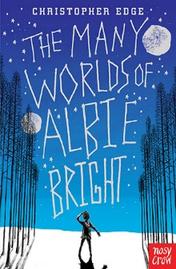
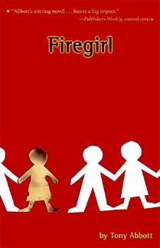
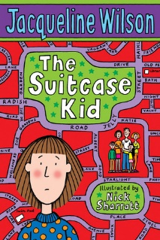
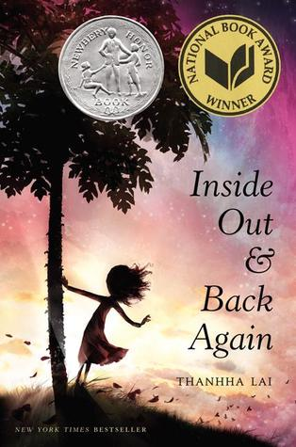
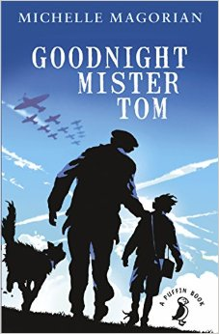
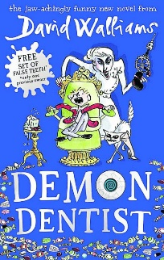
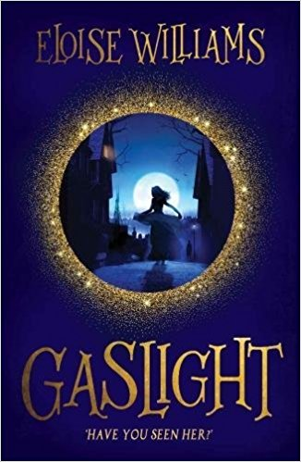
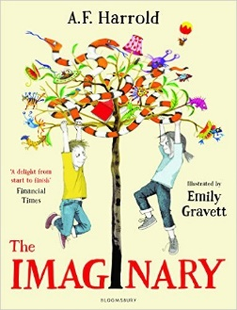
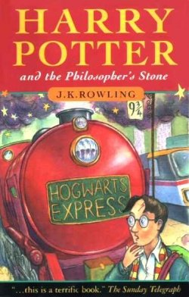
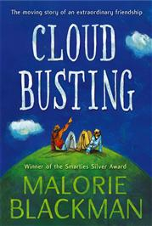
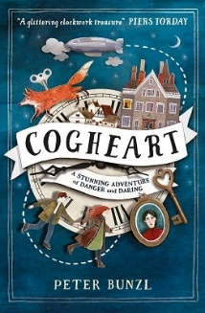
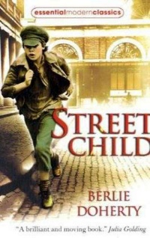
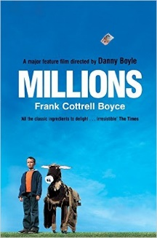
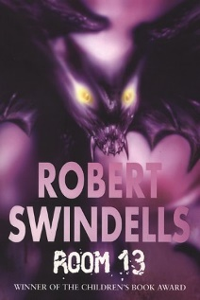
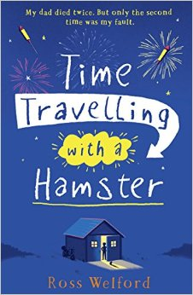
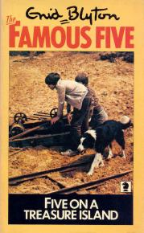
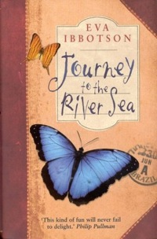
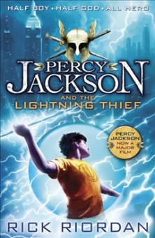
v
Five On A Treasure Island
Enid Blyton
The Imaginary
A F Harold
Harry Potter and the Philosopher’s Stone
JK Rowling
Gaslight
Eloise Williams

Cloud Busting
Malorie Blackman
Cogheart
Peter Bunzl
Street Child
Berlie Doherty
Millions
Frank Cottrell-Boyce
Inside Out and Back Again
Thannha Lai
Kick
Mitch Johnson
Room 13
Robert Swindells
Time Travelling With a Hamster
Ross Welford
Journey to the River Sea
Eva Ibbotson
The Graveyard Book
Neil Gaiman
Percy Jackson and the Lightning Thief
Rick Riordan
The Many Worlds of Albie Bright
Christopher Edge
Firegirl
Tony Abbott
Mortal Engines
Philip Reeve
The Suitcase Kid
Jacqueline Wilson
Goodnight Mister Tom
Michelle Magorian
Demon Dentist
David Walliams

